Student awards form FA1-Tuition fee

Award process: Schools and departments
Last updated: 18/02/2025 AEG
If you have any problems filling out the below form, please contact Student Fees via email at FA1queries@leeds.ac.uk or by telephoning 0113 343 6700
The forms are located on the website below. Please ensure that you always use the most recent version of the forms:
https://ses.leeds.ac.uk/info/21710/funding_and_awards/839/tuition_fee_scholarships_and_awards

Master Forms available
- FA1: Tuition fee award (scholarship, fee bursary, fee discount, fee waiver to multiple (or a single) students from a single cost object number (account number).
- FA1 Amendment Form - used to notify Student Fees of an amendment to an existing student fee award
- FA1 Reversal Form -used to notify Student Fees of the need to completely reverse a fee scholarship

All the above forms are located on the website as follows: https://ses.leeds.ac.uk/info/21720/fees-and-charges/839/tuition-fee-scholarships-and-awards

Macro use on FA1 form

Please note that the FA1 form uses macros to facilitate some of the built in functionality and it is important that once you have finished using the FA1 form you completely close down Excel before continuing on with other work. If you do not completely close Excel there can be issues with certain action (such as copy and pasting) that occur as a result of the Visual Basic for Applications (VBA) programme continuing to run in the background.

Summary of procedure
- Create file from the master form
- Send the file via an authorised signatory to FA1@leeds.ac.uk
- If you need to amend an award, please use an FA1 Amendment Form.
- If you need to cancel an award, please use an FA1 Reversal Form.

1. Create file from master form
All formatting should be preserved in the sheets when completing them. In the top section of the form, all of the white boxes must be completed.

IMPORTANT NOTE: DUE TO THE FORMATTING, PLEASE ONLY USE ONE GL CODE & MAJOR SOURCE OF FUNDING CODE PER FA1

Each white box carries a brief description of the action that needs to be taken. For example:-
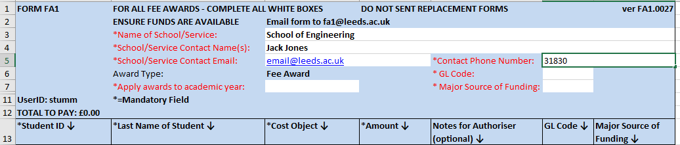

The first 4 boxes require data entry:-
‘Name of School/Service’: Please ensure that you complete this section, as it will be used when created the payment code for the payment request.
‘School/Service Contact Name(s)’: Please ensure you put your own name into this field, or the name of a colleague who deals with the FA1 forms, so that if there is a query with any of the information on the form we know who to contact.
‘School/Service Contact Email’: Please ensure that you include an email address, in case there is a query. Please try to use a non-generic email, where possible.
‘Contact Phone Number’: Please include the best number for us to contact you directly.

The next three are all selected via a drop down. For example:-
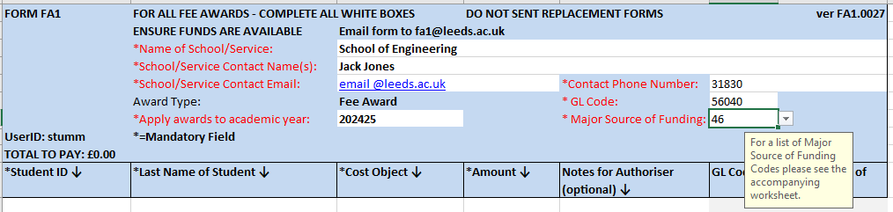

Apply award to academic year’: Please choose the correct academic year.

GL Code’: Select the correct GL code for the award as below:
56041 for Alumni Bursary only
56042 for Fee waivers (for example, a reduction for mitigating circumstances)
56040 for all other awards

Major Source of Funding. This is always a two digit code. This code is used to report scholarship information to HESA and is essential for processing the form. For HESA codes, please see Stud https://www.hesa.ac.uk/collection/c18054/a/mstufee

The GL code and Major source of funding code will update automatically from the information you have provided in the above boxes

When filling the body of the form:-

‘Student ID’: You can only enter a 9 digit student ID number. If it is too long or short, you will see the message, as below:-
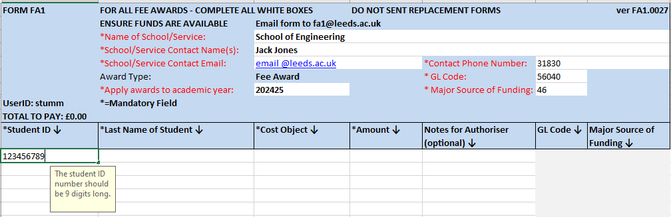

Last Name of Student’: To keep in line with GDPR compliance, please only enter the last name of the student.

Cost Object’: This box will only accept a correctly configured Cost Object number (account number), ie 6 / 8 numbers or a combination of 6 letters & 6 numbers. Please make sure that the account number is correct and that there is enough budget to cover the fees that you are paying.

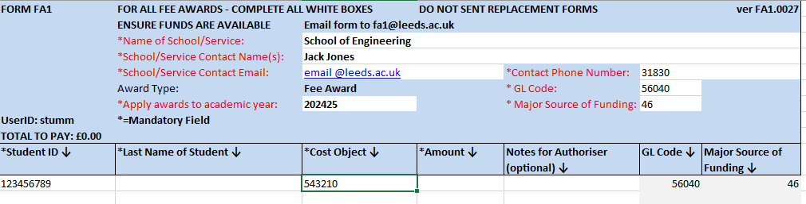

Amount’: Please enter the total amount of the award.

Please be aware that the ‘Notes for Authoriser’ is purely for the use of the schools and will not be read by the person processing the form.

When saving the form please ensure that it is saved in the original .xlsm format. If this is changed to any other format, then the form will not process correctly, which could result in the award not being processed.

Please find below an example of a complete form:-
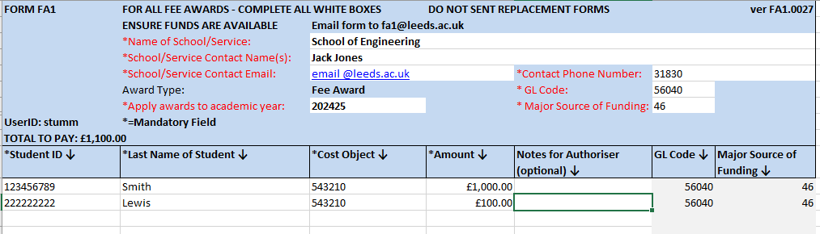

Debiting funds from the department/school account.
In the case of tuition fee awards, the cost object/ account number will only be debited once the student has completed registration. If you send the form in early, then your account may not be debited for several months, so please make sure you have enough funds in your account to cover the award. If the budget does not cover the funds, Student fees will contact you and ask you to increase the budget immediately.

Additional FA1

Any changes to an existing award that result in the award being increased are achieved by sending in a new FA1 form for the additional amount – this cannot be achieved by sending in an FA1 Amendment Form. Again, this should be sent through by an Authorised Signatory

2. Send file via authorised signatory
The file must be attached to an email and sent to FA1@leeds.ac.uk by an authorised signatory. The form is approved and verified (equivalent of a signature) by this act of the authorised signatory sending the form.
3. Amending an award
If you wish to amend a form which does not result in the award being increased, then you should send in a FA1 Amendment Form.
FA1 Amendment Form
If there is a change to be made to an award, such as: a reduction in the award amount; a change to the academic year; or a change to the cost object number, then a ‘Fee Payment Amendment Form’ would need to be completed. An authorised signatory must be copied into the email - unless they send the email - so that the change is made with the awareness of the authorised signatory.
It is important that all sections of this forms marked with an asterix, are completed in full. If not the form will be rejected.
The Original Payment Request Stated – please ensure that this section mirrors the information that was sent through on the original FA1 form.
Please Amend This To – Enter the new details in this section. For example:-
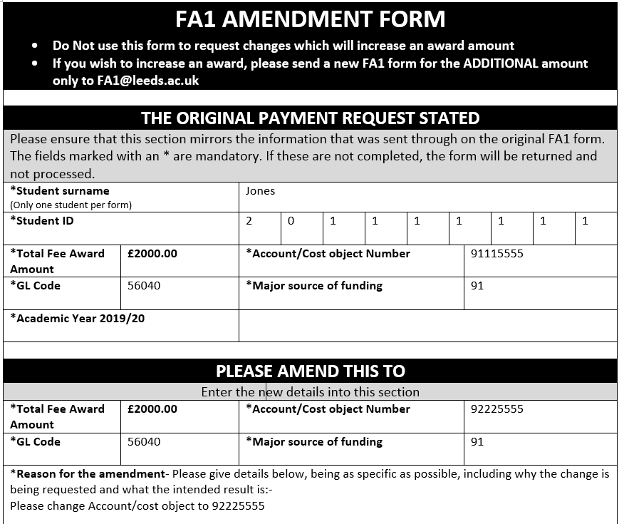
In the body of the form, please give a detailed description of the amendment to be made. This is extremely important, so that we can correctly interpret the information.
It is extremely important that you fill out the final section, so that we can contact you to clarify any issue. We also need to know that the Authorised Signatory is aware of any change, so if they are not cc’d into the email that is sent to FA1@leeds.ac.uk, the automated system will not accept it. The request will be rejected, which will delay any changes from being made.
Please find an example of a completed Fee Payment Amendment Form below,
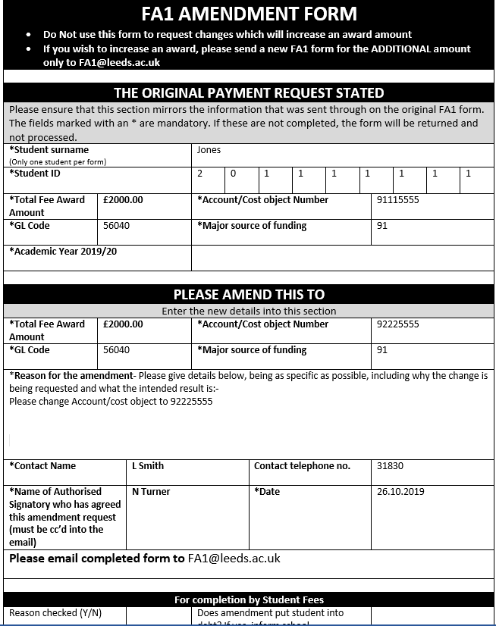

Reversing an award
If you wish to reverse or remove an award in full, then you should send in a FA1 Reversal Form.
FA1 Reversal Form
The reversal form can be used for single or multiple students. Please complete all the sections of this form. If not the form will be rejected.
Please send the completed form to FA1@leeds.ac.uk

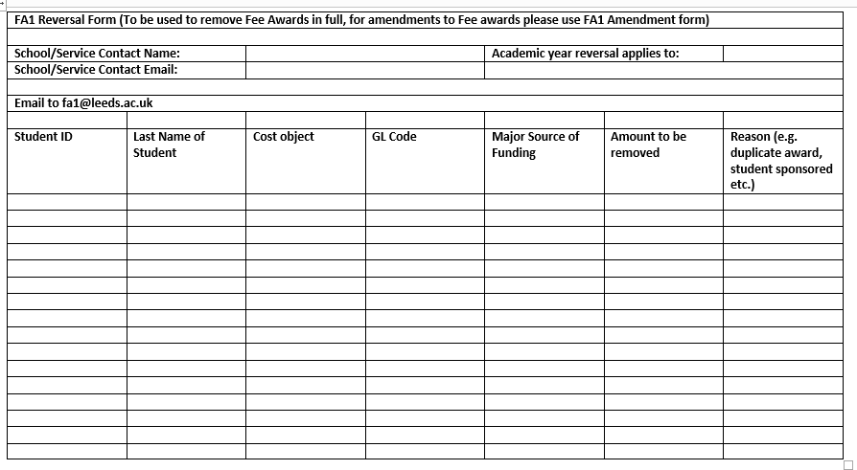

Contact us
If you have any queries about FA1 forms, please contact Student Fees;
Email FA1queries@leeds.ac.uk
Telephone 0113 343 6700

