Doctoral College Programmes

Information and guidance for split-site Model C.

This Model is designed for collaborations (either through partnership enquiries or a successful funded project) where a HEI/organisation/research institute is entering into a partnership with Leeds to deliver the PhD research project.

- General entry requirement: A relevant degree equivalent to a British Bachelor (Honours) 2:1 and a Masters degree. Exceptional cases, where applicants do not have a Masters degree may be brought forward for special consideration by the PGR Programmes and Quality Group.

- English language requirement: International postgraduate researchers will normally be required to have achieved at least 6.5 on IELTS (with no component below 6.0) or an equivalent English language qualification. Some Schools may require higher levels of English language.

- All applicants are required to submit a clearly planned Research Proposal at the application stage. Schools will be expected to address any relevant ethics issues and to undertake risk assessments where relevant.

- Method of study: Candidates accepted under these arrangements are normally expected to study on a full-time basis with some periods of full-time study in Leeds. This model is typically for a collaborative arrangement with a non UK based HEI / Research Organisation where the partner’s commitment to the research activity of the PGR and their project is both integral to and supportive of their studying on a full time basis. The candidature is split site because mobility and therefore attendance at Leeds is often limited which reduces the number of months overall spent at Leeds.

- Duration of programme: 3 year standard period of study with a maximum time limit for submission of the PhD thesis of 4 years.

- Requirements for supervision: Supervisors are appointed at the University of Leeds and a local supervisor or advisor must also be appointed. The local supervisor or advisor should normally be employed in a HEI, Research Institute or Commercial or Industrial Organisation. Other individuals may be appropriate for appointment as local supervisor or advisor and schools should put forward information to support these cases.

7. Role of the local supervisor/advisor The local supervisor/advisor would normally be expected to be based in the institution/organisation where the candidate will be conducting research and where the candidate might also be employed and should be readily available for consultation.

The local supervisor/advisor is not required to meet the University criteria as a supervisor and as such is not responsible for providing the same level of advice and guidance as the appointed Leeds supervisor(s). The appointed Leeds supervisor(s) is expected to provide supervisory support in accordance with usual practice. i.e. conduct 10 formal supervisory meetings a year, although when not in Leeds these may be facilitated through available technology such as Teams. Whatever medium of communication is used the notes of each meeting should be kept in GRAD.

The candidate should not be disadvantaged by the split-site arrangements so it is important that the local advisor/supervisor can help the candidate access appropriate facilities and resources and provide advice on ad hoc and day-to-day issues. The Leeds supervisor remains the main supervisor for the research project.

- Visit by Supervisor(s): The Leeds supervisor(s) are normally expected to visit the postgraduate researcher at their place of study at least once during the course of the candidature and the costs of this visit should be included within the fee charged.

- Attendance requirements: The candidate is normally required to be in full-time residence in Leeds for at least 6 months over the course of the programme. The candidate must take appropriate advice from International Student office in relation to visa requirements for visits to Leeds as part of this split site programme. At least 2 months must be spent in Leeds in Year 1 so that appropriate training can take place (and to resolve any relevant ethical approval processes, which may not have been dealt with at the admissions stage).
Appropriate research and generic training will also take place during the first twelve months. A training plan should be agreed by month 3 of Year 1 and identified training may take place at the University of Leeds during the course of the candidature. The postgraduate researcher must also be present in Leeds at the end of year 1 for assessment for transfer to full PhD registration and this equally applies to a second (or repeat) transfer assessment should one be needed.

Two months must then be spent in Leeds in each of the following years of study taking the total time spent at Leeds across the 3 years to 6 months. This may be in a block of 2 months in each year or split into 2 separate blocks of 1 month. The postgraduate researcher must also be present in Leeds for the examination of the thesis. This equally applies to a second (or repeat) viva, should one be needed.

- Academic fees: The rates charged by the University are Year 1, 75% of the standard University full-time fee, Years 2-3, 50% of the standard University full-time fee. Fees are chargeable at either the UK rate or the international rate, as appropriate to the relevant fee status of the candidate. Year 4, the overtime year will be the standard overtime fee. Normally, no Bench fee would be charged for the 6 months spent at Leeds, although depending on the research project, this may be revisited if an extended period of time is planned at Leeds.

Please note that Faculties/Schools may reduce the level of fees directly chargeable to individual postgraduate researchers, provided that the Faculty/School meets the residual University fees by completing a FA1 form and returning it to the Student Finance and Support Office. If Faculties/Schools require an additional bench fee to cover specific research expenses this should be clearly indicated on the Recommendation Form and the Offer Letter.

- Resources: If this arrangement is part of a collaborative arrangement the support of the partner institution / organisation will be included in the agreement. If this is an individual application the applicant must have a statement of support from their employer (if in employment) which provides evidence that relevant resources and facilities are in place for the research. This information must be provided on the Form for Employers. PGR Programmes and Quality Group must be satisfied that the applicant has access to appropriate facilities for the conduct of the research.

Once all the required information (set out above) is provided the application will be considered by the University Programmes and Quality Group . Please ensure that the attached forms are fully completed and returned to Doctoral College Admissions together with the application form and other documents relating to the applicant.

- Progress monitoring during the candidature: The PGR will follow the usual progression milestones for PhD study: Training Plan by month 3; First Formal Progress (FFPR) by month 6; Transfer by month 12; Annual Progress Review (APR) at the end of year 2 and again at the end of year 3 if the thesis has not been submitted. The Thesis to be submitted by the maximum time limit or 48 months. PGRs will use the GRAD system for all milestones and supervisions.

- Where a number of postgraduate researchers are accepted under Split Site Model C from an academic institution, the partners will be academic institutions which engage in research activity (see Ordinance XIX article 9).

Split-site PhD Model C: Fees (full-time)

The University fee level is “front-loaded” in Year 1.
Year 1: 75% of the standard University full-time fee

Years 2-3: 50% of the standard University full-time fee.

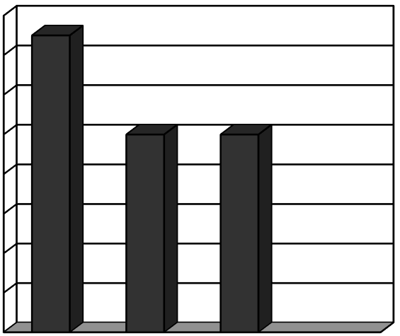  %  0  10  %  20  %  %  30  40  %  50  %  60  %  %  70  %  80  Yr 1  Yr 2  Yr 3  Yr 4 | Full-time

NB: Fees are chargeable at either the UK rate or the international rate, as appropriate to the relevant fee status of the candidate. Please bear in mind that the standard levels of academic fees for UK postgraduate researchers normally increase each year to take account of inflation. However, the standard fee levels for international postgraduate researchers will remain the same throughout the candidature. Candidatures in year 4 will be charged the Overtime Year fee. Postgraduate Researchers are not required to be resident for a 2 month period in Leeds during this year as the overtime year is for the writing up and completion of the thesis rather than any further research.

For arrangements with partners from HEIs this may take the form of a local supervisor; for other organisations this is may be an Advisor. This will be confirmed in the agreement.

