Operational Guidance for New Change of Programme Process for the Academic Year 2020-21

The process for Changes of Programme has been moved online for the 2020-21 session, as opportunities for students to have face-to-face interaction with Academic and SES staff will be much reduced due to Covid-19.

The updated process will go live on Monday 28th September:-
- For Taught Students only
- Minor process changes only - NO policy changes

1. High Level overview of new Process

Two forms have been created that the student will need to complete
- Change of Programme Initial Enquiry (Form 1)
- Change of Programme Formal Submission (Form 2)

Process:-
- A student submits Form 1, an online Change of Programme Initial Enquiry Form, located here which sends an automated email to the proposed new Parent School.
- Proposed new Parent School investigates based on local criteria, e.g. programme capacity or pre-requisite study, entry requirements, academic record. For requests to change to a variant programme involving a study abroad year or year in industry, this investigation may involve referral to a specialist team within the School/Faculty. In some cases the proposed new Parent School may request further information from the student, such as proof of qualifications required for the programme.
- If the request is from a Tier 4 student wishing to make a change which would involve a change to the duration of their study, the proposed new Parent School forwards the request to the Tier 4 Team (pbs@leeds.ac.uk) to consider visa implications. Parent School must await communication of outcome from Tier 4 Team before next steps.
- Proposed new Parent School makes a decision as to whether to accept the student in principle and responds to the student. If their request is approved in principle, the School advises the student of any implications, and to contact relevant teams as appropriate for further advice, e.g. Student Finance, current Parent School. The School also provides the student with the online Change of Programme Formal Submission Form (Form 2) located here.
- If student wishes to formally continue with change, the student completes and submits the online Change of Programme Formal Submission Form (Form 2) which sends an automated email to the proposed new Parent School.
- Proposed new Parent School formally processes the request and updates Banner record.
- New Parent School confirms to student that the change has been processed, copying in former Parent School, and provides information about next steps.

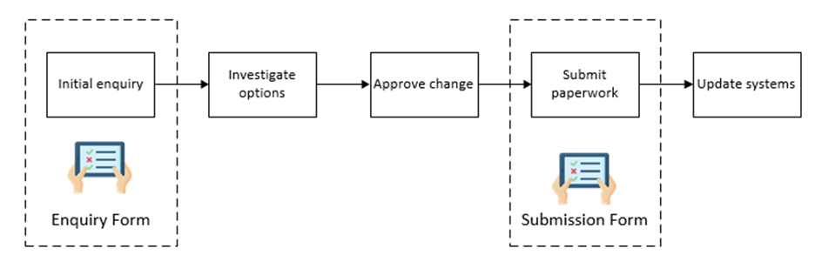
Figure 1 – High Level overview of Change of Programme process

2. Initial Enquiry Form Process (Form 1)

The student instigates the enquiry by accessing the online form from the For Students website here.

Students will only be able to access the form via their UoL Microsoft login (university e-mail log in) and will be prompted to log in when they click on the form.

Proposed New Parent School will take responsibility for considering change of programme requests in the first instance, taking into consideration local criteria e.g. programme capacity or pre-requisite study, entry requirements, academic record. For requests to change to a variant programme involving a study abroad year or year in industry, this consideration may involve referral to a specialist team within the School/Faculty.

Students are advised that initial response and guidance should usually be expected within 5 working days.

Once the student has completed the online form and submitted it, the data is sent to a SharePoint List. From here, two actions occur:-
- The student will receive an automated email receipt confirming the information submitted and a unique reference (of format “COPxxx”) – see Appendix 2
- The proposed new Parent School (selected by the student) will receive an automated email containing details of the request – see Appendix 3

Based on the information contained in the email, the proposed new Parent School will:-
- If the request is from a Tier 4 student wishing to make a change which would involve a change to the duration of their study, the proposed new Parent School forwards the request to the Tier 4 Team (pbs@leeds.ac.uk) to consider visa implications. Parent School must await communication of outcome from Tier 4 Team before next steps.
- Make a decision as to whether to approve the change in principle, and email the student with indicative decision, guidance and relevant information.

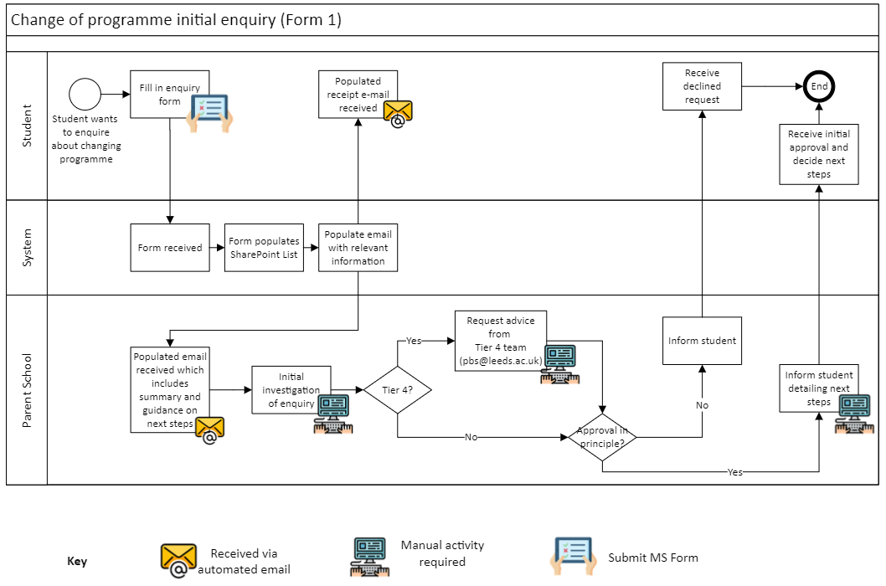

Figure 2 - Change of Programme Initial Enquiry

3. Formal Submission Form Process (Form 2)

The student will have been provided with the link to the Change of Programme Formal Submission (Form 2). The link to this form is not on the For Student website but can be directly accessed here.

Once the student has completed and submitted the Change of Programme Formal Submission Form, the data is sent to a SharePoint List. From here, two actions occur:-
- The student will receive an automated email receipt confirming the information submitted and a unique reference (of format “COPxxx”) – see Appendix 4
- The proposed new Parent School (selected by the student) will receive an automated email containing details of the request – see Appendix 5

The School must then formally approve or refuse the change* and confirm the outcome to student, copying in the former Parent School (if different). The School updates relevant systems as appropriate e.g. Banner, local databases.

*Note: at this stage in the process, a refusal of the requested change would only happen in exceptional circumstances, such as incorrect information having been submitted earlier in the process, or circumstances having changed since initial enquiry was made.

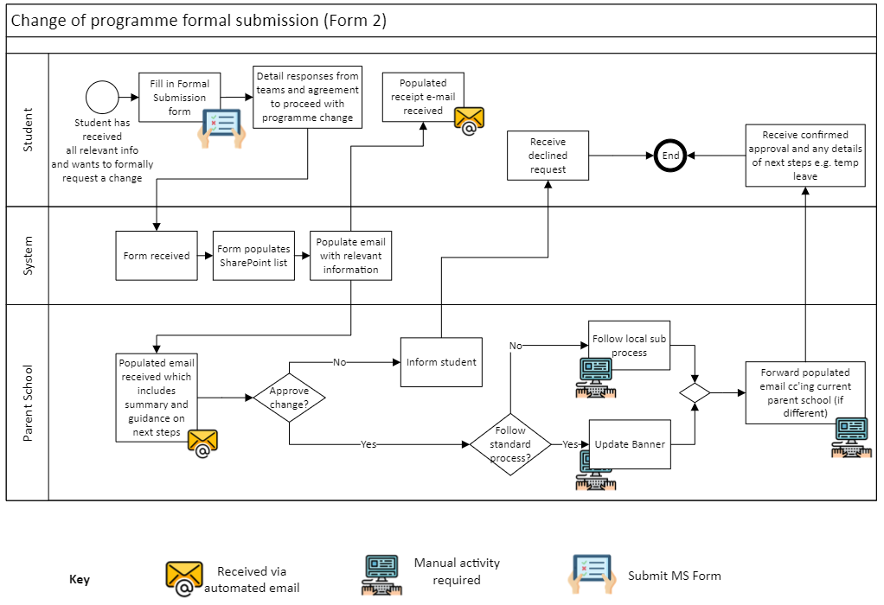

Figure 3 – Change of Programme Formal Submission

APPENDICES

Appendix 1 – Overview of automated flow actions (using PowerAutomate)

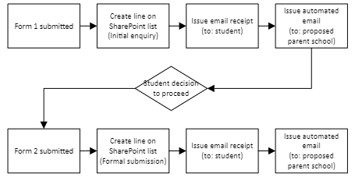

Appendix 2 – Copy of student receipt for initial enquiry (Form 1)

Dear Test Test,
Thank you, your Change of Programme enquiry has been submitted to Civil Engineering.
The reference for the submission is COP27.
We will aim to complete your enquiry within 5 working days.
The details of your request are shown below.
Proposed programme: Test Study
Proposed school: Civil Engineering
Proposed year of study: 1
Proposed move within the same school? Yes
Current programme: Testing
Current year of study: 1
Current Parent school (if different):
Reason for change: Programme or subject not as expected
Considering temporary leave? No
Studying on an international visa? No
Additional Information (if provided): Something to say
You will be contacted by Civil Engineering to discuss your request and any implications. If you require a Tier 4 visa discussing the options and impact of a change is especially important e.g. when it results in amendment to duration of study.
There may be financial implications to changing programmes, this is particularly likely if you are repeating a year, have programme specific funding or scholarship, will be taking temporary leave or have moved between Universities. If any of these apply you will need to contact the University's Student Finance department (email: funding@leeds.ac.uk and fees@leeds.ac.uk) to understand any financial implications of the change e.g. scholarships, outstanding tuition fee.
Please allow at least 5 working days before submitting further enquiries about this enquiry. We will contact you through your University of Leeds e-mail address.
Please do not reply to this email. It is an automated email and is not monitored. For further advice and guidance, please check https://students.leeds.ac.uk/ in the first instance or e-mail studentinfo@leeds.ac.uk.
Best Wishes,
Student Education Service Team

Appendix 3 – Copy of email to School for initial enquiry (Form 1)

Dear Colleague in Civil Engineering
The student below has requested permission to change programme within your school. This is an initial enquiry to begin the process. The Reference for the submission is COP27.
Details of the request are shown below:
Student ID: 123456
Student Name: Test Test
Proposed parent school: Civil Engineering
Proposed programme of study: Test Study
Current parent school (if different):
Current programme of study: Testing
Level of Study: Postgraduate Taught
Current year of Study: 1
Proposed year of study: 1
Student e-mail address: eenbw@leeds.ac.uk
Specific student type / categories (e.g. incoming study abroad):
["Previously transferred from another institution"]
Studying on an international visa? No
Student considering temporary leave? No
Additional Information (if provided):
Something to say
Reason for change request: Programme or subject not as expected
------------------------------
Next steps:
1. For students requiring a Tier 4 visa, the school should contact the Tier 4 Policy & Support team (pbs@leeds.ac.uk) to discuss whether a change is appropriate, any implications etc. This is especially important when a request will result in a change to duration of study
2. Students should contact the Student Finance department to discuss the financial impact of the change. This is confirmed in the email receipt issued to students when submitting this form
3. Once you have investigated the request and suitability of proposed change schools should follow the appropriate operational guidance here
4. Indicative text is shown below which may be provided to the student, amending as appropriate
Dear ,
Thank you for your enquiry regarding Change of Programme Ref: COP
Having reviewed the options I can advise:
These additional modules would be required:
Your end date will not change / will change to:
Once you have gathered all the relevant information and made a decision on your options, you can fill in this form Change of Programme formal submission request to submit a formal request to change.
Additional information:
For reference the link to the student form for Change of Programme is here.
Please note students received an automated response upon submission which advised:
• 5 working days for initial response
• Approval by proposed school is not guaranteed
• They may be contacted to discuss options if appropriate
------------------------------
Best Wishes, Student Education Service Team
This is an automated email and is not monitored, please do not reply.

Appendix 4 – Copy of student receipt for formal submission (Form 2)

Dear Test TEST,
Thank you, your request to make a formal change of programme has been submitted to Civil Engineering.
The reference for the submission is COP17.
We will aim to complete your enquiry within 5 working days.
Submission of a request does not guarantee a change can be processed.
The details of your request are shown below.
1. Changes
Proposed programme: Testing
Proposed parent school: Civil Engineering
Current programme: TESTING
Current parent school (if different):
Reason for change: Programme or subject not as expected
Considering temporary leave? No
Studying on an international visa? No
2. Additional information you submitted
Tier 4:
Programme & school:
Modules:
Civil Engineering will consider your submission and make a decision on the requested change.
Please allow at least 5 working days before submitting further enquiries about this enquiry. We will contact you through your University of Leeds e-mail address.
Please do not reply to this email. It is an automated email and is not monitored. For further advice and guidance, please check https://students.leeds.ac.uk/ in the first instance or e-mail studentinfo@leeds.ac.uk.
Best Wishes,
Student Education Service Team

Appendix 5 – Copy of email to School for formal submission (Form 2)

Dear Colleague in Civil Engineering,
The following student has submitted a formal request to change programme within your school:
Change of Programme Ref: COP17
Student ID: 2563899
Student name: Test TEST
Proposed programme of study: Testing
Proposed parent school: Civil Engineering
Current programme of study: TESTING
Current parent school (if different):
Level of study: Postgraduate Taught
Year of study: 2
Student e-mail address: eenbw@leeds.ac.uk
Specific student type / categories (e.g. incoming study abroad):
["International Foundation Year"]
Tier 4 student? No
Student considering temporary leave? No
Additional information the student submitted:
Tier 4:
Programme & school:
Modules:
------------------------------
Next steps:
The consideration of the request and decision on the change should be processed as agreed within your school or faculty.
1. If change is approved:
The proposed parent school should update Banner (and any relevant additional / local systems) with details of the changed programme and any modules etc.
Confirmation of the change should be sent to the student cc’ing the current parent school (if different).
2. If change is refused:
The proposed parent school should confirm the decision, and any rationale, with the student cc’ing the current parent school (if different).
The current parent school may find it appropriate to contact the student to discuss next steps or implications e.g. further support for teaching, temporary leave.
Additional information:
Operational guidance is shared here with information around process changes.
For reference the link to the student form for formal submission of Change of Programme is here.
By submitting this request a student has confirmed:
• The information they have supplied is accurate
• They have clearly understood all options discussed and any implications of change
• Submission of a request does not guarantee a change can be processed
• They wish to proceed with the formal request to change programme
------------------------------
Best Wishes, Student Education Service Team
This is an automated email and is not monitored, please do not reply.

