Recording On/Off Campus Status

This document details the process for keeping the On/Off Campus Status up to date in Banner.
The On/Off campus data fields are within the SGASADD Banner Page. Details on how to update this information can be found further below.

It is critical for a number of processes like Registration, Tier 4 compliance, Teaching and students activities planning, etc. that this data is accurate and kept up to date.
It is the responsibility of individual Schools to update the data regularly as students circumstances change.

An initial update of the student record (Taught and Research, New and Returning) will have been done systematically, with the majority of students flagged as On Campus (ONC). Where students are not expected to be on campus (as on placement, studying abroad, or enrolled on programmes which do not require students to attend lectures on campus, e.g. Distance Learning Programmes, etc.), they have been updated to Exempt (EXM).

- Why do I need to update records:

It is important that as a university we understand how many students are on campus and will be attending activities or using campus services. This data will support SES, estates, health and safety and other key campus services resource and plan accordingly.
Campus status information will support us to ensure Tier 4 compliance as a sponsor for international students. Holding latest arrival information for a student means we are able to handle enquiries from UK Visa and Immigration caseworkers if required, and if necessary the student's CAS (confirmation of acceptance for studies) can be annotated by colleagues who are UKVI SMS users to confirm this latest arrival date.
This information will also be used in conjunction with the online registration data to issue the appropriate reminders to students, understand when identity checks are expected to be completed and when Student Cards and Biometric Residence Permits may be required for collection.
The information will also be cross-referenced as part of the withdrawal process for failure to register.

- When do I need to update records:

- Approved Late Arrival: If students enquire about arriving in Leeds later than the start of teaching, it is up to individual Schools to decide if this can be accommodated based on: the student's personal circumstances, the design of curriculum delivery, and equity and quality of student experience. Where a later arrival is to be accommodated, the latest arrival date must be agreed with the student and the 'Campus Status' in Banner should be updated. The Late Arrival process can be found on the Student Education Service website.
- Reaching the Late Arrival Date: Once the approved late arrival date has been reached for one of your students, you must review the campus status and update the flags from AOC (Approved- Off Campus) to ONC (On Campus) as appropriate, and remove the late arrival date as this is no longer applicable. Argos reports are available to support you with this process.

- New Students: A Banner overnight job is run in the background to update the On/Off Campus details for any new student, and by default these students will be flagged as being on campus -ONC. If new students enquire about arriving in Leeds later than the start of teaching, and this is to be accommodated by the School, then the information must be inputted to Banner as necessary.

- Reports supporting the process:

A suite of Argos reports are available to view and review the data recorded on Banner so that you can take action as necessary; these can be found in the Argos General Folder/Campus Status/Monitoring.

Report Name | Detail | Report Logic
00 All Campus Status Students | Shows all students with any campus status | None. Report displays all students with any campus status based on dashboard parameter selections.
01 Students On Campus | Shows students with On Campus status only | Campus Status = ONC
02 Students Off Campus | Shows students with Off Campus status codes only | Campus Status = AOC, NOT
03 Students Expected On Campus Arrival Date Has Passed | Shows students who are Off Campus and the Expected On Campus Arrival Date has passed | Expected On Campus Arrival Date < Today AND Campus Status is not ONC, EXM
04 Students Campus Status Unknown | Shows students with Unknown status only | Campus Status = UNK
05 Students Campus Status Exempt | Shows students with Exempt status only | Campus Status = EXM

4. How can I ensure that I have updated the data accurately:

The Data is being monitored and any anomalies/inconsistencies will be picked up and queried with individual School.
However, you are encouraged to do these checks yourself to identify data issues and to rectify these swiftly.
The data quality reports supporting these checks can be found in the Argos General Folder/Campus Status/Data Quality

Report Name | Detail | Remediation
01 Missing Status | shows students without a campus status flag on their FULLTIME or PARTTIME cohort in SGASADD | Key in relevant information as required
02 Missing Expected Date | shows students who have a flag “AOC” on their profile, but do not have an expected arrival date | Update missing date or alter the status code as necessary
03 Non-AOC/NOT with Date | shows students who have an expected arrival date entered on a flag which is not “AOC” or “NOT” (*please see criteria below) | Remove the date recorded against codes other than AOC/NOT
04 Status on Wrong Cohort | shows students who have a flag entered on a non-FULLTIME/PARTTIME cohort | On/off campus status needs to be deleted from the cohort code and keyed in against the Fulltime/Parttime cohort as appropriate
05 AOC and NOT with Date | shows expected arrival date; to be used to identify records with dates prior to start of term This report will bring a mixture of correct and incorrect data and needs to be checked manually | Update date as necessary

* The criteria used to identify anomalies around Expected Arrival Dates are as follows:

On/Off campus flag | Expected Arrival Date Exists
Off Campus Approved | √ - with date that should be greater than Start of Term (e.g. greater than 28 September 2020 for 2020/2021)
Unknown | X No date expected
Off Campus Not Approved | √ - date can exist but should be greater than Start of Term (e.g. greater than 28 September 2020 for 2020/2021)
On Campus | X No date expected
Exempt | X No date expected

- How do I update the records in Banner:

SGASADD - Additional Student Information
The Additional Student Information page is used to view and record a student’s mode and year of study (cohort and attribute). This page is also used to record a student’s on / off campus status.

- Enter SGASADD into the Search field and press Enter.
- Enter the ID of the student who you want to see details for into the ID field; alternatively you can search for them using the techniques covered in the Banner Navigation manual.
- Enter the appropriate Term, or click on the button adjacent to the Term field and select the appropriate value from the list.
- Click on the button to display the records for the specified ID.

When recording / amending an On/Off Campus flag, it is important that this is associated with the correct Cohort record.

In this example, the student has four different Cohort records: two relating to the Access to Leeds programme, one related to the Plus Programme and one which says Full-time;
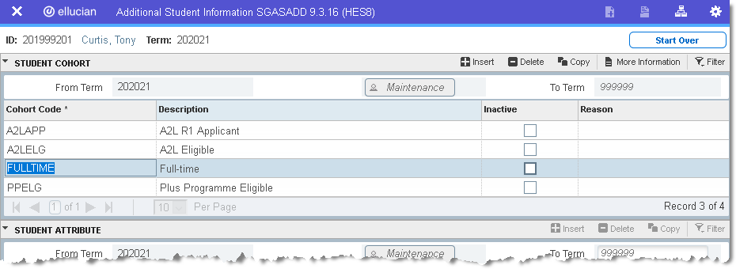

On/Off Campus flags should only be recorded against the Full-time or Part-time Cohort records.

- Select the appropriate record and click on the button;

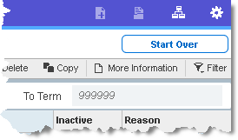

- The Supplemental Data window will be displayed;
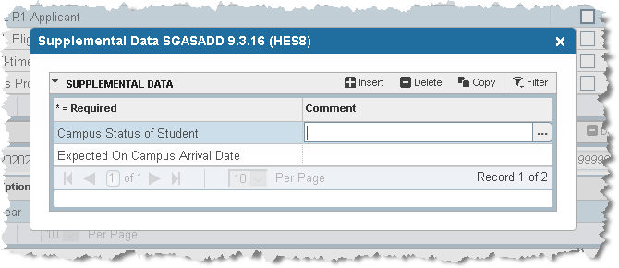

By default the Campus Status of Student will be ONC - On Campus - and the Expected On Campus Arrival Date field will be blank, apart from where students are studying abroad / on a placement or a distance learner.
To update this status, follow the guidance below, using one of the available options;

Code | Description | Notes
AOC | Off Campus - Approved | Approved by parent school
EXM | Exempt | Exempt from attending (e.g. Distance Learners)
NOT | Off Campus - Not Approved | Student has informed their parent school that they are not on campus, but no arrival date has been agreed
ONC | On Campus | Default setting
UNK | Unknown | Used as a temporary status, when seeking confirmation over a student’s arrival date

Do not click on the or buttons in the Supplementary Data window.

- Click on the button adjacent to the Campus Status of Student field and select the appropriate value from the list that is displayed;

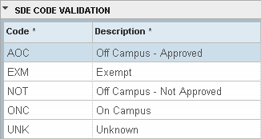

- If you selected AOC - Off Campus - Approved - in the Campus Status of Student field then a date must be recorded in the Expected On Campus Arrival Date field.
- Enter the appropriate date in the Expected On Campus Arrival Date field, alternatively you can select the date by clicking on the button and using the date picker;

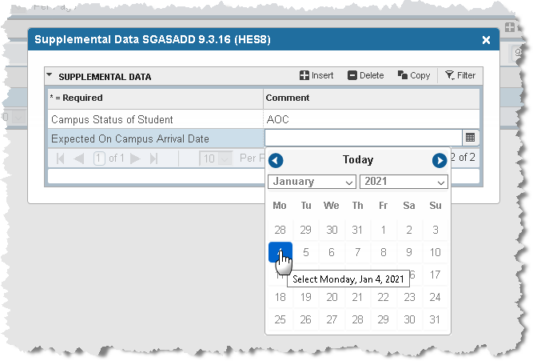

- Click the button;

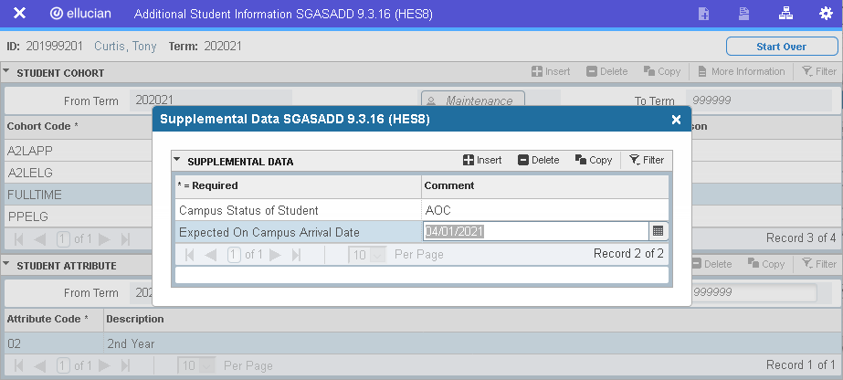

- Who do I contact if I require further guidance:
Should you have any query around this process, you can contact the Programme & Assessment – Operations team at studentrecords@adm.leeds.ac.uk

