Operational Guidance for the Change of Module Process

From 202021 onwards the process for Changes of Module after the closure of online enrolment has been moved online.

It is recommended that Schools publicise the online process to students (https://students.leeds.ac.uk/info/10103/module_enrolment/652/change_of_module) as part of their general communications to students about enrolment and related matters.

1. Online Process

A student submits an online Change of Module request, which goes to their Parent School.

Parent Schools will take responsibility for processing change of module requests and ensuring that any changes approved meet with the requirements of the programme of study. Where change requests involve other teaching Schools, the parent School will also consult with them on changes where required. Students can expect to receive guidance when required and confirmation of the outcome within 5 working days.

The student will access the online form from the For Students website on this link:-
https://students.leeds.ac.uk/info/10103/module_enrolment/652/change_of_module . Students will only be able to access the form via their UoL Microsoft login (university e-mail log in) and will be prompted to log in when they click on the form.

Once the student has completed the online form and submitted it, the data is sent to a SharePoint Excel document. From here, two actions occur:-

- The student will receive an automated email – see Appendix 1
- The parent school (selected by the student) will receive an automated email containing details of the request – see Appendix 2 and 3

Based on the information contained in the email, the school will need to either:-

- Contact the student to guide on choices, or
- Continue with the change of module process

Figure 1 outlines the process.

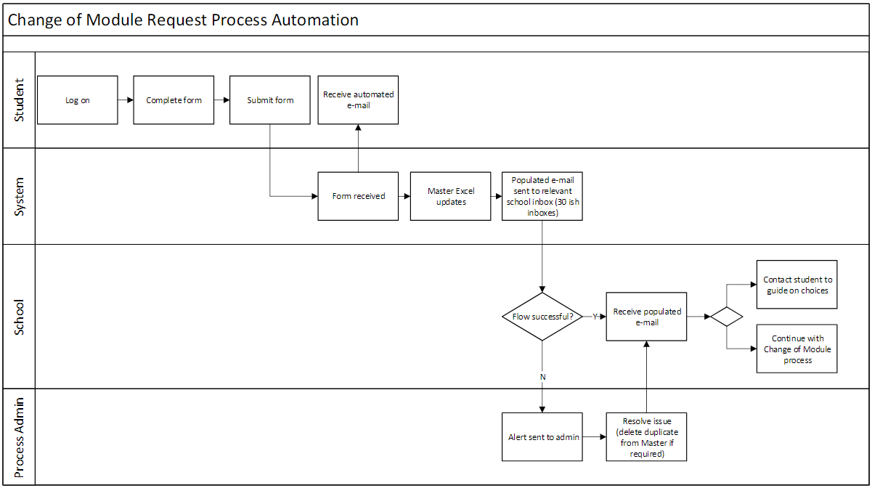
Figure 1 – Online Change of Module Process

2. Scenarios

Scenario 1: Student requires guidance on module selection
The parent School will arrange to contact the student via TEAMS or current communication method used by the School.

Scenario 2: Parent School is also the Teaching School for modules to be added/removed. See figure 2

1. The following conditions are checked by the Parent School for each new module to be added:
- the module has space;
- the module complies with the student’s programme requirements;
- the student satisfies any pre/co-requisites to take the module.
2. If the changes are accepted, the student record is updated in Banner (SWAREGS) accordingly by the Parent School and an email confirmation is sent to the student.
3. If the changes are not accepted, an email is sent to the student by the Parent School to initiate a conversation about alternative options.

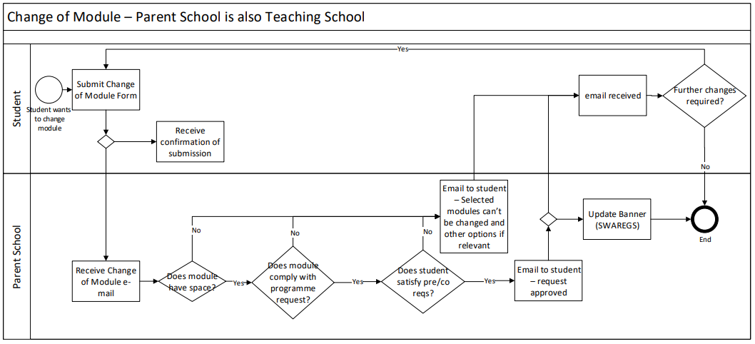
Figure 2 – Parent School is the Teaching School

Scenario 3: Parent School is not the Teaching School for modules to be added/removed. See figure 3

1. The following conditions are checked by the Parent School for each new module to be added/removed:
- the module complies with the student’s programme requirements;
- the student satisfies any pre/co-requisites to take the module.
2. The Parent School identifies via a centrally-held list whether the Teaching School(s) need(s) to be consulted about new modules to be added and/or removed.
For Staff Change of Module page

N.B. Students wishing to enrol on a Languages for All (LfA) Discovery language (FLTU) module must be referred directly to the LfA team within LCS (lcsenrolment@leeds.ac.uk). Parent Schools must not enrol students on FLTU modules, as their language proficiency must be assessed first.

3. If a Teaching School requires consultation for new modules to be added
- the Parent School emails the Teaching School.
- if the changes are approved, the Teaching School adds the module(s) to the student record in Banner (SWAREGS) with the temporary holding code “LH”.
- the Teaching School confirms by email that the change is approved
- the Parent School updates the module(s) against the student record in Banner (SWAREGS) with the full enrolment code “RE”.

4. If a Teaching School does not require consultation for modules to be added:
- the Parent School checks whether the module has spaces using the Banner report SWRTPCD, or the ARGOS report ‘Modules with Spaces’.
- If the module has spaces, the Parent School updates the module(s) against the student record in Banner (SWAREGS) with the full enrolment code “RE”.

5. An email confirmation is sent to the student. The Teaching School(s) for modules being added or removed are copied in to the email. The Teaching School updates their local waiting list, if held.

6. If the changes are not approved by the Teaching School or there are no spaces available, an email is sent to the student by the Parent School to initiate a conversation about alternative options.

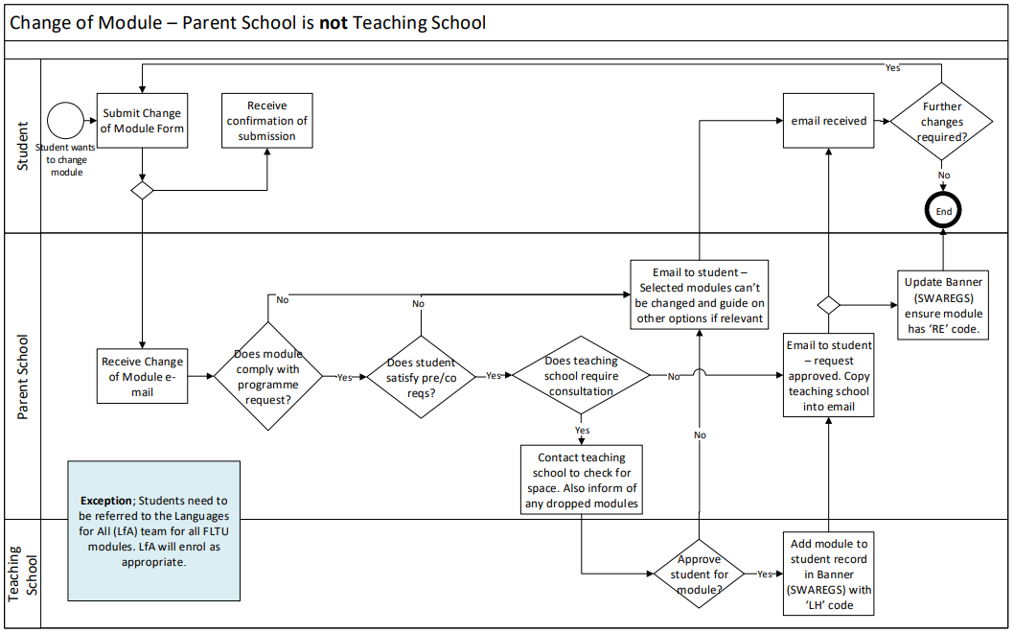

Figure 3 – Parent School is NOT the Teaching School

APPENDICES

Appendix 1 copy of student receipt e-mail

Dear <student name>,
Thank you, your Change of Module request has been submitted. The reference for the submission is COM11.
We will aim to complete your request within 5 working days but normally sooner. The length of time may depend on the number of schools involved.
The details of your request are shown below.
You requested; Change module(s)
With the additional Information;
If you requested to change modules the details were;
Add; SLSP1200 SLSP1210
Drop; SLSP1170 SLSP1190
Please allow at least 5 working days before submitting further enquiries about this change. If there are any issues with your selected module choices, such as unavailability of space, you will be contacted to discuss alternative options. We will contact you through your University of Leeds e-mail address.
Please do not reply to this email. It is an automated email and is not monitored. For further advice and guidance, please check https://students.leeds.ac.uk/ in the first instance or e-mail studentinfo@leeds.ac.uk.
Best Wishes,
Student Education Service Team

Appendix 2 Copy of Scenario 1 email to school

Dear Colleague in <School>
A student from your school has filled in a Change of Module request. The Reference for the submission is COM15
Please find details of the request below:
Student ID: 123
Student Name: test test
Programme of study: test
Student e-mail address: <brings through from student Outlook>
Request type: Receive guidance on module choice
Additional Information;
test
Please note students received an automated response upon submission which advised;
- 5 working days for response
- A request to change does not guarantee the modules are available
- They may be contacted to discuss options if appropriate
Operational guidance has been shared to inform of process changes (particularly when a module change is between two schools) here or ask your Programme Support Manager for further guidance.
For reference the link to the student form for Change of Module is here.
Best Wishes, Student Education Service Team

Appendix 3 Copy of ‘Change of module’ (scenario 2 or 3) email to school

Dear Colleague in Civil Engineering
A student from your school has filled in a Change of Module request. The Reference for the submission is COM16
Please find details of the request below:
Student ID: 123456
Student Name: testing test
Programme of study: Civil engineering development
Student e-mail address: <brings through from student Outlook>
Request type: Change module(s)
Additional Information;
Has student checked pre-requisites, credits and timetable? Yes
Modules to Add
1. Module: CIV001 Building bridges, Semester 1 School (if not parent school):
2. Module: , School (if not parent school):
3. Module: , School (if not parent school):
4. Module: , School (if not parent school):
Modules to Drop
1. Module: GEO222 Human movement, Semester 1 School (if not parent school): Geography
2. Module: , School (if not parent school):
3. Module: , School (if not parent school):
4. Module: , School (if not parent school):
Please note students received an automated response upon submission which advised;
- 5 working days for response
- A request to change does not guarantee the modules are available
- They may be contacted to discuss options if appropriate
Operational guidance has been shared to inform of process changes (particularly when a module change is between two schools) here.
For reference the link to the student form for Change of Module is here.
Best Wishes, Student Education Service Team

