UNIVERSITY OF LEEDS

Support at Leeds
[Transcriber's note: hyperlinks are given as plain text, and can be pasted into a browser]

[Slide 1]
Support at Leeds
A session with information and activities to help you to:
- find out about your support network
- take care of yourself and your student community

[Slide 2]
Introduction to our support for you
[video link]: https://mymedia.leeds.ac.uk/Mediasite/Play/159bdbef87db43048b0542e05657aa081d

[Slide 3]
Our Vision
"To enable and empower you to engage fully with all aspects of student life, removing barriers as necessary, so you can achieve your potential and succeed in your studies"
It’s about …
Maintaining your wellbeing:
' where each individual realises his or her own potential, can cope with the normal stresses of life, can work productively and fruitfully and is able to make a contribution to his or her community' – World Health Organisation
Meeting challenges:
'a task or situation that tests a person's abilities' – Oxford dictionaries https://en.oxforddictionaries.com

[Slide 4]
A wide range of support
- Support to manage student life and develop skills to meet challenges
- Activities to build friendships and maintain your wellbeing and health
- Free specialist confidential support services and independent advice
[photos below: working in the library; Advice in the Students Union]

[Slide 5]
Online information you can use independently:
- [link]: https://students.leeds.ac.uk
- Faculty/School website/Minerva area
- [link]: luu.org.uk
Contact points for questions and to find out how to get the right support:
- Student Office in School
- Help and Support in Leeds University Union
Specialist support and advice to enable and empower you to meet challenges:
- Personal Tutor (academic support)
- Skills@Library (study skills)
- Advice in Leeds University Union
- Student Counselling and Wellbeing
- Disability Services
- Student Services Centre (including finance)
- International Student Office (immigration)
- Lifelong Learning Centre (mature students)
- Accommodation Wardens and Residence Life Assistants
- Chaplaincy and Muslim Student Adviser
- University Security

[Slide 6]
Student Counselling and Wellbeing
- Free, confidential, specialist support from an experienced team of counsellors, mental health advisers and wellbeing practitioners
- The team works with students to identify solutions to difficulties and signpost or refer to specialist services in Leeds
- Support includes: wellbeing drop-ins; single session consultations; groups and workshops; online resources; short series of counselling or wellbeing appointments; weekly meditation; downloadable relaxation MP3s on website
- To book an appointment, complete the Student Counselling and Wellbeing Self-Referral Form on: [link] http://students.leeds.ac.uk/counsellingandwellbeing

[Slide 7]
Disability Services
- Confidential, specialist advice, guidance and support for disabled students, including those with physical disabilities, mental health conditions, autism spectrum condition, specific learning needs (e.g. dyslexia) and long term medical conditions.
- The team identifies and recommends adjustments schools can make for individuals.
- Start by filling in Disability Services’ online sign-up form at
[link]: http://students.leeds.ac.uk/settingupyoursupport
- Perhaps you had support or adjustments at school or during previous study? Contact the team at disability@leeds.ac.uk, or look at the website below to see if you might benefit from the team’s services.
- Contact our friendly Disability Services team to find out more. No appointment needed, confidential drop-ins between 9:30am and 4pm Monday to Friday. [link]:http://students.leeds.ac.uk/disabledstudents

[Slide 8]
Funding and Money Support
Student Funding Team in Student Services Centre
- Help and guidance on student funding
- Can communicate directly with Student Finance England (and other funding bodies) to help resolve funding issues
- Administer applications to Leeds Hardship Fund
and International Leeds Hardship Fund [link]: https://students.leeds.ac.uk/fundsandscholarships
- You can email the Student Finance team at funding@leeds.ac.uk
Advice in Leeds University Union
Money help, budgeting advice, financial support
[link]: luu.org.uk/student-help-support
(Photos below – Marjorie and Arnold Ziff building, location of Student Services Centre, and the Leeds University Union foyer, location of Advice in LUU)
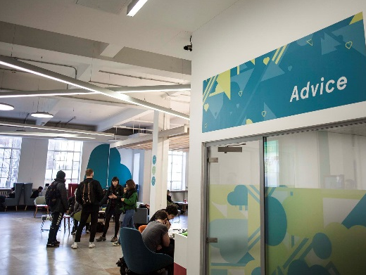

[Slide 9]
Activities for friendship, wellbeing and health
Five Ways to Wellbeing* [link]: https://issuu.com/neweconomicsfoundation/docs/five_ways_to_well-being
- Connect
- Be active
- Take notice (mindfulness)
- Keep learning
- Give
*Five ways to wellbeing report: New Economics Foundation [link]: https://b.3cdn.net/nefoundation/8984c5089d5c2285ee_t4m6bhqq5.pdf
(Photos below – Give it a go, students doing yoga)

[Slide 10]
Our Support Partnership
[triangle diagram below]:
Our Support Partnership:
- Students
- LUU
- University
Students:
- seek information/ advice/support in good time
- contribute positively to your community
- let University/ Leeds University Union (LUU) know about problems or what may need to change
University & Leeds University Union (LUU):
- empower you to manage student life and meet challenges
- work with students to understand what's happening and what's needed
- develop and provide support services and activities

[Slide 11]
Students supporting students, for example:
School-based peer support
School reps (representatives)
Academic societies
Other student-run societies:
[link]:luu.org.uk/clubs-and-societies/welfare

- LUU LGBT Society
- Leeds Nightline – 8pm-8am Listening service
- LUU Mantality Society
- LUU Mind Matters Society
- Insulin Army – Active group for people with diabetes. Socials, activism & peer mentoring. Find us on Facebook – Insulin Army

[Slide 12]
Another example...
A partnership of students, University and Leeds University Union staff developed the "Draw the Line" project to help the University community to stand up to harassment. [link]: https://www.luu.org.uk/student-help-support/hate-crime-reporting-project/
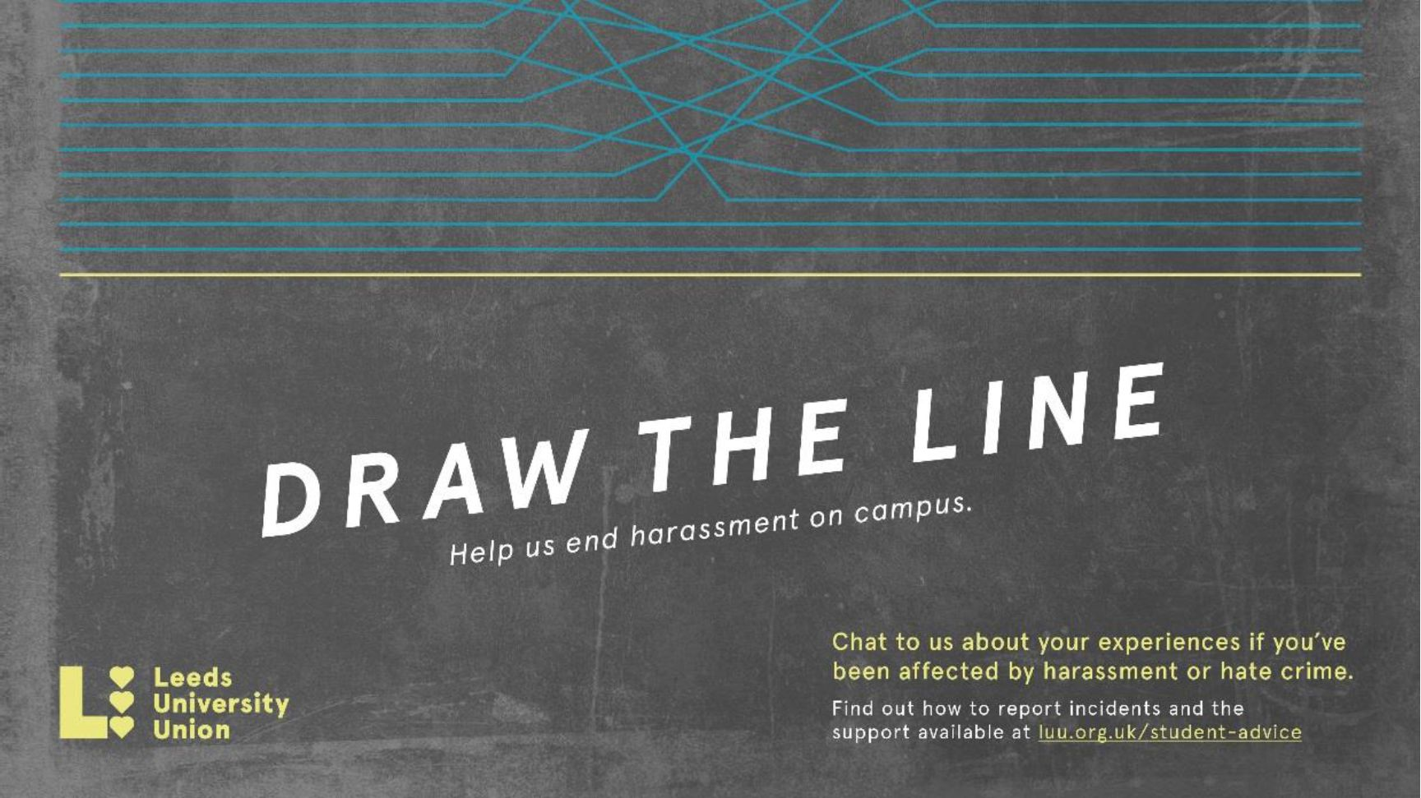
The project raises awareness of the campus online reporting form [link]: luu.org.uk/student-help-support/hate-crime-reporting-project and the support available from LUU Advice [link:] luu.org.uk/student-help-support
[photos below: LUU ADVICE; PROJECT AMBASSADORS
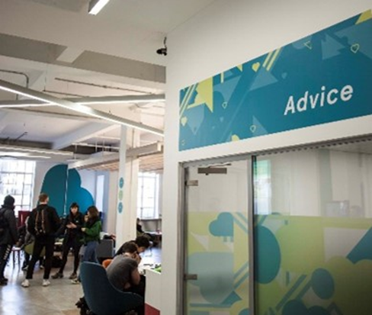
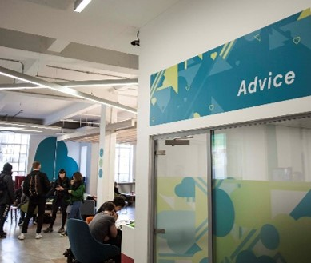
LUU ADVICE
PROJECT AMBASSADORS

[Slide 13]
Emergency and outside office hours contact points
University Security Office:
- Open 24 hours, every day of the year
- 175 Woodhouse Lane; email security@leeds.ac.uk
- Tel: 0113 343 5494/5 (non-emergencies)
Tel: 0113 343 2222 (emergencies)
Ambulance/Police/Fire Emergency phone 999:
- Police non-emergency [link]: www.police.uk/contact phone 101
- Nearest Hospital Accident & Emergency is at Leeds General Infirmary: [link]: www.leedsth.nhs.uk/a-z-of-services/emergency-medicine
- If ambulance is called for on campus, ring University Security to inform them
- Wellbeing Crisis information on [link]: https://students.leeds.ac.uk/supportandwellbeing
- Wardens and Residence Life Assistants in University accommodation

[Slide 14]
Together All —Wellbeing support at any time
- What is Together all? A safe place to talk, share and support others like you
- [image below]
- 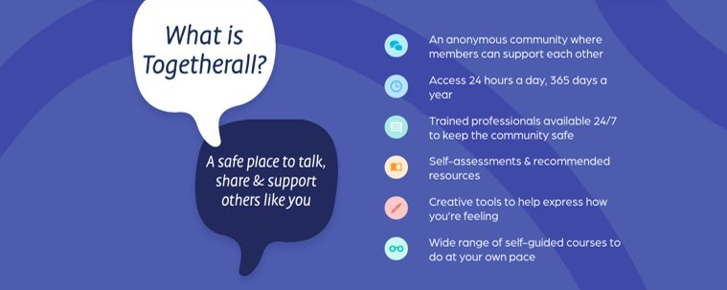
- An anonymous community where members can support each other
- Access 24 hours a day, 365 days a year
- Trained professionals available 24/7 to keep the community safe
- Self-assessments and recommended resources
- Creative tools to help express how you’re feeling
- Wide range of self-guided coureses to do at your own pace
- Free to all students at the University of Leeds
- [link]: togetherall.com

[Slide 15]
Support when you need it
- Talk to school Student Support Officer
- Personal tutor for academic support
- Supportive conversation with another student
- Skills@Library study skills workshops, appointments and resources [link]: https://library.leeds.ac.uk/info/1401/academic_skills
- Disability Services support for students affected by a long term condition e.g. dyslexia [link]: http://students.leeds.ac.uk/disabledstudents
- Leeds University Union wellbeing and social activities and workshops [link]: luu.org.uk
- Together All online resources and support
- Student Counselling and Wellbeing Workshops, groups and online resources [link]: http://students.leeds.ac.uk/info/100001/counselling_and_wellbeing
- Sport and Physical Activity [link]: https://sport.leeds.ac.uk/
- Universities Chaplaincy 1 to 1 with a Chaplain [link]: http://unichaplaincy.org.uk
- Leeds Nightline 1 to 1 with a trained student outside office hours [link]: https://leeds.nightline.ac.uk

[Slide 16]
Take away messages ...
Your time at University will test you in different ways, but you'll be empowered to find solutions. You'll develop skills to meet challenges while you're studying and in your future lives.
- Make time for wellbeing (5 ways)—for the best experience and academic results
- Remember the range of support offered by the University, Leeds University Union and other students, including 24/7
- Ask for help as soon as you need it. It's a normal part of University life, a strength not a weakness.
A warm welcome to our supportive University community!
[end]

