Registration Guidance 2022/23
Programmes and Assessment

Online Registration (on Minerva)
Last update: 19/07/2022
This is a step-by-step guide of the online registration process. Further student guidance is at:
Website: students.leeds.ac.uk/registration
Email: studentinfo@leeds.ac.uk
Telephone: 0800 9150402 or +44 113 343 7000 (Student Information Helpline)
Staff guidance on registration can be found at ses.leeds.ac.uk/registration and the above details.
NB: please ignore variation in the dummy student details as the screenshots have been taken from multiple test instances.
Contents
How to access the online registration steps 2
Troubleshooting login page 2
Start page 3
Notes on navigation of each step 3
Registration checklist page 4
HELP text as seen by students: the Registration Checklist page 4
Personal details 1 6
HELP text as seen by students: Personal Details 1 6
Personal Details 2 8
HELP text as seen by students: the Personal Details 2 page 8
Addresses, telephone numbers and emergency contact details 11
HELP text as seen by students: all contact details pages 13
Sports membership 16
HELP text as seen by students: the Sports membership page 16
Programme of Study Details 18
HELP text as seen by students: the Programme of Study page 18
Fee Payment Arrangements 19
HELP text as seen by students: the Fee payment arrangements page 20
Declaration Statement 22
HELP text as seen by students: the Declaration page 22
Final confirmation (registration certificate) page 24
HELP text as seen by students: the Final confirmation page 25

How to access the online registration steps

Log in to Student Services (https://studentservices.leeds.ac.uk/). New students will need to follow the link to retrieve their username and password from the homepage.

Troubleshooting login page
Retrieving username and password | Have you entered your university student ID number (i.e. not UCAS ID/staff number)?  Are you trying to log in before you have accepted your unconditional offer/paid your tuition fee deposit (TP international only)/before your cohort’s account-live date (listed on the mypassword.leeds.ac.uk page)?  Are you following the format of the first name field  Best to retrieve username and password using laptop/computer, mypassword webpage not greatly functional from mobile devices.
Username | Are you using the correct username (i.e. not your Student ID number or UCAS number)? If not, please locate your student ID on offer letter and go to retrieve username (above).  Are you entering your username followed by ‘@leeds.ac.uk’
Password | Have you been blocked on a time-out (i.e. it asks you to wait 30 minutes)? If so, wait and try again.  Is the issue password related? If so, refer to Student Information Service helpline (see first page).

Choose Registration from the list of options, as below:
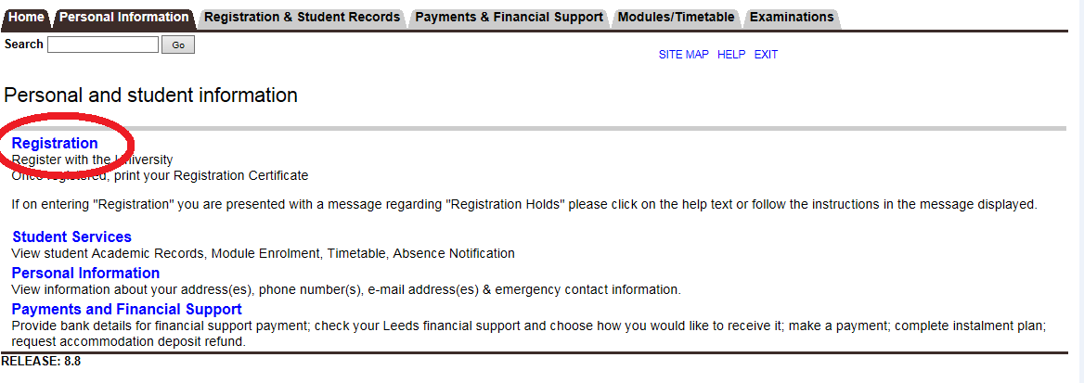
Start page
You are required to register for each year of every programme of study you take. If you are starting more than one programme of study you will be given a choice of which programme to register for.
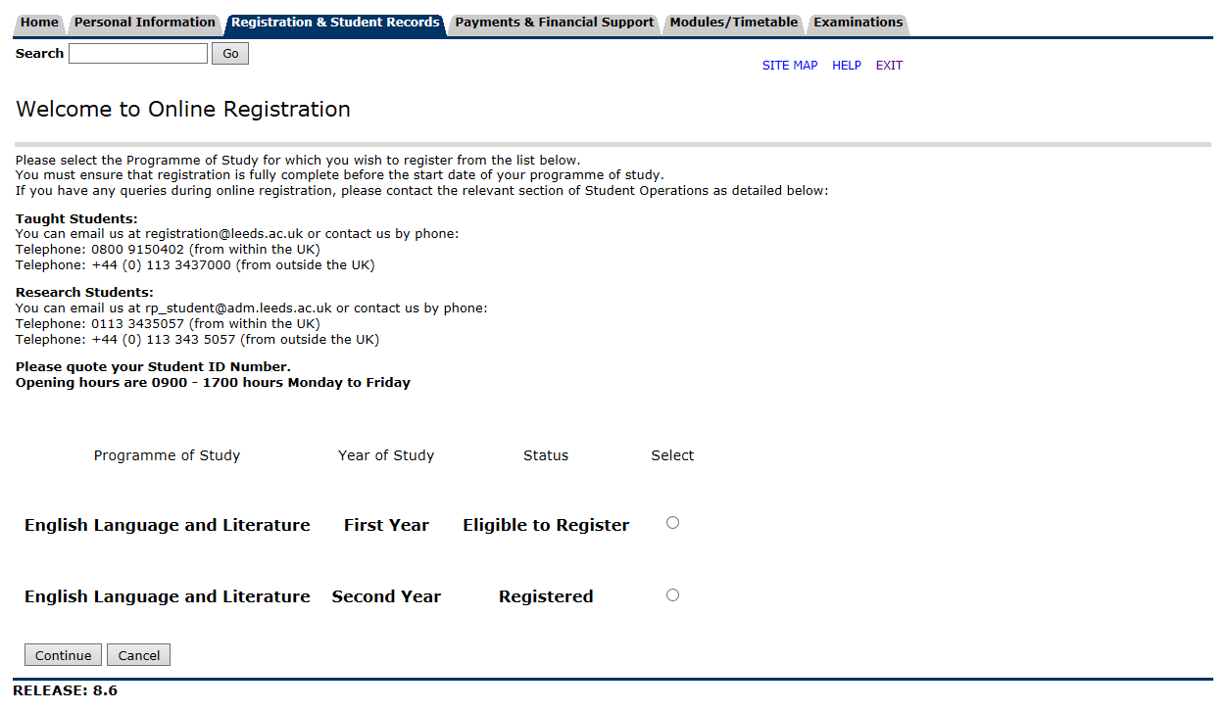
If you have only one programme of study you will skip this step and be taken straight to the registration checklist (see below).

Notes on navigation of each step
With the exception of the checklist page, all pages will have navigation buttons at the bottom of each page:

- 'Continue' - save any changes and take you on to the next step
- 'Checklist' - save any changes and take you back to the Checklist page,
- 'Cancel' - back to the Checklist page without saving any changes.
The help pages can be accessed by clicking on HELP in the top right hand corner of each screen.

Registration checklist page
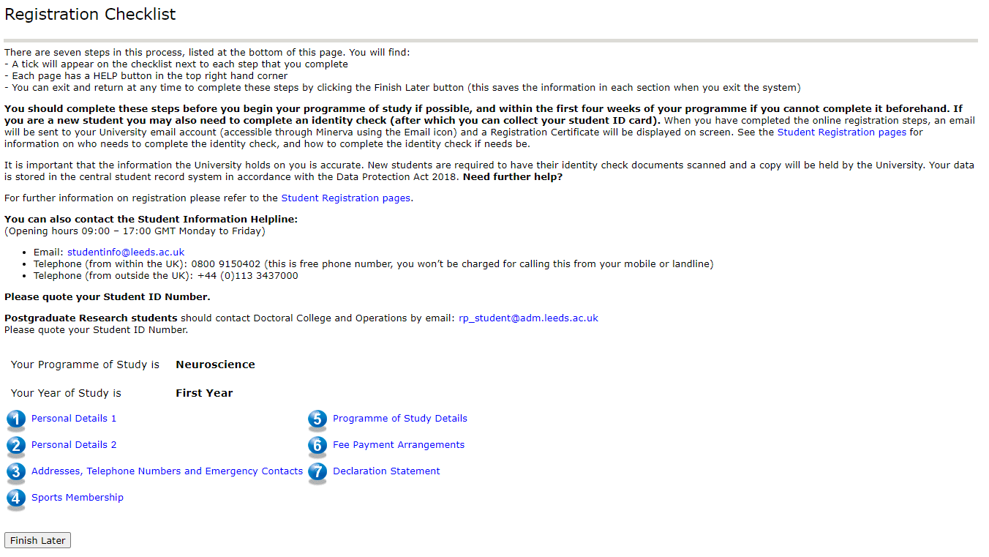
The process is split into seven steps with help pages at each step. Most of these steps can be completed in any order but step 5 must be completed before step 6. This is because the tuition fee is calculated based on the current programme of study. Similarly, step 7 cannot be completed until all previous steps are complete. All steps must be completed to finish the online part of registration.
Click on a checklist item to confirm/update information. Once you have entered a page of the checklist, use the navigation buttons to go through each step in sequence.

HELP text as seen by students: the Registration Checklist page
What is registration?
Every student at the University of Leeds is required to register at the start of each academic year. Registration is the formal process of becoming a student of the University. It enables you to attend lectures and seminars, receive tuition or supervision, sit examinations, register with the Library and other services and become a member of Leeds University Union. It includes a financial process of paying fees as well as ensuring that the University holds accurate and up-to-date information about you. It is not about choosing and confirming the modules you wish to study - this is a separate exercise (that does not apply to research students).
What happens when I complete these steps?
On successful completion of the online registration process your student status will be updated on the University Student Record System. If you are a returning student, this will allow you to continue using University facilities such as computing, library and sports facilities (if paid for). New students should also complete an identity check on campus before they are fully registered.
Deadlines
The final date for registration is four weeks after your programme of study commences. Your School will notify you if you are approaching this deadline and still unregistered. After this date your student record will be updated, and you will be withdrawn from your studies.
What do I need for these steps?
In order to complete registration you will need your address details including emergency contacts and telephone numbers along with your fee payment information; this may include bank account details, sponsor letter, scholarship information, credit/debit card details.
Need further help?
For further information on registration please refer to the Student Registration pages.
You can also contact the Student Information Helpline:
(Opening hours 09:00 – 17:00 GMT Monday to Friday)
- Email: studentinfo@leeds.ac.uk
- Telephone (from within the UK): 0800 9150402 (this is free phone number, you won’t be charged for calling this from your mobile or landline)
- Telephone (from outside the UK): +44 (0)113 3437000
Please quote your Student ID Number.
Postgraduate Research students should contact Doctoral College and Operations by email: rp_student@adm.leeds.ac.uk
Please quote your Student ID Number.

Personal details 1
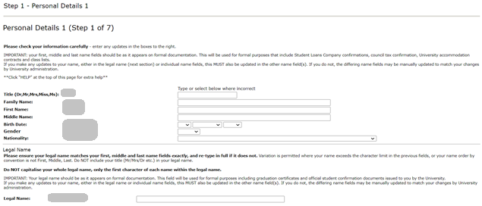
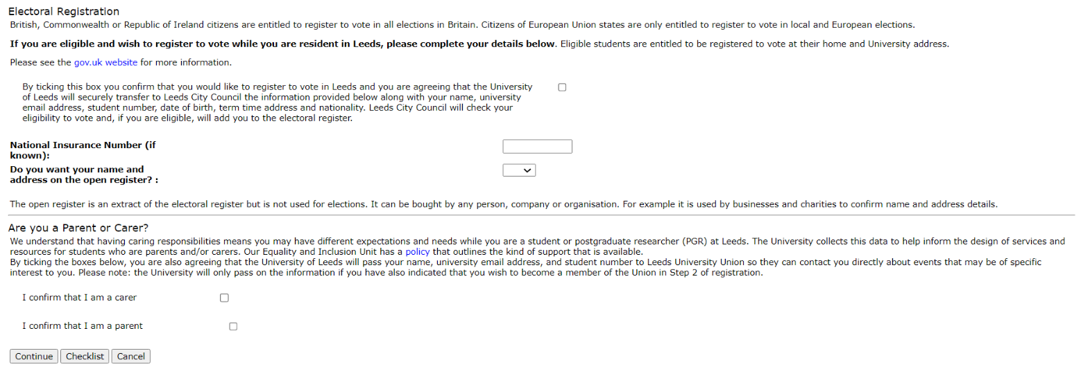

HELP text as seen by students: Personal Details 1
Name(s)
Your name details should:
- Match the spelling of your name as it appears on your passport, National Photo ID Card or your birth certificate
- Not be capitalised
- Not use informal names or nicknames
If you change your name and evidence is required, the University will contact you via email. Students who have made significant name corrections will be asked to complete an identity change request form. You may also need to submit relevant supporting documentation before name details can be updated. Details can be found here.
Birth Date
If you want to correct the date of birth shown for you, select the correct date using the drop down lists for day, month and year. Your date of birth should match the information on your birth certificate/passport.
Gender
If you want to change the gender shown for you, select the alternative value from the drop down list. For information on why we collect this data please click here.
Nationality
If you want to correct the nationality shown for you, select the required value from the drop down list.
Please note: we can only hold one nationality on your student record.
If you hold dual nationality, please follow the below advice:
- If your dual nationality includes British, please select United Kingdom (GB) as your nationality.
- If your dual nationality does not include British but does include a non-UK EU country, then please select the relevant EU country as your nationality.
- If your dual nationality does not include British or a non-UK EU country, then please select either of the countries that make up your nationality.
The nationality values are standard coding structures supplied to the University by the Higher Education Statistics Agency (HESA), a list of which is provided here.
Legal Name
If you make any updates to your name, either in the legal name or individual name fields, this MUST also be updated in the other name field(s). If you do not, the differing name fields may be manually updated to match your changes by University administration. Please check your legal name carefully as it will be used on official documentation such as University graduation certificates.
If your name is incorrect, type your correct name details in the box provided (do not include your title e.g. Mr, Dr etc.).
If you change your name and evidence is required, the University will contact you via email.
If proof is required:
New students MUST state their full legal name in this first registration process. If the legal name is not correct when printed on the Student ID card and needs to be changed, evidence must be given and the student will be charged the replacement ID card fee.
Returning students who have made significant name corrections will be asked to complete an identity change request form and may also need to submit relevant supporting documentation before name details can be updated. Details can be found here.
Registering to vote
Please see the gov.uk website for more information.
Parent/Carer
A ‘carer’ is someone who provides unpaid care to a family member, partner or friend who has, for example: a long-term illness, a disability, a mental health condition, an addiction, a temporary need for care following an accident or operation. A ‘parent’ is an adult who is responsible for the care and wellbeing of a child/children aged 17 or under. This may involve providing a home, looking after health and wellbeing, providing financial support, ensuring medical and educational needs are met. ‘Parenting’ includes the following relationships: biological, step, adoptive, foster, legally-appointed guardian. It also includes providing parental care to the child of a family member or friend.
Need further help?
For further information on registration please refer to the Student Registration pages.
You can also contact the Student Information Helpline:
(Opening hours 09:00 – 17:00 GMT Monday to Friday)
- Email: studentinfo@leeds.ac.uk
- Telephone (from within the UK): 0800 9150402 (this is free phone number, you won’t be charged for calling this from your mobile or landline)
- Telephone (from outside the UK): +44 (0)113 3437000
Please quote your Student ID Number.

Personal Details 2
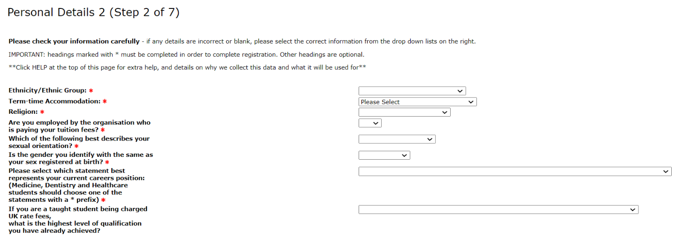
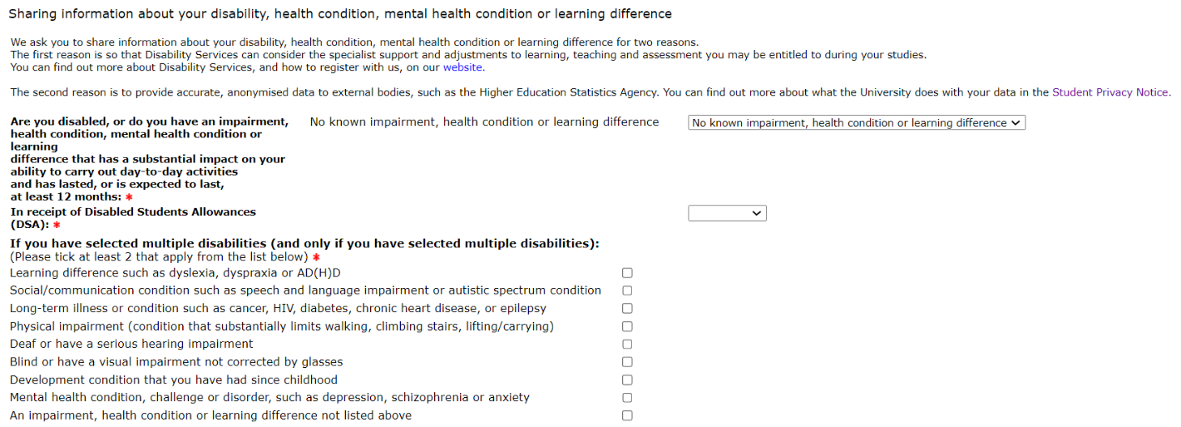
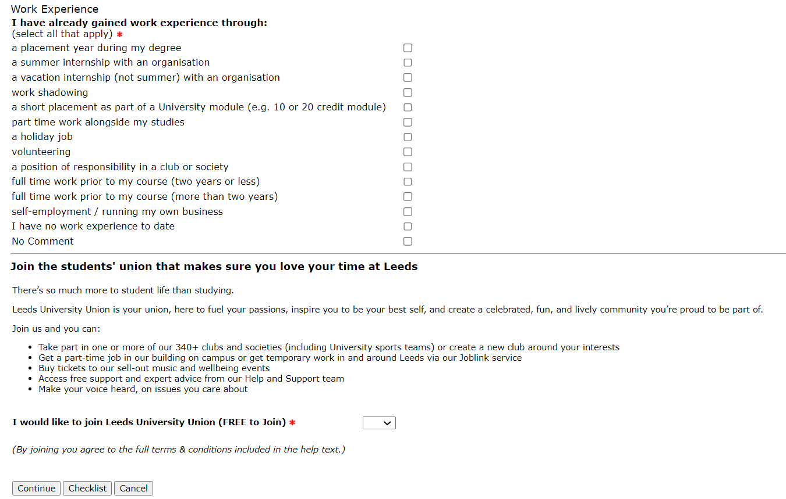

HELP text as seen by students: the Personal Details 2 page
We collect your equality information at registration to help us understand and improve the diversity of our student body, develop and implement appropriate services and make appropriate provision for all students. We will otherwise use it to fulfil our external reporting responsibilities (to the Higher Education Statistics Agency (HESA)). Please see the HESA Privacy Notice. All information will be kept secure and confidential.
Ethnicity
If you are a UK National and we do not currently hold your ethnicity on your student record, you MUST choose an option from the drop down list. For information on why we collect this data, and why it is not mandatory for everyone please click here.
Disability
If you do not have a disability or would prefer not to disclose your disability please select 'No Known Disability' from the drop down list. We would encourage disabled students to disclose their disability to ensure that they have full access to the support which is available to them. We would also recommend that you contact Disabled Students Assessment and Support (disability@leeds.ac.uk) as soon as possible to enable them to arrange your support.
If you have more than one disability please choose the ‘Multiple Disabilities’ and select each of your disabilities from the list. For information on why we collect this data please click here.
Disabled Students Allowances (DSA)
Disabled Students Allowances (DSA) are funds made available through UK government student finance organisations (Student Finance England, Student Finance Wales, Student Awards Agency Scotland, Student Finance Northern Ireland) which help disabled students to pay for the extra support they need for their studies.
Further information, including information on how to apply for DSA, can be found here. Alternatively you can contact University of Leeds Disabled Students' Support and Assessment in the following ways; email disability@leeds.ac.uk, tel +44(0) 113 3433927, text phone +44 (0) 113 3433616. For information on why we collect this data please click here.
Term-Time Accommodation Details
Only select 'University of Leeds accommodation' if you have received and accepted an accommodation contract with the University of Leeds Accommodation services.
You MUST select an option from the drop down list which best describes your term time accommodation for the academic year. Completion of this section is compulsory and failure to complete this section may result in you experiencing difficulties with Council Tax exemption. For information on why we collect this data please click here.
Religion
If we do not currently hold your religion on your student record, please choose an option from the drop down list. This information will also be used to ensure that religious constraints are taken into consideration when timetabling the University examinations. For information on why we collect this data please click here.
Are you employed by the organisation who is paying your tuition fees?
You MUST choose an option from the drop down list. If your employer is paying your tuition fees, please select Yes. If they are not, please select No. For information on why we collect this data please click here.
Sexual Orientation
If we do not currently hold your sexual orientation on your student record, please choose an option from the drop down list. The options are defined below.
Bisexual - a man or woman romantically/sexually attracted to men and women.
Gay/Lesbian - a man romantically/sexually attracted to men, a woman romantically/sexually attracted to women.
Heterosexual/Straight - romantically/sexually attracted to the opposite sex.
Other - a person who does not define their romantic/sexual attraction in any of the ways listed above.
No Comment - select this option if you would rather not disclose the information.
For information on why we collect this data please click here.
Gender Identity
If we do not currently hold your gender identity on your student record, please choose an option from the drop down list.
If you have changed gender since birth, or are in the process of changing gender, please select No. If you do not intend to change your gender, please select Yes. If you would prefer not to say, you can select No Comment. For information on why we collect this data please click here.
Current Careers Position
You MUST choose an option from the drop down list. You will be provided with some Careers advice upon completion of the Registration process based on the option you choose.
Work Experience
Please select all options that apply to you.
Research Council Identifier
For Research Students only - this may be found on your Scholarship award letter and is often known as the "reference number".
Students' Union Membership
By joining the Union, the University will share your data with Leeds University Union to enable the following:
- For you to be able to engage with LUU services that require knowing your identity - key examples are joining a club and society and voting, which requires the data to be added to our membership system.
- For you to participate in activities that require LUU membership - Leading a club or society and having a say in how they are run, standing for an elected post and playing or competing for a University of Leeds sports team run by LUU.
- For LUU to understand how its services effectively support its full membership - for example, knowing if students from certain parts of the university or specific groups of students are underrepresented in areas of student-led activity. When processing sensitive personal data the University holds, including enrolment in any support programmes (including but not limited to Access to Leeds and the Plus Programme), any processing will respect your confidentiality and data rights as an individual and will be in accordance with the data sharing agreement setup between the Union and the University. A typical example is that the Union may seek to understand the participation within clubs and societies of students with recognised disabilities compared to the complete University enrolment, and via anonymous reporting, inform what accessibility support and guidance is provided to student leaders to encourage greater participation.
- For LUU to contact you in regard to core membership activities - such as voting in the annual election of our sabbatical officers (Lead LUU).
- If you join a Gryphon sports club, we will share your details so the university can setup your pass to access sports facilities - so you can take advantage of the sports facility agreement without having to register separately.
- So LUU can represent your academic interests and provide independent help to with any problems on your programme of study (i.e. appeals, complaints, disciplinary procedures) - To ensure LUU gives you the best advice and can really help you, they will request relevant information from the university. For example, for an academic dispute, they will ask for recent academic performance records. To respond, the university may request appropriate case information and LUU will share only that which is necessary, preserving any confidentiality and the ability to effectively represent you.
You will be invited to sign up for communications that may interest you – job alerts, Union events like the annual Leeds Ball, new services, initiatives and offers in Union bars/restaurants. You can manage your subscription at any time.
You may be auto-enrolled in an academic society connected with your course, if that is at zero cost to you, to help you build your academic community.
For more details about the Union and how your data will be used, please visit the link below which also includes a detailed list of all data shared:
https://www.luu.org.uk/legal/privacy-policy/
Need further help?
For further information on registration please refer to the Student Registration pages.
You can also contact the Student Information Helpline:
(Opening hours 09:00 – 17:00 GMT Monday to Friday)
- Email: studentinfo@leeds.ac.uk
- Telephone (from within the UK): 0800 9150402 (this is free phone number, you won’t be charged for calling this from your mobile or landline)
- Telephone (from outside the UK): +44 (0)113 3437000
Please quote your Student ID Number.

Addresses, telephone numbers and emergency contact details

There are three address types that require checking: Home, Term Time and Emergency Contact.
Each address type is displayed on separate pages with the requirement to update (if necessary) and confirm the address.

Notes on adding a UK address:
The search facility (see screenshot below) can be used to find UK addresses using postcode, city or address line 1. Postcode is the most accurate piece of information and it is recommended that if this is known then it is used on its own.
Once the search criteria have been entered, click the 'Find UK Address' button. This will present you with a list of matching addresses. Choose the correct address from the drop down menu and click 'Accept Address' to populate the address fields below with the new address.
Contact details screenshots
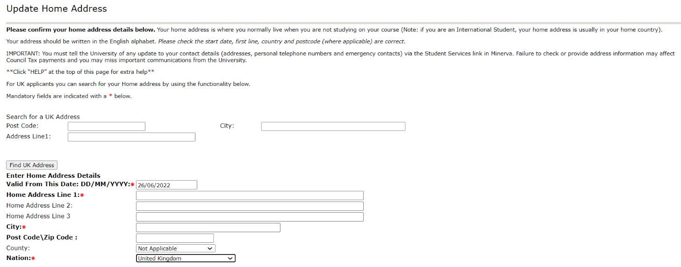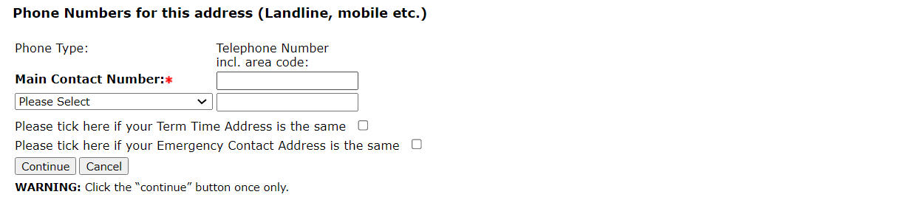
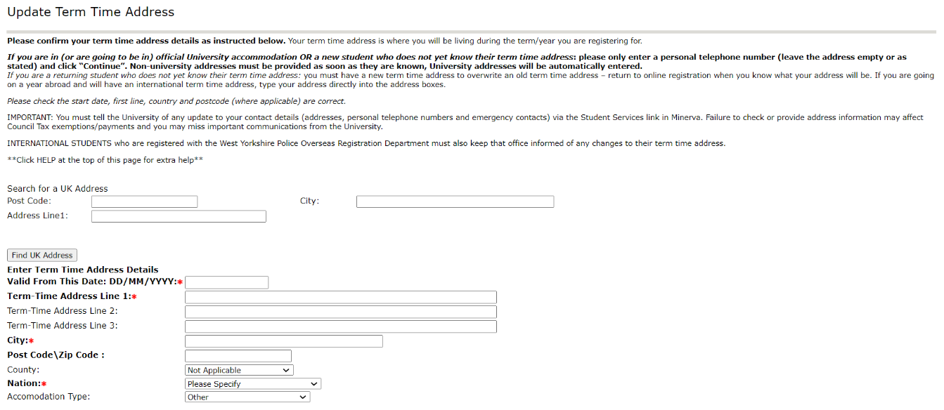
If students are in University maintained property, the term time address will show as follows:
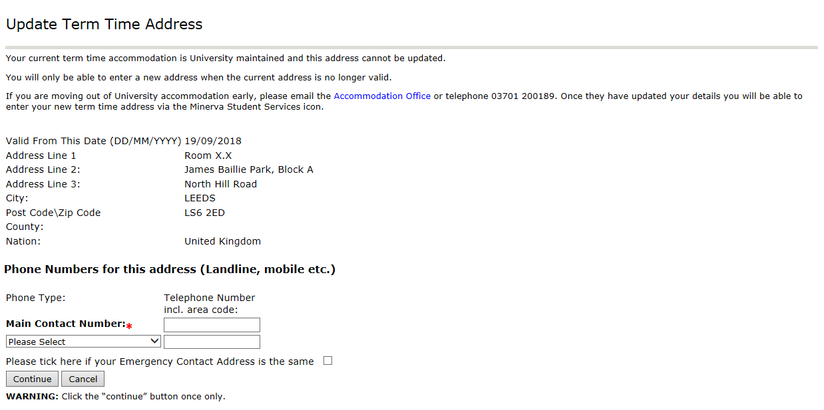

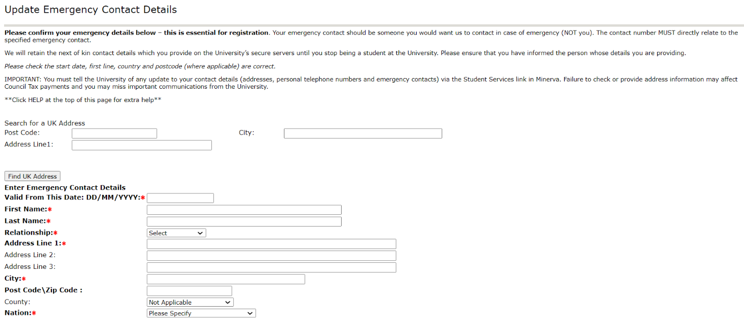

HELP text as seen by students: all contact details pages
If we already have address data for you, this will be displayed along with any telephone numbers. If we do not hold a current address for a category, the fields will be blank. Please check this information and update if needed.
Required fields:
Address type: home address and emergency contact details are required - you will NOT be able to continue if you do not provide this information. Other addresses can be left blank until known.
Address fields: Address Line 1, City, Nation, “Valid from this date” (cannot be before today's date).
You can check and update your addresses throughout the year using the Student Services link in Minerva.
TIP: you can search for UK addresses. Enter your Postcode OR City and Address Line1, and click on 'Find UK Address'. Select your address and click “Accept address”.
IMPORTANT: You must tell the University of any update to your contact details (addresses, personal telephone numbers and emergency contacts) via the Student Services link in Minerva. Failure to check or provide address information may affect Council Tax payments and you may miss important communications from the University.
INTERNATIONAL STUDENTS who are registered with the West Yorkshire Police Overseas Registration Department must also keep that office informed of any changes to their term time address.
Home address: within the “home address” and “term time address” pages. You can copy addresses by ticking the box(es) at the end of the page.
International Students - your home address is the address in your own country.
Emergency Contact Details: you will need to provide the name of your emergency contact(s) and their relationship to you, as well as the address and telephone number. If you wish to provide details for a second emergency contact, you need to do this outside of this process, via the Student Services link in Minerva.
Term time address: Within the home address and term time address pages you can copy addresses by ticking the box(es) at the end of the page.
If you are a new student and cannot provide your term time address at this time: leave all address fields BLANK, but do add your personal contact telephone number(s). You MUST update your address as soon as you know your address using the Student Services link in Minerva.
If you are a returning student and cannot provide your term time address at this time: you must have a new term time address to overwrite your old address – contact the Registration Helpline if this causes any problems.
If you have applied for University accommodation: leave all address fields BLANK, but do add your personal contact telephone number(s). Your address will be entered by the University accommodation team once your accommodation is confirmed.
Need further help?
For further information on registration please refer to the Student Registration pages.
You can also contact the Student Information Helpline:
(Opening hours 09:00 – 17:00 GMT Monday to Friday)
- Email: studentinfo@leeds.ac.uk
- Telephone (from within the UK): 0800 9150402 (this is free phone number, you won’t be charged for calling this from your mobile or landline)
- Telephone (from outside the UK): +44 (0)113 3437000
Please quote your Student ID Number.

Contact details summary page
After all three address types have been confirmed you will be presented with a summary of the information and required to confirm that all the addresses held are correct. If you return to step 3 again you will be presented with this page.
The system can only display one address of each type on the summary page. If the address displayed has an end date, this indicates that we may also be holding a future address for you. However, we cannot display it as it is not currently your active address. If we have been provided with a future address we will be holding it but if you want to be sure you can log back into Minerva and go to Student Services (via the ‘Access Student Services’ icon) to check your current address data.
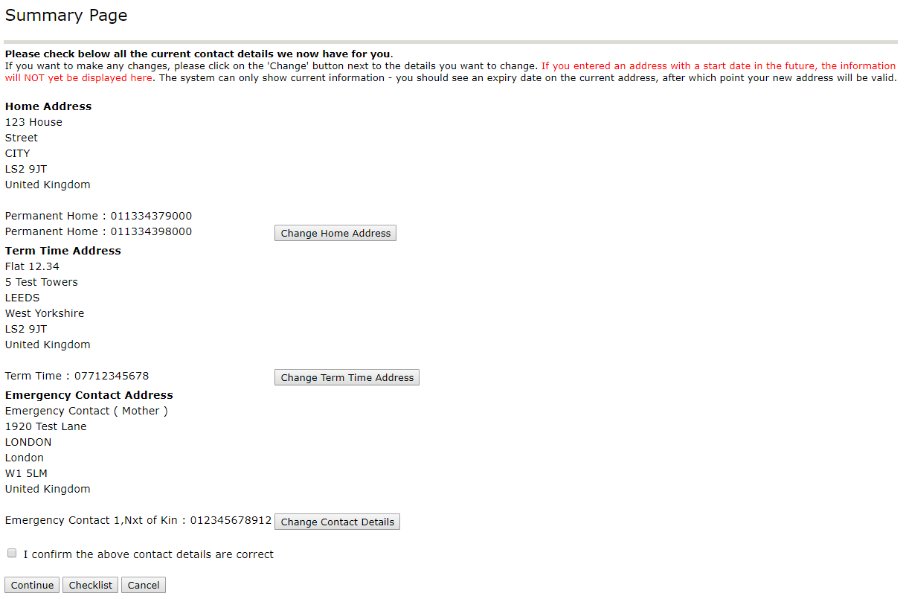

Sports membership
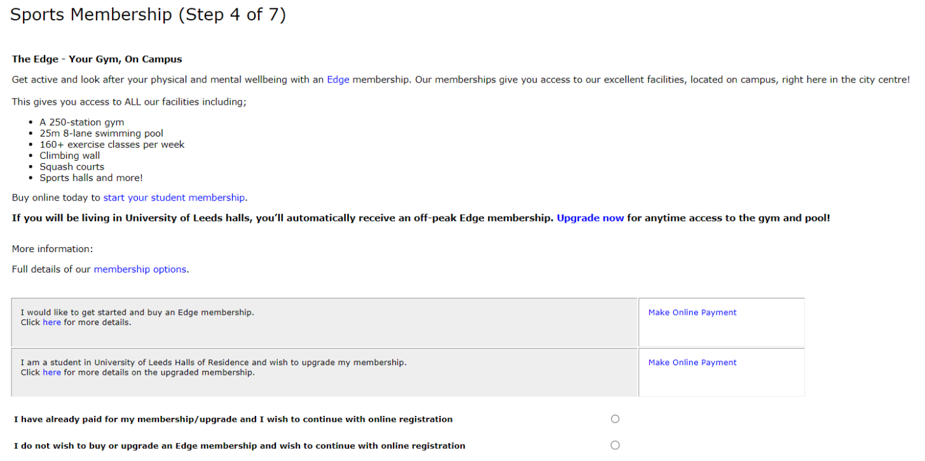

HELP text as seen by students: the Sports membership page
More information about The Edge is available via the University's Sport & Physical Activity website. If you wish to join the Edge membership (or wish to upgrade if you are a student living in University of Leeds Halls of Residence), choose the relevant Make Online Payment link to buy your membership. At the payment stage, you must read and understand the terms and conditions of membership before making your payment.
If you purchase Edge membership as part of the registration process, your Student ID Card will be updated with the membership and then can be used to gain access to our facilities. Monthly memberships will need to be activated at the main Edge reception and annual memberships/halls upgrades will be activated by the team automatically.
Students who decide not to join The Edge membership scheme via online registration can always join at a later date online.
Need further help?
For further information on registration please refer to the Student Registration pages.
You can also contact the Student Information Helpline:
(Opening hours 09:00 – 17:00 GMT Monday to Friday)
- Email: studentinfo@leeds.ac.uk
- Telephone (from within the UK): 0800 9150402 (this is free phone number, you won’t be charged for calling this from your mobile or landline)
- Telephone (from outside the UK): +44 (0)113 3437000
Please quote your Student ID Number.

Programme of Study Details
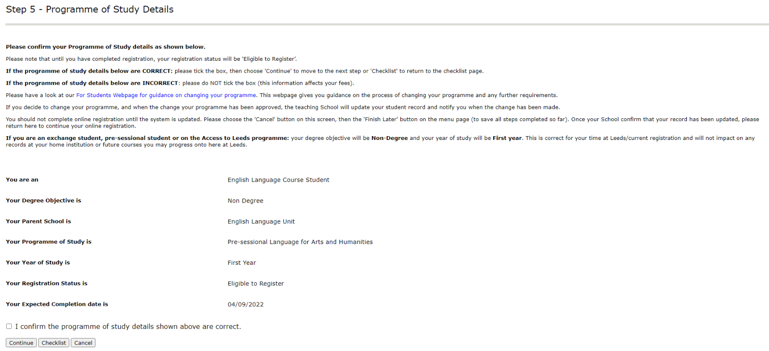

Please note that Postgraduate Researchers will also see their method of attendance, thesis title, status of thesis and supervisors below their expected completion date.

HELP text as seen by students: the Programme of Study page
Your Registration Status will be displayed as Eligible to Register until you have successfully completed the full online registration process, at which point this will be updated to Registered online. For new students, you are not fully registered until you have completed an identity check.
If your Expected Completion Date is NOT displaying the correct date, you should contact your Parent School to query this.
Need further help?
For further information on registration please refer to the Student Registration pages.
You can also contact the Student Information Helpline:
(Opening hours 09:00 – 17:00 GMT Monday to Friday)
- Email: studentinfo@leeds.ac.uk
- Telephone (from within the UK): 0800 9150402 (this is free phone number, you won’t be charged for calling this from your mobile or landline)
- Telephone (from outside the UK): +44 (0)113 3437000
Please quote your Student ID Number.

Fee Payment Arrangements
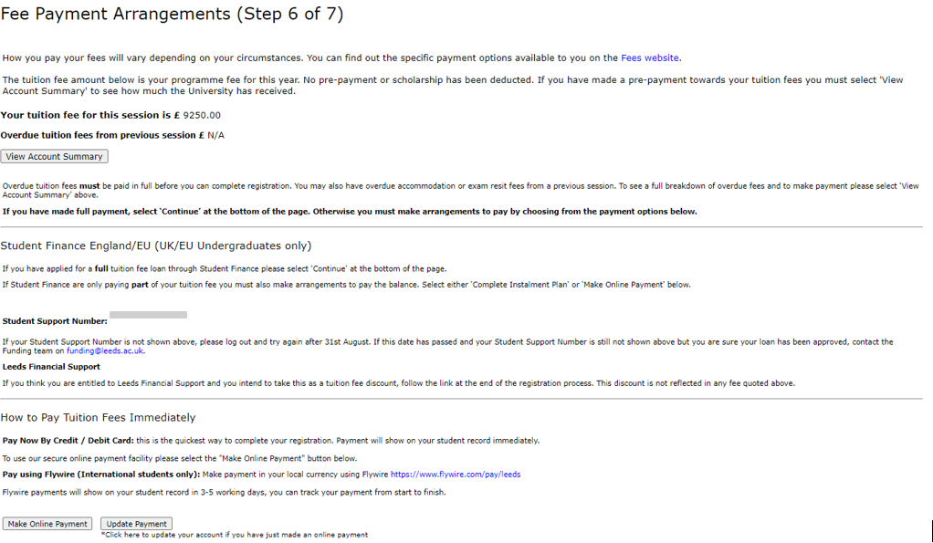
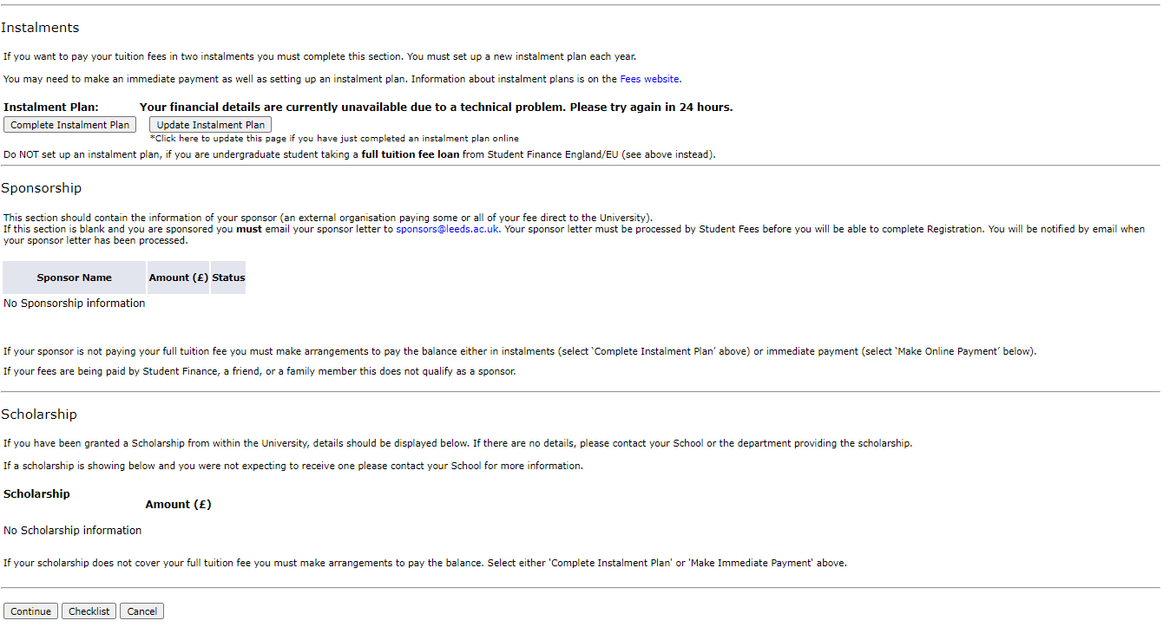

HELP text as seen by students: the Fee payment arrangements page
Tuition Fees
The fee shown is for this academic session, based on your current programme of study. You must make arrangements to pay your tuition fees as part of registration, unless they are paid in full by Student Finance (UK/EU Undergraduates only).
Please Note: the tuition fee shown will not include any costs invoiced directly by your department, for example field trips and bench fees. Contact your department directly if you think this may be relevant to you.
If your fee has been manually amended, it will display as an overdue balance rather than a fee.
If you think the fee shown is incorrect please contact the Student Information Helpline team (details at the bottom of this Help page)
Overdue Balance
Overdue tuition fees from a previous session must be paid in full before you can register for a further session.
If you cannot make payment of your outstanding balance immediately you must make arrangements to pay before the registration deadline.
Student Finance (UK/EU Undergraduates only)
If we have been notified that you have made an application for student support to Student Finance England/EU your Student Support Number (SSN) will be shown. If you have made an application but your Student Support Number was not shown this may be because your application is still being assessed. If you wish to enquire about your application please contact the Student Support Helpline on 0300 100 0607.
If Student Finance England/EU are only paying part of your fee you must make arrangements to pay the balance by instalments or in full by selecting the relevant option.
Student Finance Postgraduate loans
Student Finance (UK/EU Postgraduates only)
If you are receiving a postgraduate student loan we must receive confirmation from Student Finance that your loan has been approved before the PG LOAN instalment plan will display. While you wait for this confirmation you can still complete the Identity Check and obtain your Student ID card.
Instalments
You can pay your tuition fee by instalments; we offer a two-part scheme with each instalment being 50% of the fee due. You can complete an instalment plan as part of registration by selecting the ‘Complete Instalment Plan’ button. Postgraduate and International students must make a manual payment for the first instalment.
Postgraduate loan students - if you are receiving a postgraduate loan from Student Finance England/EU you are entitled to an exceptional three part instalment plan. This will only display after Student Finance have informed us your loan has been approved.
Postgraduate Researchers - overtime fees must be paid in full at registration.
Sponsorship
If an external organisation (i.e. not a friend, relative or Student Finance England/EU) is responsible for payment of all or part of your tuition fee please send a sponsor letter to sponsors@leeds.ac.uk. You must then wait until you can see the sponsorship in the ‘Sponsorship’ section of the Fee Payment Arrangements page before you can continue with registration.
If you are going to be funded by the NHS for the academic year (Medicine/Dental students), please email your 'Notification of Award' letter to sponsors@leeds.ac.uk. You must then wait until you can see the sponsorship in the ‘Sponsorship’ section of the Fee Payment Arrangements page before you can continue with registration.
All sponsors must pay within 30 days of being invoiced, no instalment option is available.
Scholarship
If you have a scholarship from your School for all or part of your tuition fee which is not shown on Step 6 of Registration, contact your School. They will arrange for this to be updated.
Postgraduate Researchers: If you are in receipt of a scholarship administered by Postgraduate Research and Operations, you can commence online registration but will not be able to complete it. Once you have received your Scholarship Renewal Letter you can complete registration.
Payment Options Available:
For further information about the different ways to pay, please visit the Fees website.
Identity Check
If you are unable to complete your registration immediately for financial reasons you can still complete the Identity Check and collect your Student ID card.
Please remember to log back onto online registration as soon as you are able to complete your registration. You do not need to visit the Student Services Centre in order to do this.
Loans from Student Finance England/EU will not be will only be released when you have completed your online registration and your identity check.
Need further help?
For further information on registration please refer to the Student Registration pages.
You can also contact the Student Information Helpline:
(Opening hours 09:00 – 17:00 GMT Monday to Friday)
- Email: studentinfo@leeds.ac.uk
- Telephone (from within the UK): 0800 9150402 (this is free phone number, you won’t be charged for calling this from your mobile or landline)
- Telephone (from outside the UK): +44 (0)113 3437000
Please quote your Student ID Number.
Postgraduate Research students should contact Doctoral College and Operations by email: rp_student@adm.leeds.ac.uk
Please quote your Student ID Number.

Declaration Statement
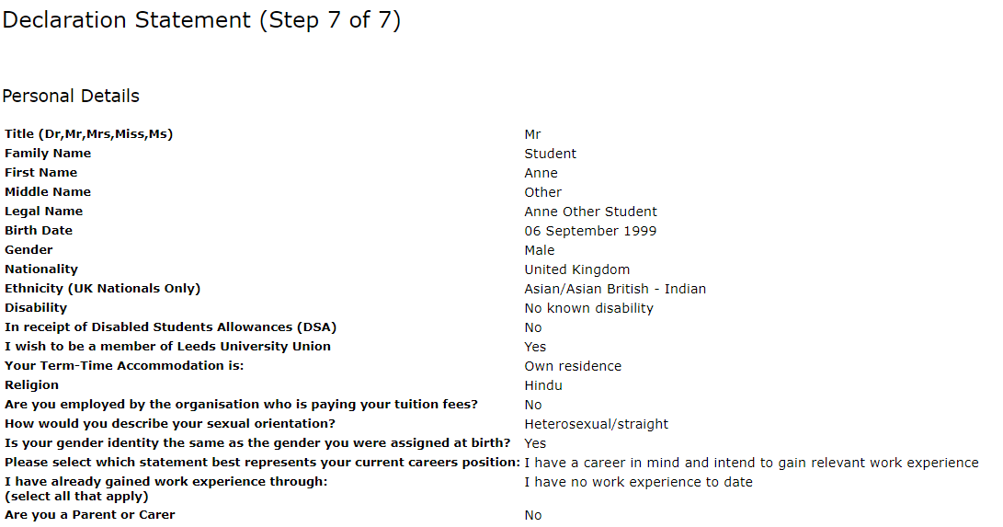
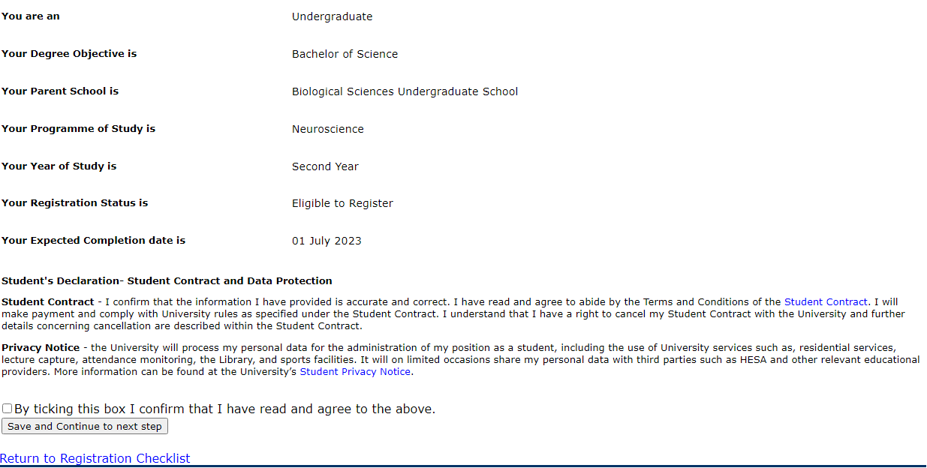
The declaration statement displays information held on your student record that requires checking and updating as part of the registration process. If you are happy that the information held is correct and that you agree to the terms and conditions of the student contract you should tick the box and click the 'Save and Continue to next step' button to complete registration.

HELP text as seen by students: the Declaration page
If you have amended your name as part of the online registration process, you will see the changes displayed on the right of the screen.
The Student Declaration Statement is printed in full with a link to the Terms and Conditions of the Student Contract which you must read and agree.
By choosing the link above you can also read the University's Code of Practice on data protection, which accords with the Data Protection Act and takes into account the codes of practice published periodically by the Office of the Information Commissioner.
You MUST read and agree the Student Declaration Statement before you can become a registered student of the University of Leeds.
Need further help?
For further information on registration please refer to the Student Registration pages.
You can also contact the Student Information Helpline:
(Opening hours 09:00 – 17:00 GMT Monday to Friday)
- Email: studentinfo@leeds.ac.uk
- Telephone (from within the UK): 0800 9150402 (this is free phone number, you won’t be charged for calling this from your mobile or landline)
- Telephone (from outside the UK): +44 (0)113 3437000
Please quote your Student ID Number.
Postgraduate Research students should contact Doctoral College and Operations by email: rp_student@adm.leeds.ac.uk
Please quote your Student ID Number.

Final confirmation (registration certificate) page
The “Print your Registration Certificate” button will open the standard print process. The CAS status field is currently showing inaccurately and will always show No CAS status even if a students CAS has been issued correctly.

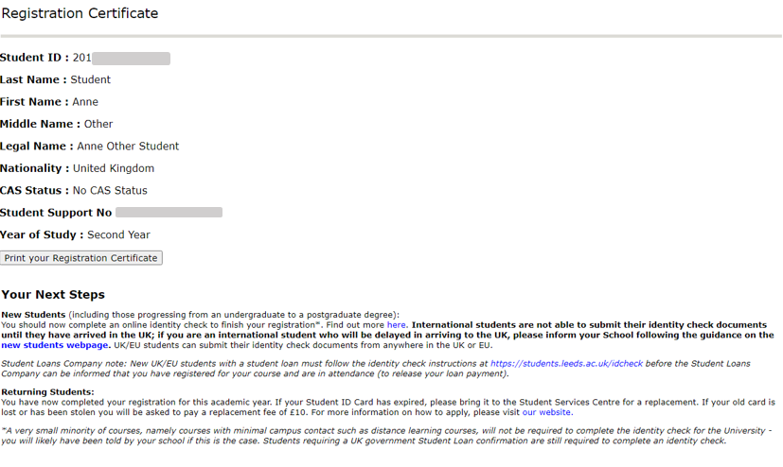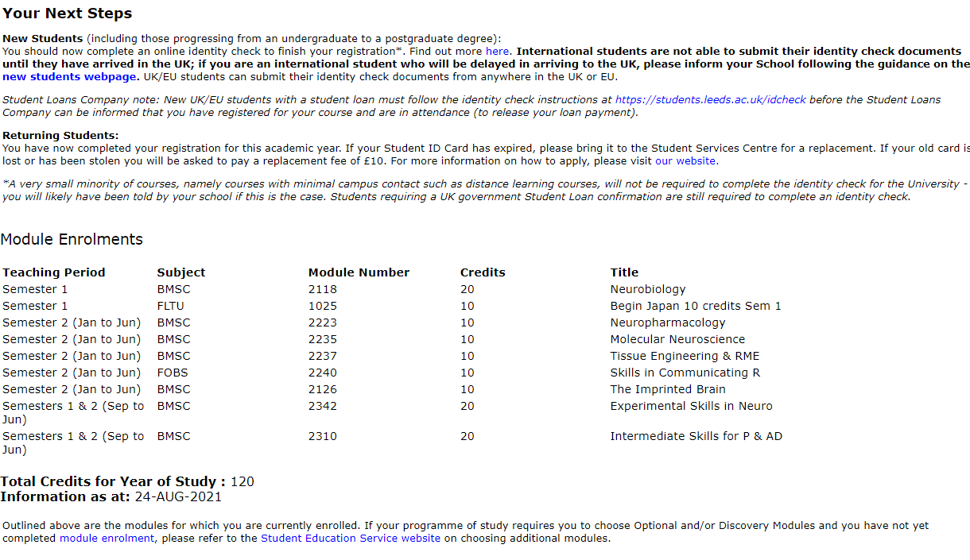
(Note Postgraduate researchers will not see module enrolments on their confirmation page, but information related to their research programme).
(Continued on following page) 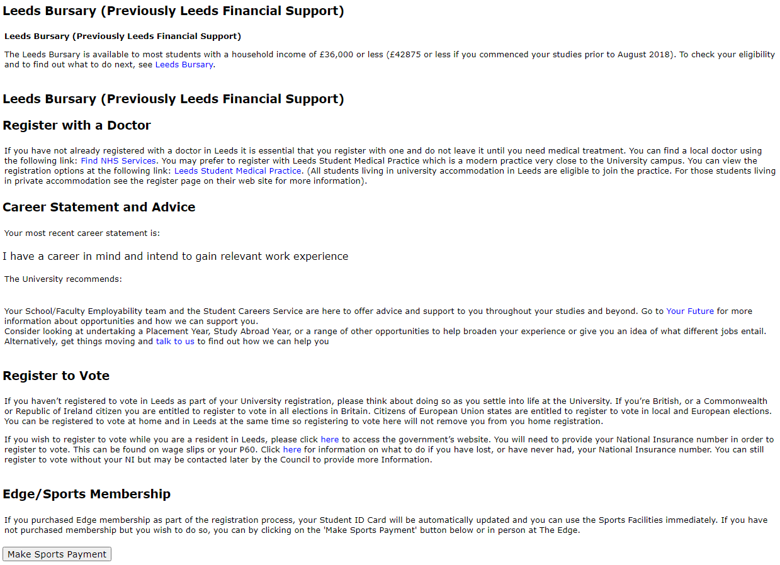
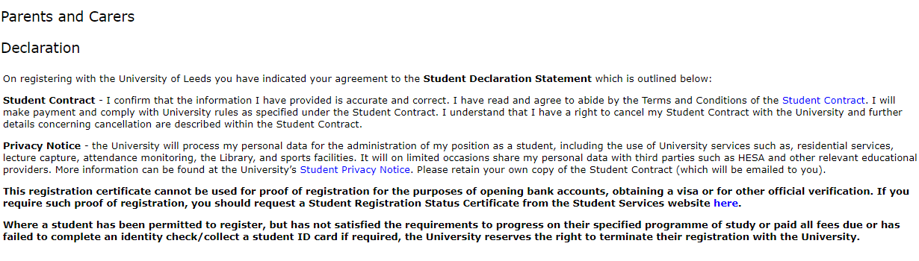

HELP text as seen by students: the Final confirmation page
You should keep an electronic or paper copy of the Registration Certificate for your records.
New students are required to have their identity check documents verified and a copy will be held by the University. New international students will see displayed on their Registration Certificate details of their Confirmation of Acceptance of Studies (CAS).
Once you have registered, if you revisit the Online Registration web pages, your Registration Certificate will continue to be displayed until the point when you are required to register again for your next academic year of study.
Need further help?
For further information on registration please refer to the Student Registration pages.
You can also contact the Student Information Helpline:
(Opening hours 09:00 – 17:00 GMT Monday to Friday)
- Email: studentinfo@leeds.ac.uk
- Telephone (from within the UK): 0800 9150402 (this is free phone number, you won’t be charged for calling this from your mobile or landline)
- Telephone (from outside the UK): +44 (0)113 3437000
Please quote your Student ID Number.
Postgraduate Research students should contact Doctoral College and Operations by email: rp_student@adm.leeds.ac.uk
Please quote your Student ID Number.

