EPSRC Adding a new student to Je-S

Je-S provides a Helpdesk service (details on website) ALL ENQUIIRES regarding completing Je-S forms should be directed to the Je-S Helpdesk in the first instance and NOT the Postgraduate Scholarships Office.

- Go to the Je-S home page http://je-s.rcuk.ac.uk
- Login to Je-s with your username and password
- Select Documents from the Account menu on the left hand side of the screen.

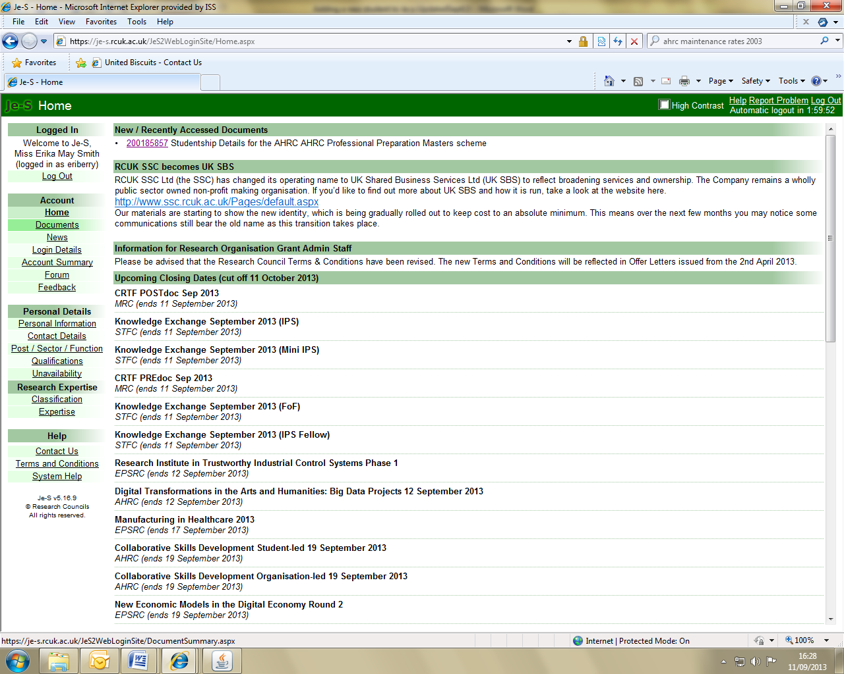

On the next screen click select New Document under the Functions menu.

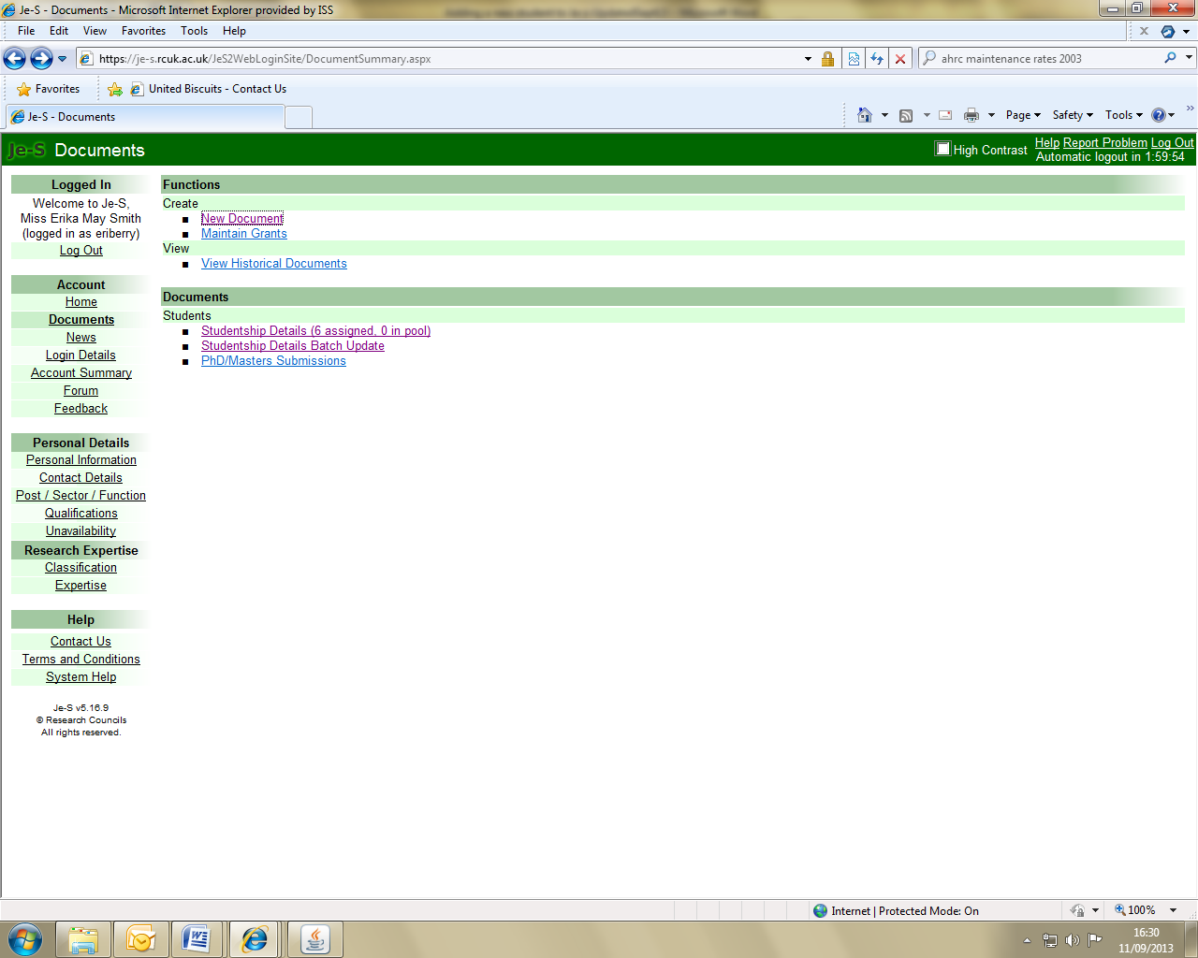

You will then be taken to the Add New Document Screen.

- Use the Select Council drop down menu to select EPSRC .
- From the Document Type list select Studentship Details.
- Select the appropriate Scheme from the the Select Scheme list. (See below for details)
- You are not required to provide a Call/Type Mode, this field can be disregarded.
- Click on Create Document to take you into the newly created student record.

EPSRC Scheme List

EPSRC Standard Research Student DTP (formally DTG): It is expected that the majority of the students funded through doctoral training partnerships (formally doctoral training partnership grants) will fall under this scheme, including CASE (though not iCASE) where there is a project partner, such as a sponsoring company.
DO NOT RECORD students as Standard Research Student DTG

EPSRC International Doctoral Scholars – IDS Grant: up to 10% of all EPSRC studentships may be awarded to the very best students whether EU, international students or otherwise. This applies to the majority of EPSRC studentship funding routes, specifically Doctoral Training Partnerships (DTP); Centres for Doctoral Training (CDT) and Industrial CASE Awards (ICASE). To ensure effective monitoring, Research Organisations are required to identify and report these individuals back to EPSRC as International Doctoral Scholars (IDS Grant). Further information can be found at:http://www.epsrc.ac.uk/skills/studentships/

Centres for Doctoral Training: The funds for these 4-year research studentships are allocated through CDT grants which provide support for 5 annual cohorts of students who undertake a common first year of modular training following a traditional PhD research programme. This category should be used for students that meet the harmonised RCUK Terms and Conditions eligibility criteria.

Incorporated Student: These are students that would be considered a core part of an EPSRC CDT cohort but that do not meet the full requirements of the harmonised Terms and Conditions eligibility criteria (i.e. are fully funded by a University or Industry partner or are self-funded).

EPSRC Industrial CASE Student: Where student funding has been placed by a company and is delivered through an Industrial iCASE Account Training Grant. Studentships charged to the 2015 grant and later grants are of a 4 year duration.

EPSRC Academic Fellowship: These fellows are funded through the Academic Fellowship grant to the Research Organisation, awarded by EPSRC. These fellowships are intended to provide contract research staff with more attractive and stable paths into academic life.

EPSRC Life Science Interface Student – DTC Grant:The funds for these students are delivered through a Life Sciences Interface Doctoral Training Centre (LSI-DTC) grant.

EPSRC Research Assistants Industrial Secondments:This CTA category encourages the transfer of knowledge by researchers on EPSRC research grants by providing further training seconded into an industrial environment. The purpose is to develop their contribution to the original research project.

Person Details – You must click on the Select Person button to start completing this section. In the pop up window that appears enter the required details and click Search.

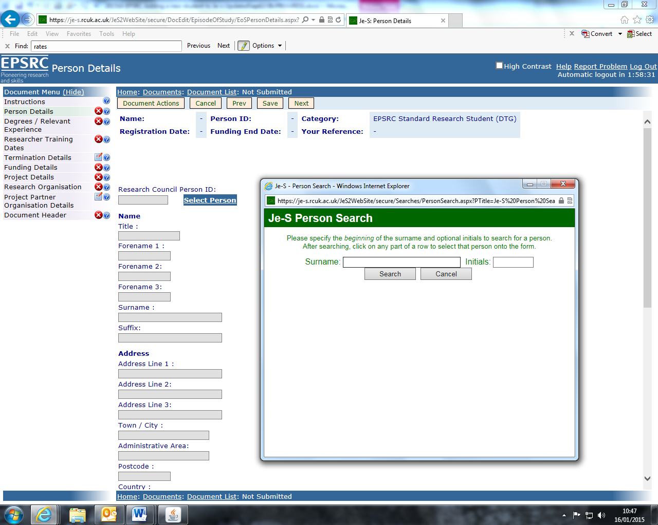

A list of people will appear – ignore the list and click on Add New Person. Complete the mandatory information and click Save. These details will be retained and you will be returned to the main Person Details page.

NEW with students now being contacted by Researchfish it is essential that the correct and live email address is recorded on Je-S as otherwise PSO is requested by RCUK to update the records. We recently updated 50!

Date of birth, email address, gender, ethnic origin, country of nationality and disability indicator are required fields.
Gender & Ethnic Origin (Banner screen ‘SPAPERS’), Country of Nationality (Banner screen ‘SKASPIN’) and Disability (Banner screen ‘SWAMEDI’)

Personal or university e-mails may be entered.

Once all Personal Details have been entered, click Save at the top of the page to retain the details and return to the document menu. (Cancel returns to the document menu without saving any changes made since the last save.)

Qualifications and Relevant Experience –
To add a qualification to a student record, select Edit Qualifications.

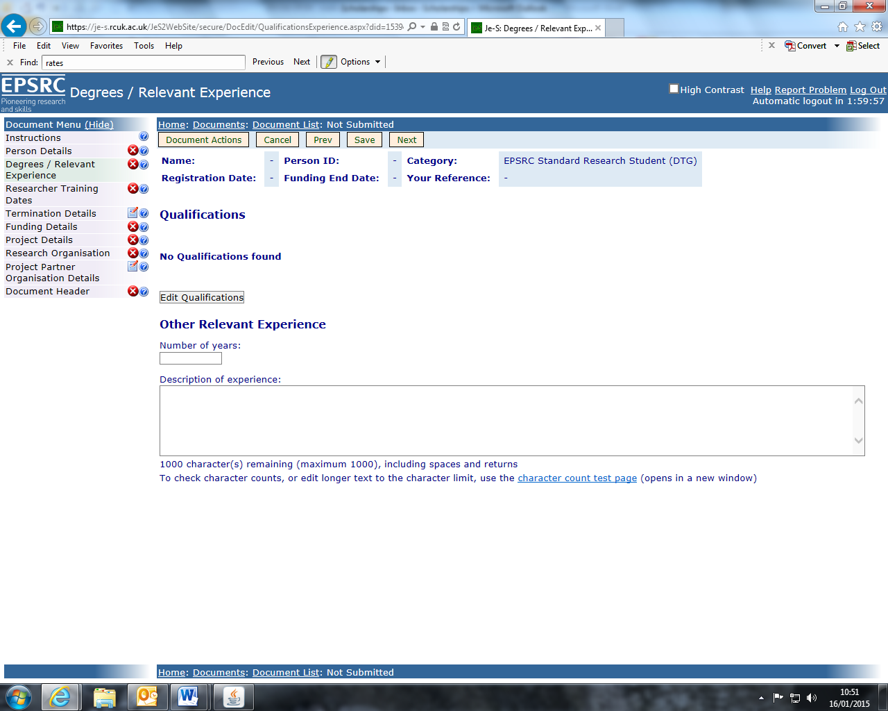

On the next screen click on Add Qualifications which will then take you to the Add new qualifications screen.
Click on Select Organisation to search for the higher education institution that awarded the qualification. Enter the organisation name in the box within the pop up screen that appears and click on search. Select the relevant organisation.

Select the year the qualification was awarded from the drop down box.
Use the radio buttons to select the qualification level (Undergraduate, Postgraduate/Masters or Higher/Doctorate). N.B. If the qualification is a 4 year integrated master’s course e.g. MChem select ‘Undergraduate’.

The qualification type, subject and class can be selected from the drop down boxes and the search button as appropriate.

Add a description if necessary then click on Save to retain the details and return to the document menu.

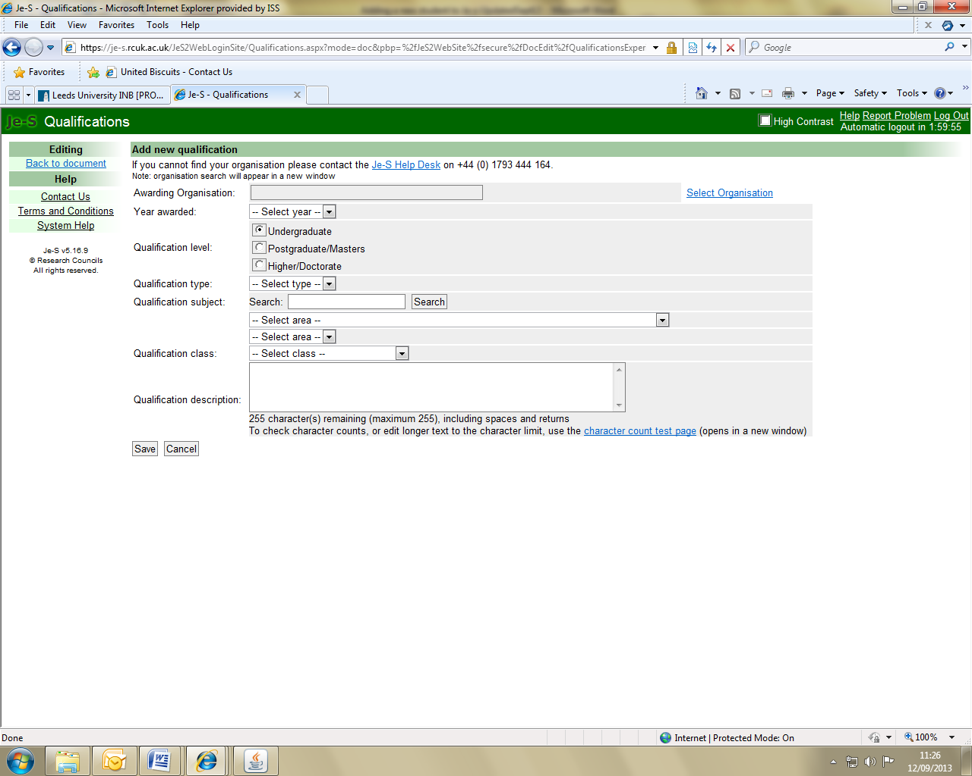

Repeat this step for all of the student’s qualifications then click on Back to document under the Editing menu on the left hand side.

Researcher Training Dates - The dates on this page can be added or amended using the toggle calendars, or by typing directly into the date boxes.

The Registration/Appointment Date is the date on which the student started their studies (BANNER screen ‘SWARDAT’).

The Funding Start Date is the date from which the student started to receive Research Council funding. This will generally be the same as the Registration/Appointment Date but may differ if, for example, a student began to receive Research Council funding part-way through their studies.

The Funding End Date is when the student’s funding from the Research Council funding will cease.

Note:
DTP and CASE students - The funding end date is 3.5 yrs from their start date
iCASE students – The funding end date is 3.5 yrs from their start date if charge to the 2014 grant or a prior one. From session 2015 all studentships charged to the 2015 grant and later grants are for 4 years.

The Expected Submission Date is the date by which the thesis is due to have been submitted (BANNER screen ‘SWARDAT’).

Once the details have been entered, click Save at the top of the page to retain the details and return to the document menu.

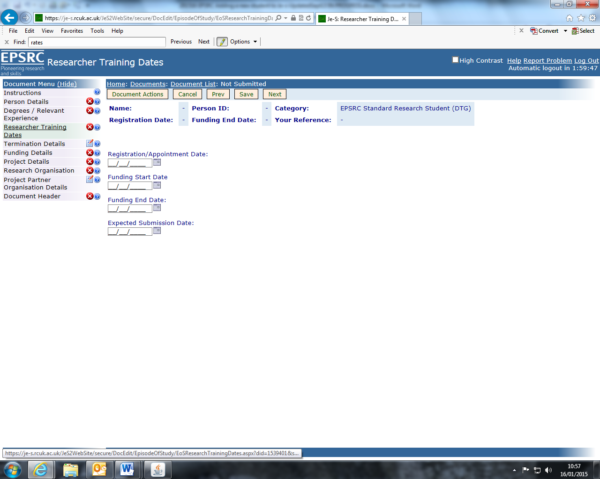

Funding Details – Click on Add Funding Details

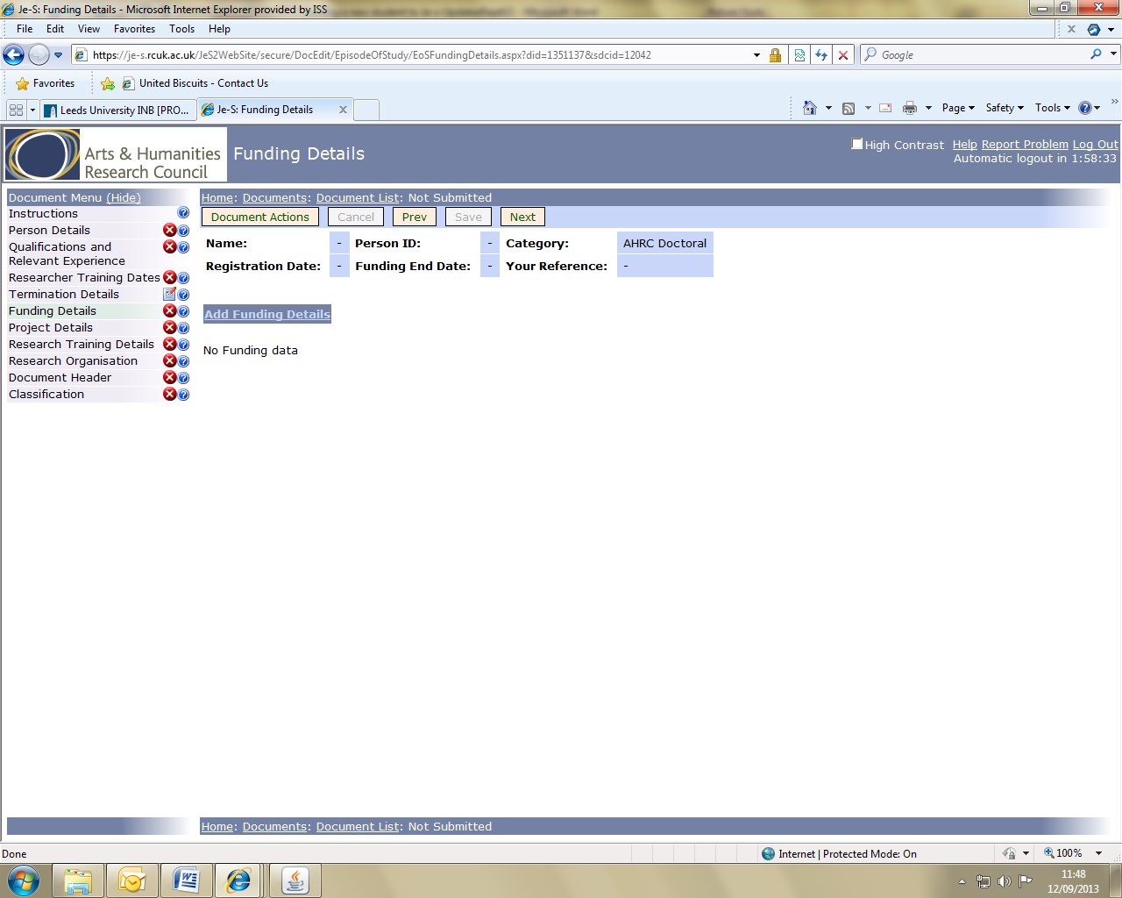

The next screen will allow you to enter the funding details for one year.

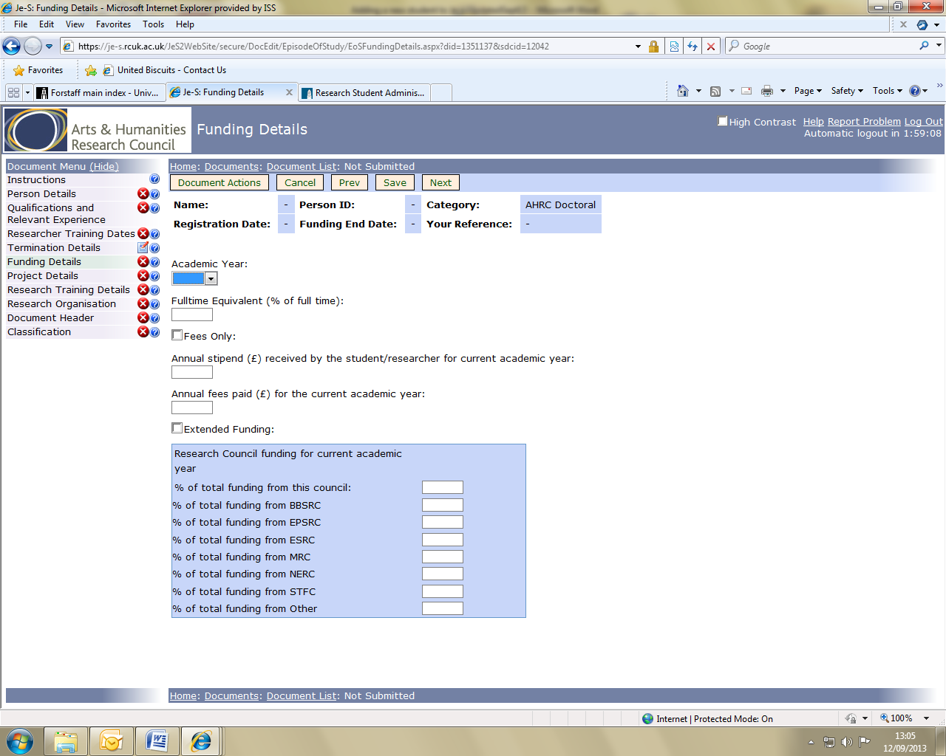

See notes on page 9 for details about adding funding amounts.

Use the Research Council Rates and List of Grant Numbers document available from the Information For Staff section on the Postgraduate Scholarships Office website for guidance:

https://ses.leeds.ac.uk/site/scripts/login.php

Session | University Fee Rate | RCUK Fee Rate | RCUK Maintenance Rates
2015/16 | 4100 | 4052 | 14,057
2016/17 | 4250 | 4121 | 14,296
2017/18 | 4250 | 4191* | 14,554*
2018/19 | 4,335* | 4262* | 14,845*
2019/20 | 4,422* | 4334* | 15,142*
*Estimated

Annual Stipend paid to the student from all sources (unless the Fees Only box has been ticked)
- Annual Fees paid (enter the Research Council rate, not than the University’s rate)
- % Research Council funding for the current academic year

Complete the funding details for each year of the studentship even if the maintenance amounts are estimates.*

The stipend should be the full annual rate paid to the student from all RC Studentship Grants during the current academic year, plus any funding from other sources (departmental, industry etc).

Note: CDT Incorporated Students – Enter the full amount of funding received by the student from whatever source

NEW for Session 2016/17

EPSRC has written to the University requesting that the quality of project summaries are improved and that CDP studentship project titles and descriptions are capture when they commence study not in year two of their period of study.

“ We also appreciate that there will be CDT students who will not start a doctoral project until later in the research degree programme. Details of these awards should be entered, along with a title and summary that can be generic, if necessary. For CDT students starting in autumn 2015, project summaries art expected by 30 November 2016”Letter from EPSRC 12/09/2016

It was recommended by the Steering Group on DTPs that a project description template (attached with this email) is completed and then signed off by the PGRT.

Project / Course Details - add a project/course title and a project summary for the student’s project. The project title field is optional, but this should be completed as soon as the title is confirmed. Plain text may be pasted from documents or emails, but there is a character limit of 150 for the title and 4,000 for the summary.

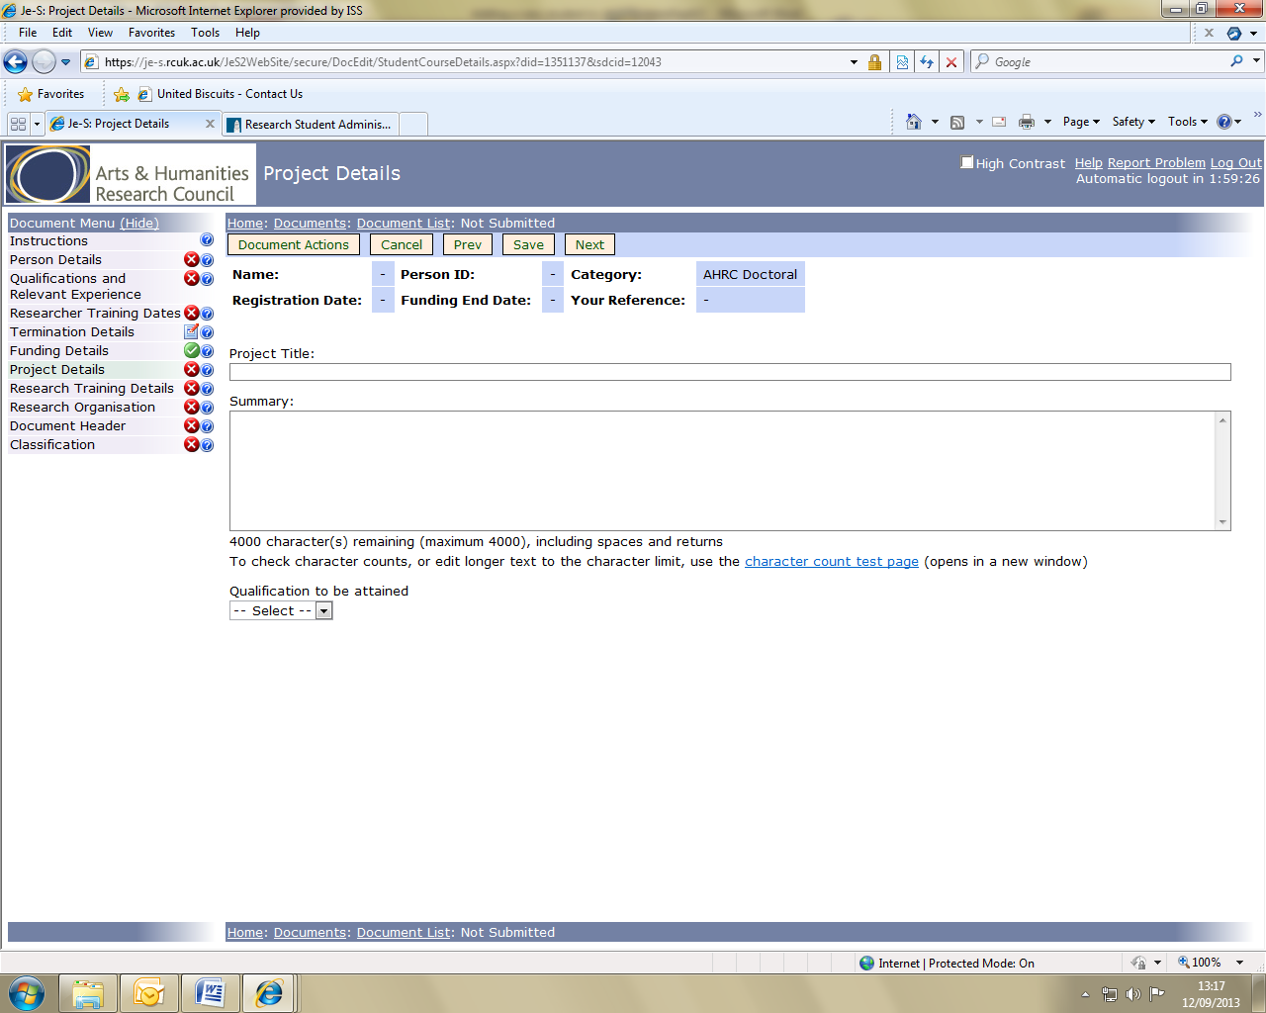

Please select the qualification that will be awarded at the completion of the programme of study.

IMPORTANT the project abstract needs to describe the novel engineering and/or physical research in the PhD project. If the project abstract does not adequately describe how the project falls within the EPSRC remit, the studentship record will be returned to the University to amend until it satisfies their requirements.

To help detail how the novel research fits under EPSRC's remit refer to the research areas which can be found on the following website: http://www.epsrc.ac.uk/research/ourportfolio/researchareas/ and describe how the research fits into one (or more) of those research areas.

Below is an example of an ideal Project Summary for an EPSRC Studentship
Context of research:
Electronic devices become smaller and smaller allowing them to be smarter and to consume less energy. All this is happening thanks to the continuous reduction in the size of transistors, the basic building blocks of each silicon chip. However, further reduction in size will become almost impossible if we continue to use the current, bulk transistor technology beyond the 32 nm technology generation. One of the solutions is a nonplanar design (e.g. trigate by Intel) allowing us to drive the technology forwards and achieve yet faster, incredibly power efficient transistors and innovative microarchitectures. These multigate, 3D transistor architectures have demonstrated to provide the future solution for the 22nm and 14nm technologies. The designers are always at war to find new designs to improve on performance. Simulation tools are there to make this process easier, faster and cheaper. But these tools (TCAD) need to be constantly improved to be even more efficient and achieve accurate results.

In this project, the development of a 3D finite element ensemble Monte Carlo (MC) device
simulator with quantum corrections (finite element 2D Schrödinger equation solutions) is
carried out in order to investigate future multigate transistors with complex 3D geometries like FinFETs and nanowire FETs. The 3D finite element quantum corrected Monte Carlo is the first such simulation toolbox in the world. The simulations are run at Swansea University on the Zienkiewicz Centre for Computational Engineering Supercomputing Cluster.

Aims and objectives.
The main aims are i) to advance the 3D finite element quantum corrected ensemble Monte
Carlo by incorporating new physical models and ii) carry out accurate study of performance
and optimisation of scaled multigate transistors giving detailed insight into carrier transport at nanoscale.

The objectives are:
To learn an in-house Monte Carlo software to carry out in-depth investigation of the multigate
transistor performance when the shape and size of the devices with different channel orientations are varied to use visualization techniques to understand the underlying physics used the above knowledge to improve the device design and efficiency or accuracy of the simulation tool to compare the Monte Carlo method with other (quantum corrected DriftDiffusion, NonEquilibrium Green's Functions simulation tools for 3D multigate transistors to understand the limitations and the advantages over different techniques.

Potential applications and benefits
During the Ph.D, I collaborate with other students to achieve the goals efficiently and in a
shorter time. I was involved in producing abstracts for international conferences (UK
Semiconductors, IWCE) which resulted in many talks and articles for top international
Peerreview journals (IEEE) that helps to publicise the work that is carried out at Swansea
University and make the community aware of the knowledge we have gained during the
research.

At the end of the Ph.D, an improved TCAD tool is developed that can make the design
process of the CMOS transistors faster and cheaper. Additionally, it can help to understand
the complex physics that happens in advanced CMOS structures. This will attain the top UK
position in simulations of nanoelectronics, will advance the digital design in the UK industry
and help retain their world leading position, as well as help to design many other devices
concepts based on low dimensional nanostructures heterostructures pursued in the UK
academia and industry.

EPSRC CDT coming into their second year of study - Revised and detailed project titles and descriptions to be signed-off by PGRT before being updated in Je-S.

The student’s specific research project details must be submitted to EPSRC within one month of the student commencing their second year of study.

Research Training Details

Please provide information on how the training requirements for the student will be identified and addressed, stating the mechanisms you intend to employ to ensure that the student is fully and effectively trained in the discipline-specific and transferable skills necessary.

Research Organisation – click on Add New Organisation to begin this step.

On the next screen click on Select Organisation. In the pop up screen that appears enter University of Leeds into the search box then click Search. Select University of Leeds to populate the Organisation box.

Click on Select Department then either use the search facility or scroll through the options to select the relevant department. Note: You MUST select the name of the registration unit from the list (e.g. Process, Environmental and Material Eng).
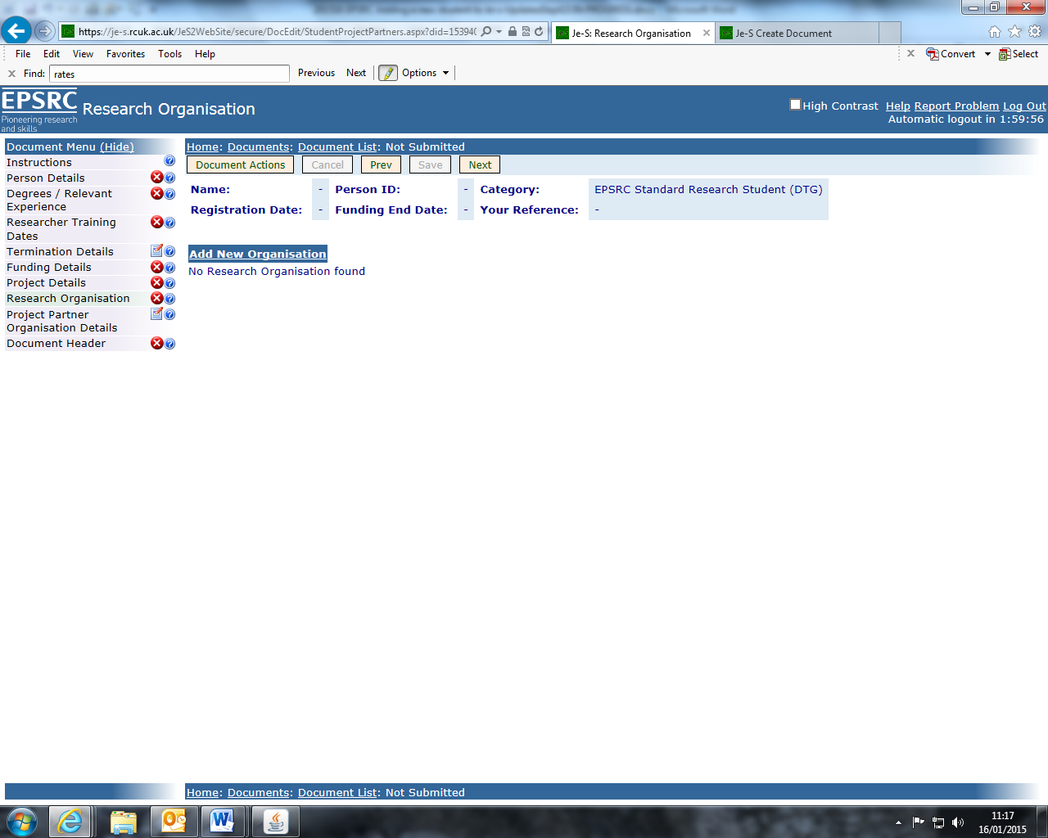

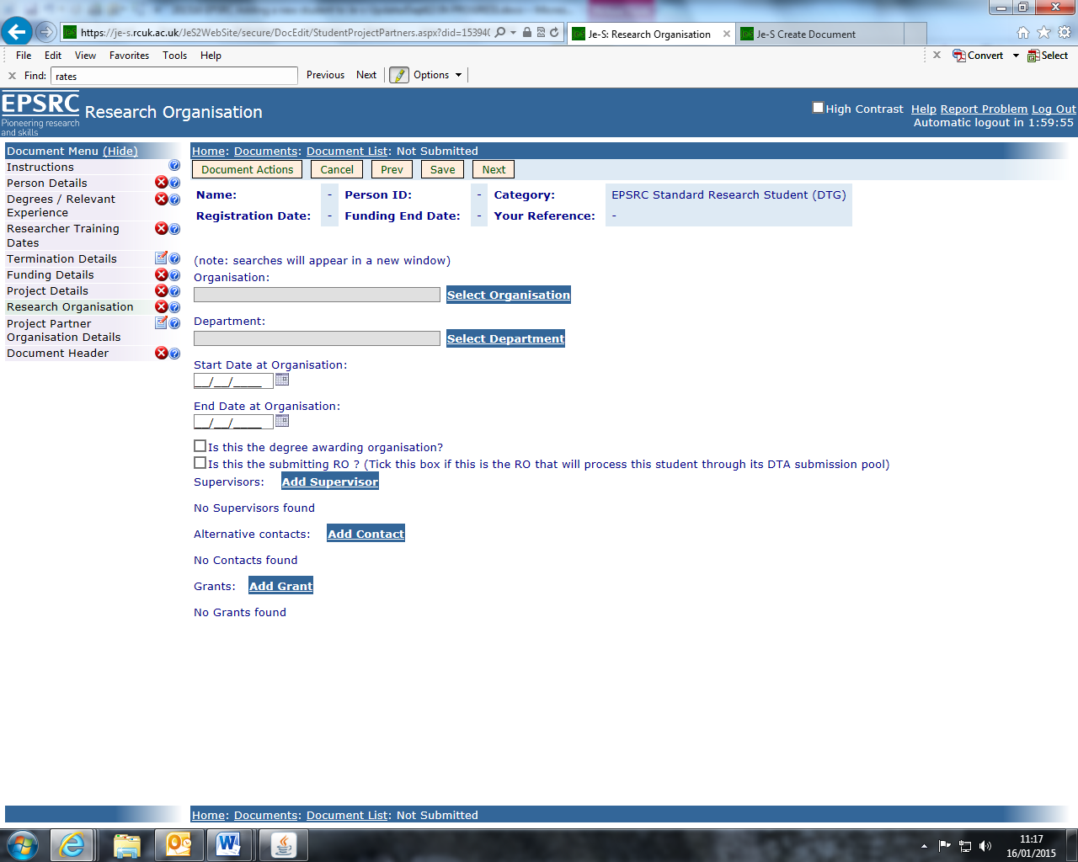

The student’s Start and End dates at the Organisation must also be entered on this screen. The End Date is taken to mean the funding end date.
There must be a tick in the box to indicate that Leeds is the degree awarding organisation and to indicate that Leeds is the submitting RO.
Click on Add Supervisor to search for and select from a list of staff at the research organisation. If the supervisor does not appear in the search results click on Add New User to add his/her details to the student record. There is a tick box for recording if the supervisor is the student’s main supervisor, and all student records must have one main supervisor identified.

Alternative contacts can be added if relevant by selecting Add Contact.

Select Add Grant to record the grant from which the student is funded. Ensure the correct Research Council is selected from the drop down list, followed by the Category to ensure that the correct grant details are available within Select Grant.

Refer to the Research Council Rates and List of Grant Numbers document available from the Information For Staff section on the Postgraduate Scholarships Office website to obtain the correct grant number: https://www.leeds.ac.uk/rsa/postgraduate_scholarships/information_for_staff/information_for_staff.html

Use Start Date of Funding from Grant and End Date of Funding from Grant boxes to allocate funding to each training grant. If a student is funded from more than one grant then this information can be added by returning to the main Research Organisation page, and selecting Add Grant again. The details of the additional grant can now be added.

NOTE if the student is registered at Leeds, but funded by another HEI eg CDT at Sheffield then Leeds must be recorded as the degree awarding HEI and submittingRO
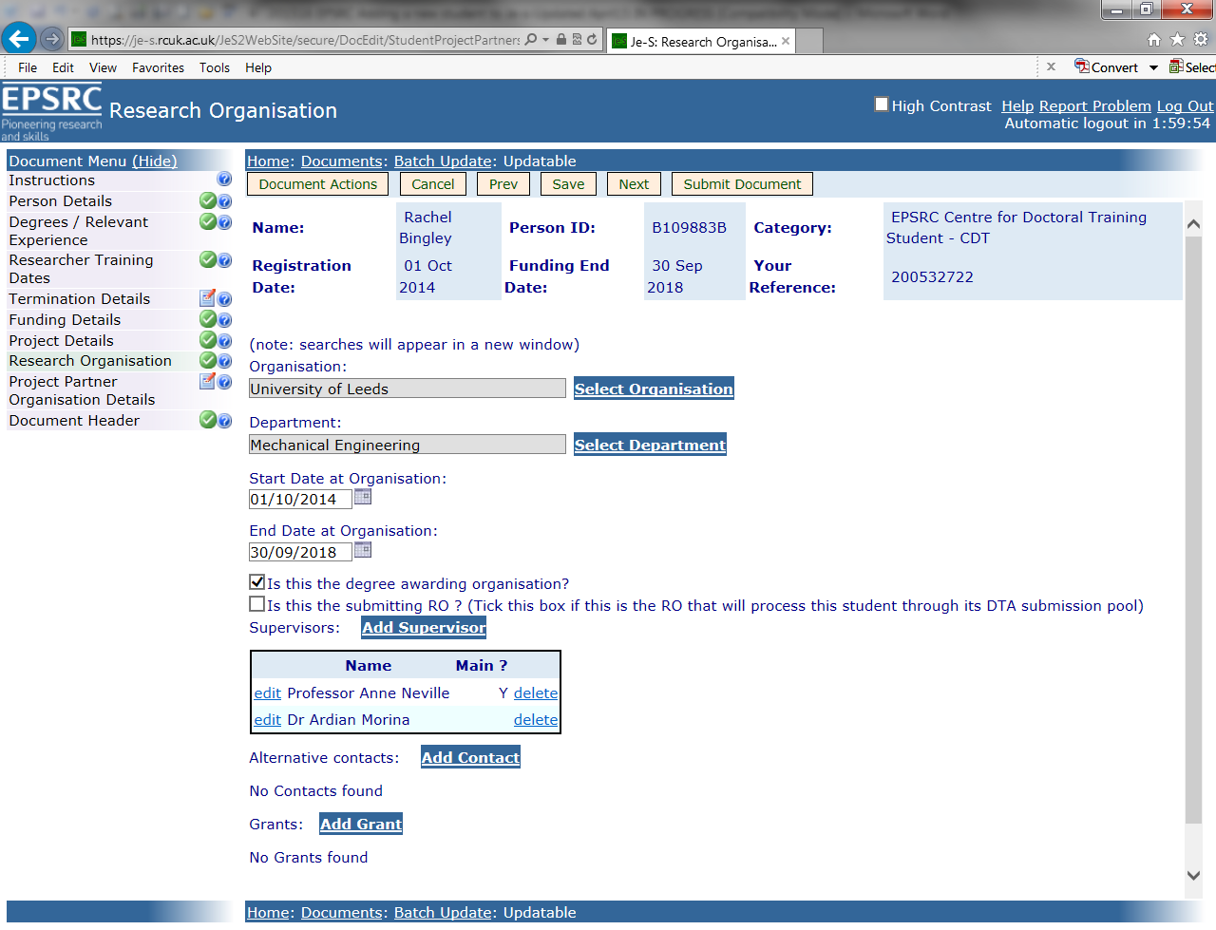

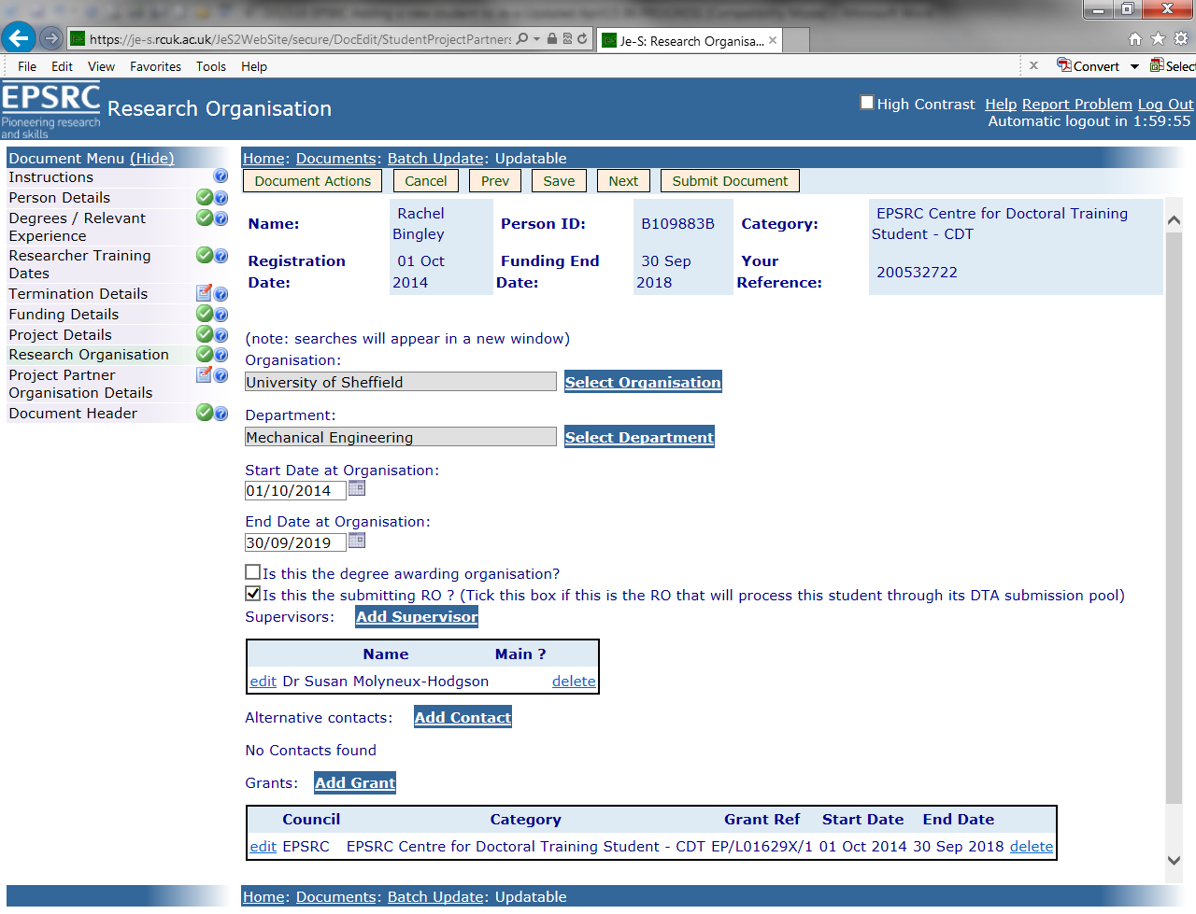

Project Partner Organisation Details – this is only necessary when the student is receiving funding from an Industrial Sponsor (iCASE, CASE).

The contributions from industrial partners (£ value in cash and/or kind) should be the proposed totals for the duration of the partnership, and NOT annual figures.

Note: EPSRC iCASE students – the company contribution must be a minimum of one-third of the funding provided by EPSRC. Studentships charged to the 2015 grant and onwards are now for 4 years.

To add a project partner, click on Add New Project Partner and use Select Organisation to search for and select the relevant body.

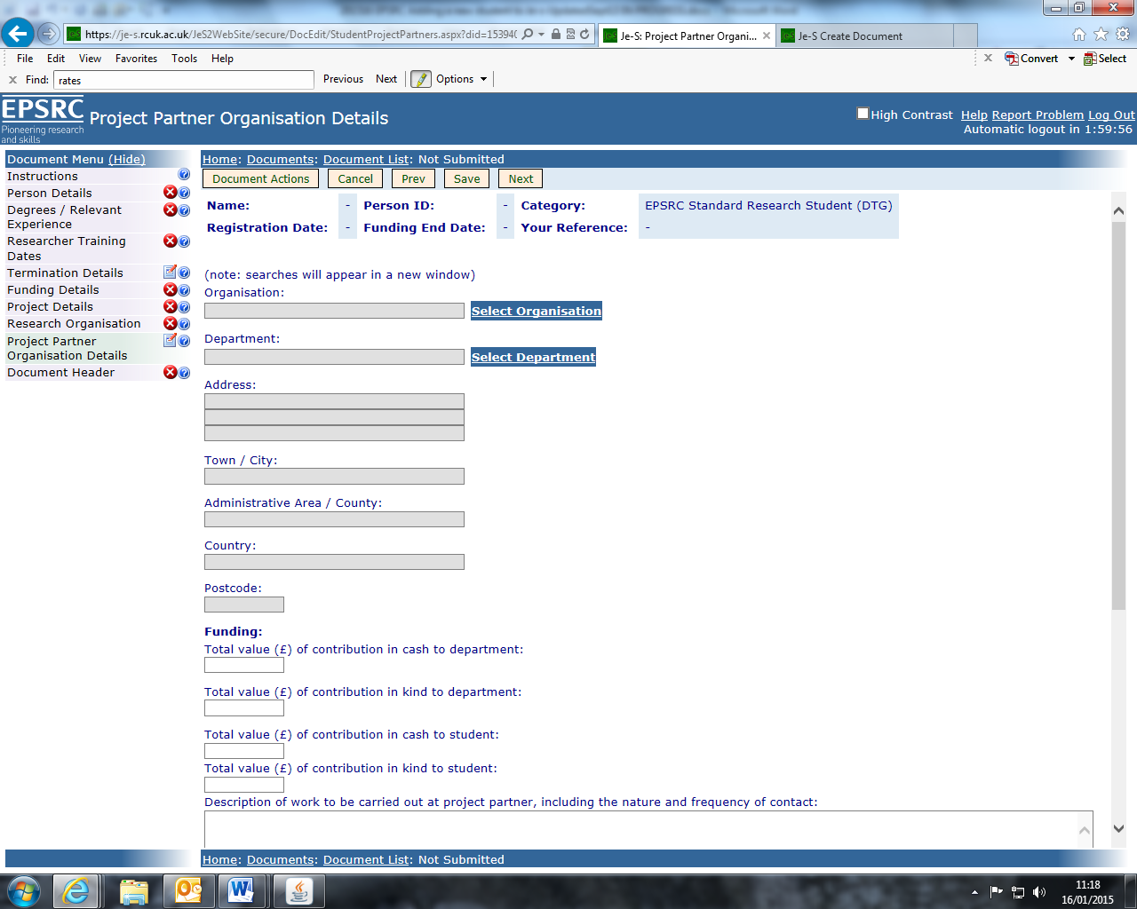

Use Select Department to select the relevant department within the project partner organisation.

Complete the dates on which the project partner became involved in the project and the end date.

A named supervisor must be selected for iCASE or CASE studentships as the company is required to provide co-supervision and a placement for the student.

Use Select Supervisor to search for and select the correct person. If not found, then use Select Contact for recording the main contact at the project partner organisation. However, it will not normally be necessary to add a named supervisor or other contact for a project partner (Add Supervisor or Add Contact). .

Document Header – All fields in this section must be completed.

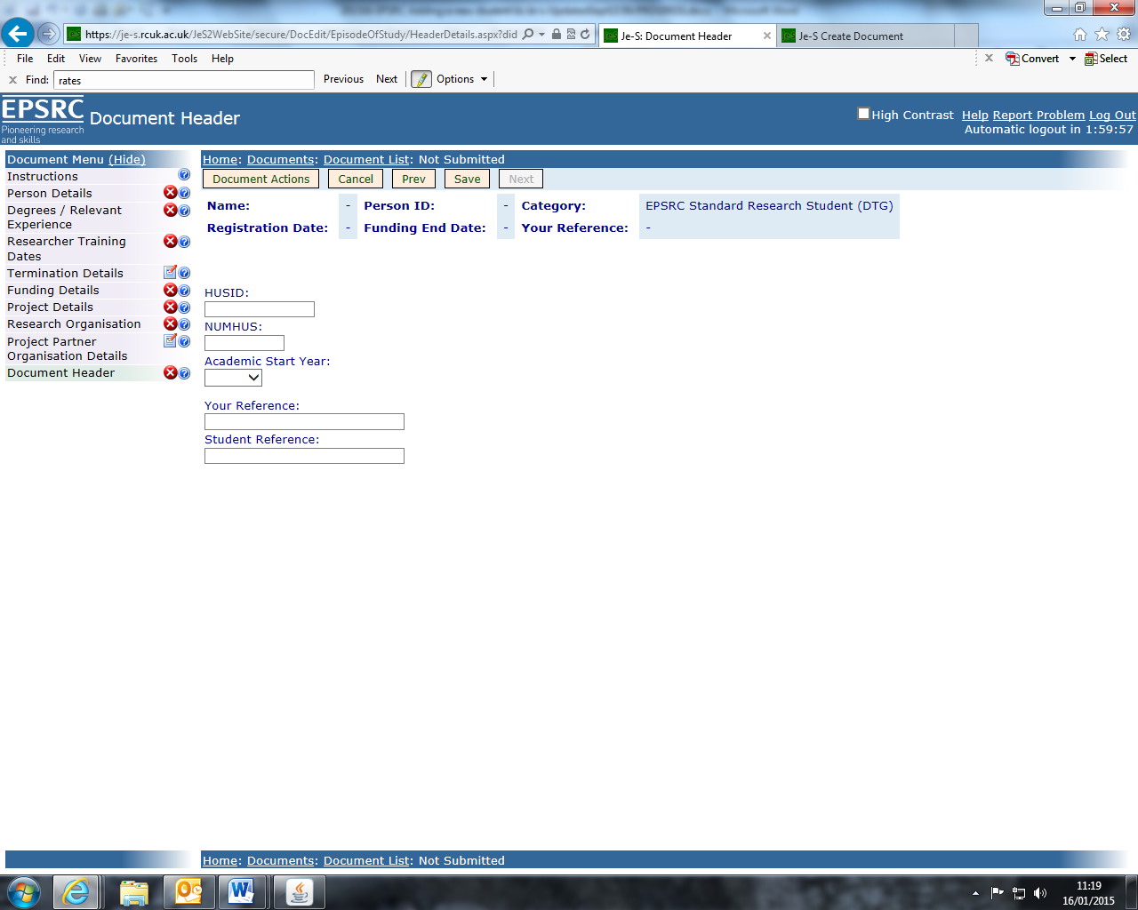

HUSID – This number can be found on Banner screen SKASPIN
NUMHUS – This is the student’s University identification number (SID)
Academic Star Year – The year the student began their course
Your Reference - The student’s University identification number (SID)
Student Reference - The student’s University identification number (SID)

When all sections of the student record have been completed and checked you will need to validate the record to ensure it meets Je-S requirements. To validate the record hover your mouse over the Document Actions button at the top of the page to display an options menu. Select Check Document Validity.

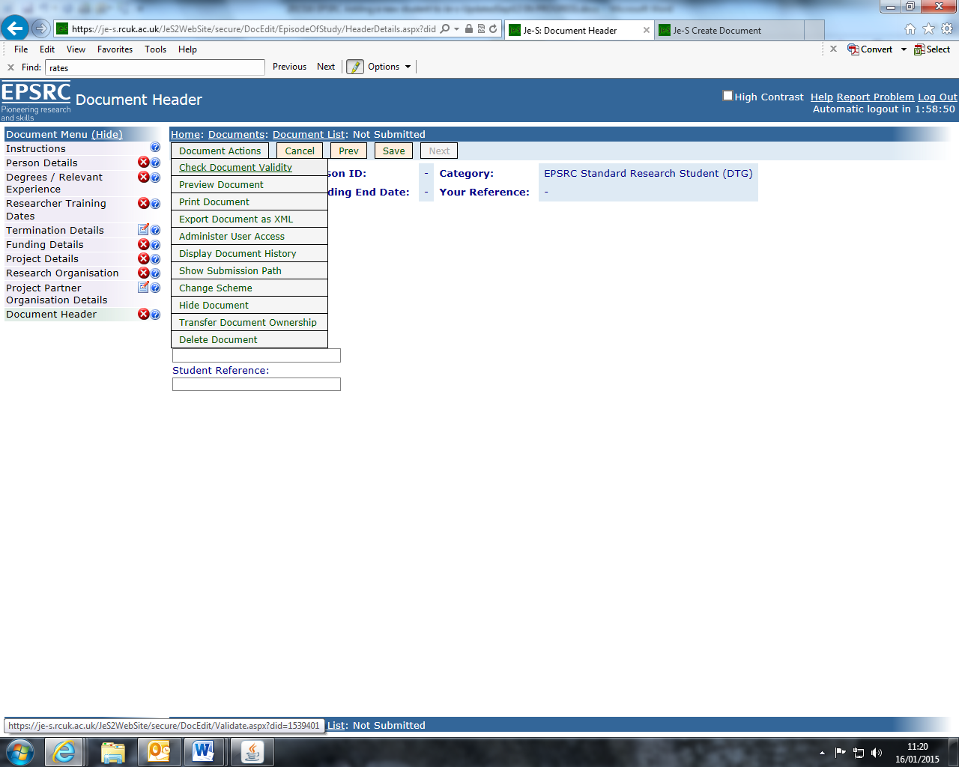

If any sections of the record do not meet Je-S requirements a warning page will display instructing you which sections are not complete.

When your document has successfully been validated you will need to view the entire record as a whole document and CHECK ALL THE DETAILS that have been entered. (Note: A student record may still validate with incomplete or incorrect information).

To view the record as whole document hover the cursor over the Document Actions option in the menu at the top of the page. A list of available actions will display in a submenu. Click Print Document.
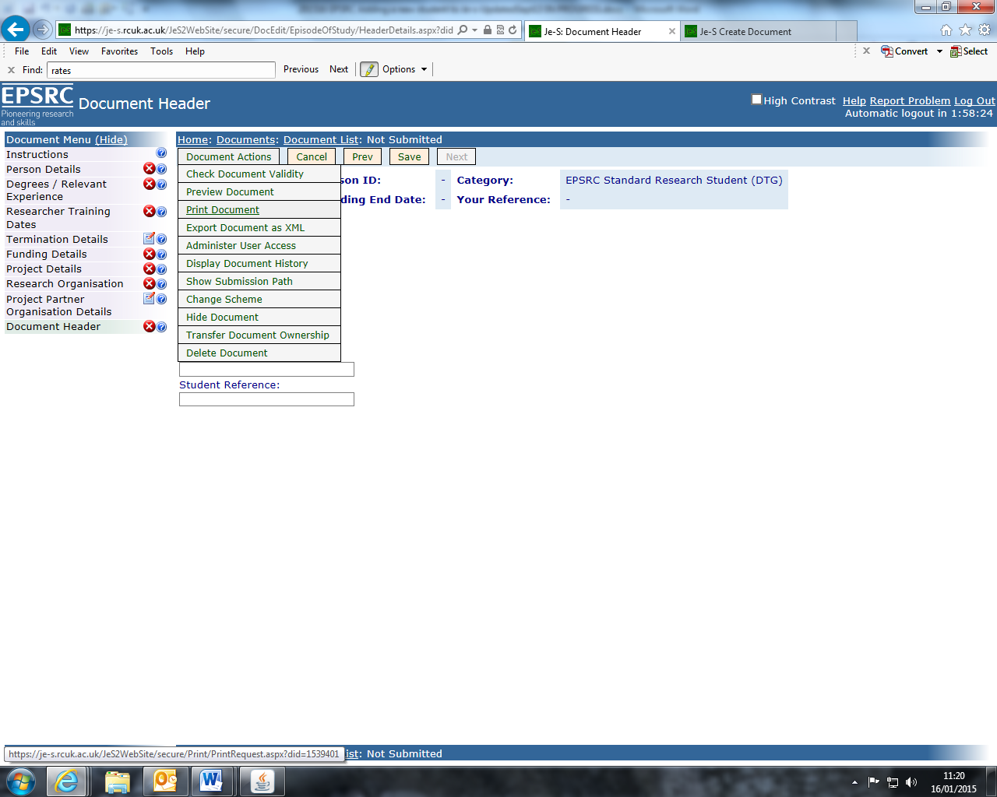

Select one of the document formats in the drop down menu then click Download the Document or have the document emailed to you. You can check the document on screen or in print form.

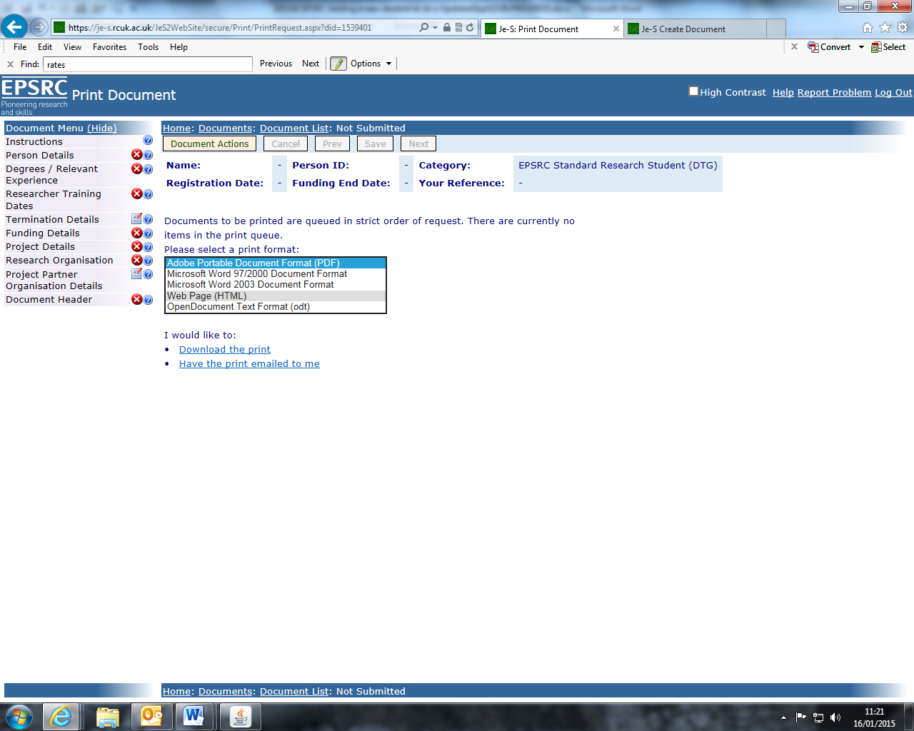

It is highly recommended that Schools save a copy of each student’s Je-S record as it is not possible for Schools to view the record once it has been submitted to the Postgraduate Scholarships Office Submitter Poll.

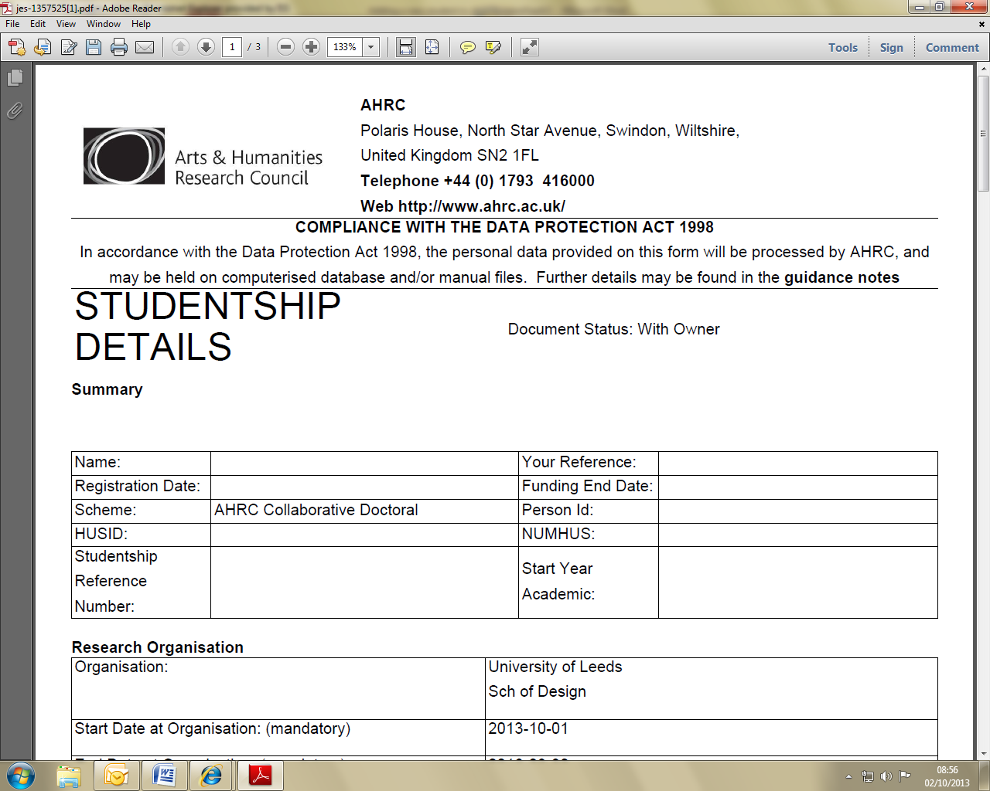

Once the record has been checked for accuracy it can be submitted to the approver pool (Postgraduate Scholarships Office). To submit the record hover the cursor over Document Actions at the top of the page and select Check Validity/Submit Document from the submenu. Answer Yes when asked ‘Are you sure you wish to submit these student/research details?’

