Creating a Je-S Account

- Go to the Je-S log-in page (https://je-s.rcuk.ac.uk/JeS2WebLoginSite/Login.aspx) and click on ‘Create An Account’.

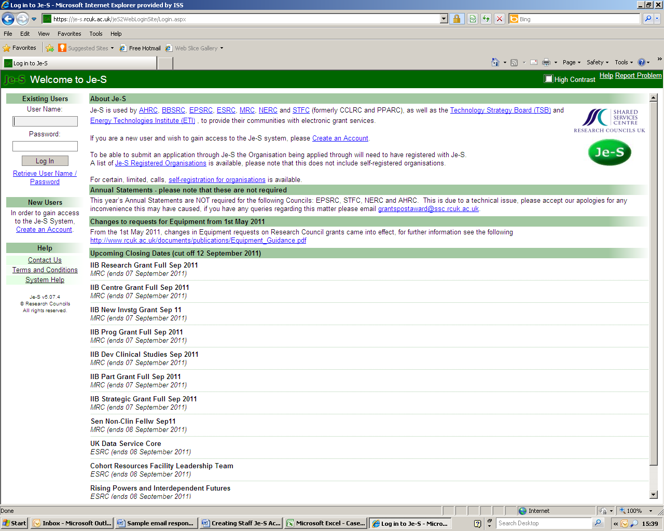

- The Je-S Terms and Conditions will be displayed on the next screen.
Click ‘Accept’ at the bottom of the page.

- On the next screen the Je-S system will check if you have an existing account. Enter your email address in the relevant box and click ‘Account Check’.

- If you do not have an existing account the Account Type screen will appear. Select one of the following under the heading Administration:
- To Prepare Documents, but not be named on it, eg, Departmental Administrator
- To Approve and/or Submit Research Proposals, Student Nomination/Proposal Forms or Ten Day Turnaround

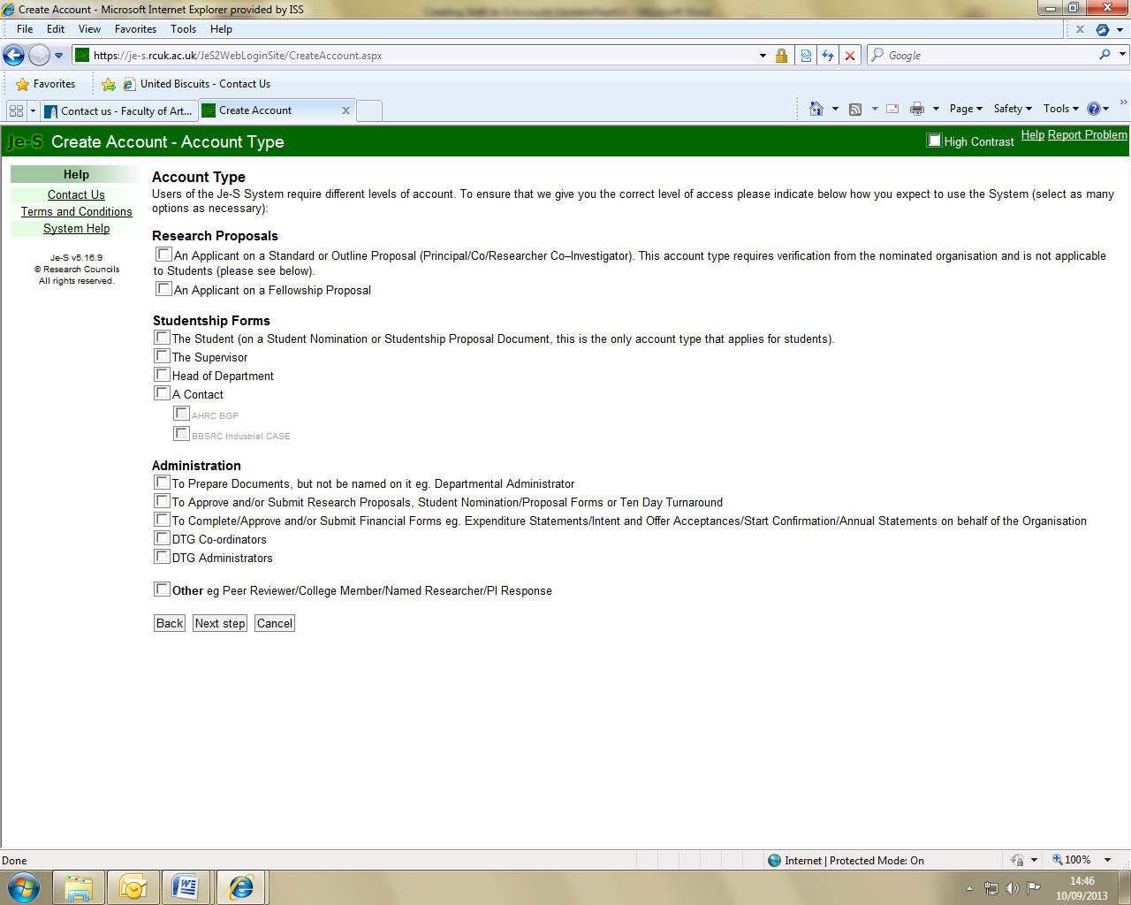

- Click on Next Step at the bottom of the page.

- The Personal Details screen will appear. Enter your personal details as appropriate.

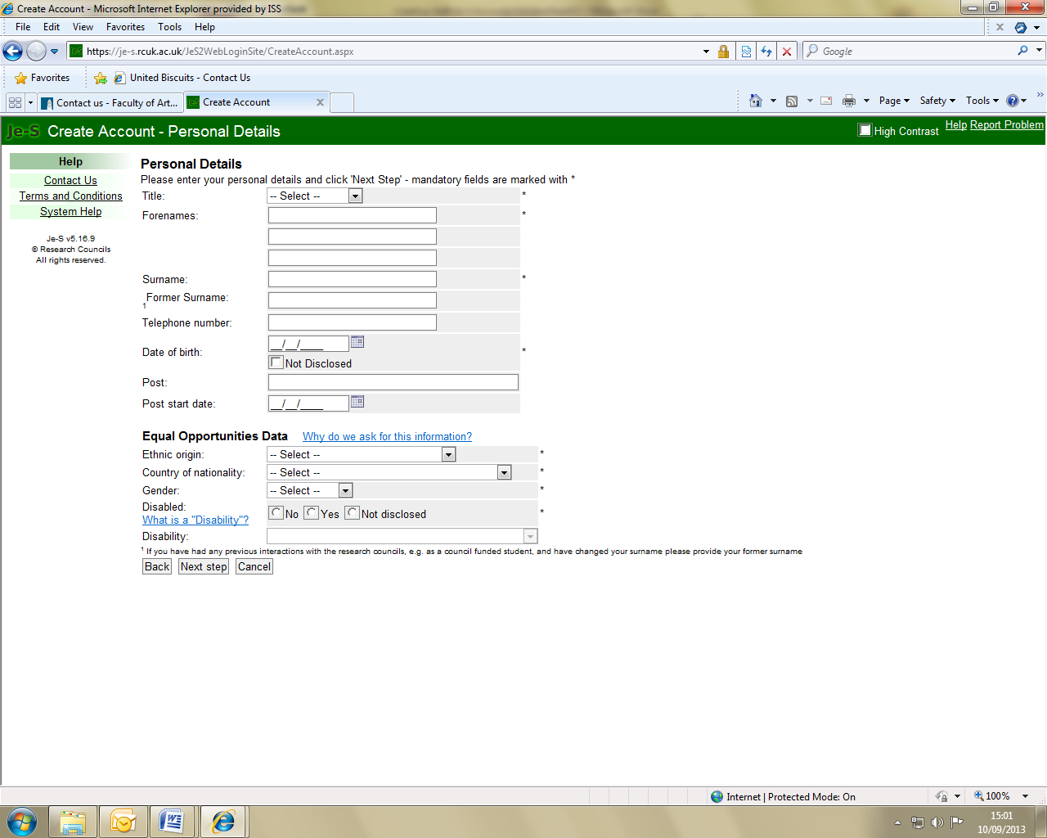

- Click on Next Step at the bottom of the page.

- The Qualifications screen will appear (this is an optional step).
- Enter your qualifications if you wish, click on Next Step.

- The Organisation screen will appear.
- Click on ‘Select Organisation’.
- Type University of Leeds then click on ‘Search’.
- Select University of Leeds which will then populate the Organisation box.
- Click on ‘Select Department’.
- Either type the name of the department you wish to select then click on ‘Search’, or scroll through the listed departments and click on your department to select it. This will populate the Department box.

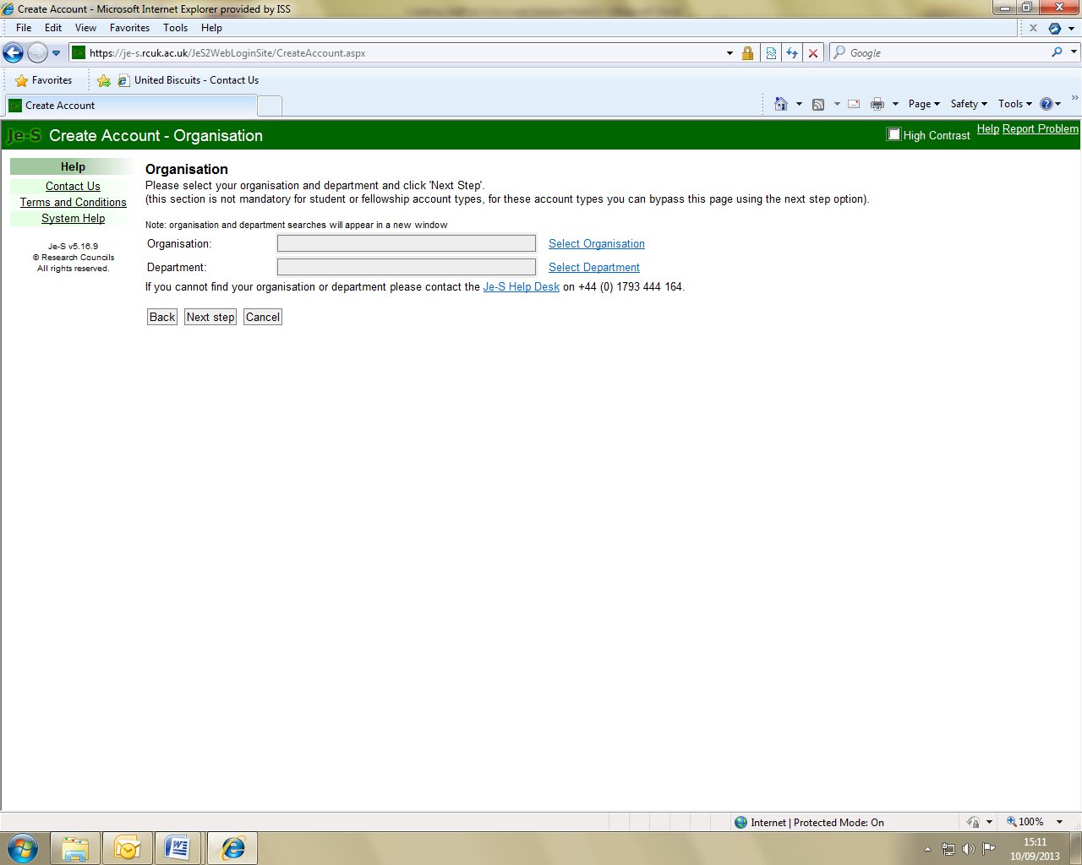

- Click on ‘Next Step’.

- The User Account Details screen will appear.
- Enter a user name, password etc.

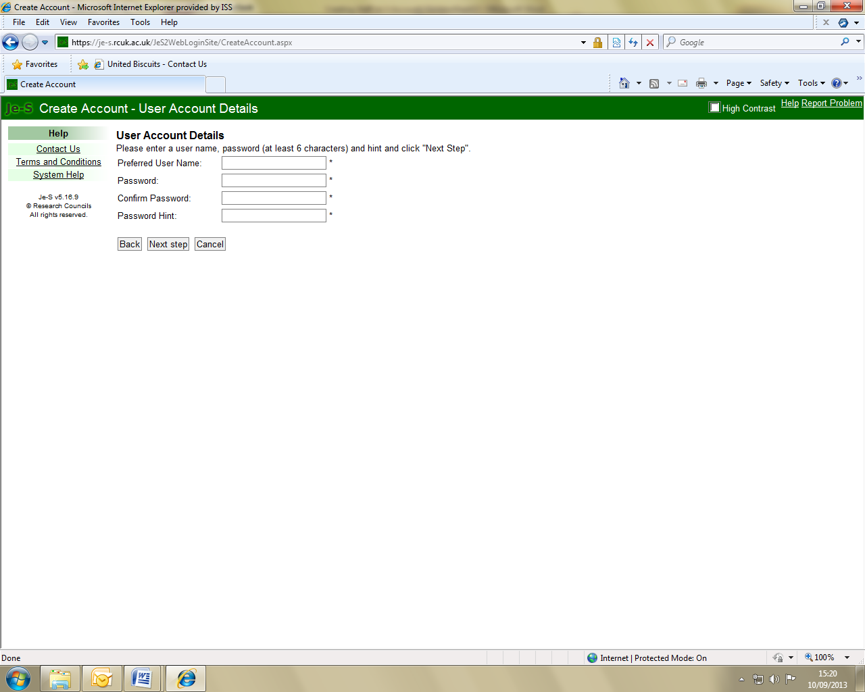

- Click on ‘Next Step’.

- The Confirm Details screen will appear.
- Check the information on the screen then click ‘Create Account’ (or ‘Back’ to make changes).
- The Account Created screen will appear which provides instructions on how to activate your account.

