Registration – 2022/23
Programmes and Assessment
Guide for School staff
Last review: 19/07/2022
Contents
Part 1: Registration 3
1.1 Staff and student resources 3
1.2 Registration dates, deadlines, and locations 4
1.3 Registration for new students 5
Registration criteria 5
Related processes 5
Pre-registration requirements 6
Part A: Online registration steps (via Minerva) 6
Part B: Online Identity checks (also student cards and BRPs) 7
Students with unusual situations and possible exceptions 8
Students with a disability 8
1.4 Registration for returners 9
1.5 Registration timeline 9
1.6 Student Loans for UK and EU students 10
1.7 Fees payment 11
1.8 Top questions 12
1.9 Technical tips 14
Student registration statuses 14
Banner screen SWATRAC 15
Holds on student records 16
International Foundation Year 20
Banner report SWRDEPT 20
Argos report “Monthly Registration Chase Up” 22
Part 2: Associated processes 24
Module enrolment 24
2.1 Enrolment dates 24
2.2 Student guidance 24
2.3 Staff guidance 24
2.4 Change of module 24
Change of programme 25
2.5 Change of programme 25
Part 3: Student contact from Admissions – September cohort 26
3.1 Welcome email to new UK UG students 26
3.2 Welcome email to new international/EU UG students 27
3.3 Welcome email to new UK TP students 28
3.4 Welcome email to new international/EU TP students 29
3.5 Welcome Guide for new students (accompanies other info) 30
Part 4: Student contact from Operations – September cohort 31
4.1 From Operations: returning students reminder email A 31
4.2 From Operations: all students reminder email B 32
4.21 All ‘EL’ students 32
4.22 New ‘RE’ students 33
4.23 Personal email reminder 34
4.3 From Operations: all students 5-day warning email C 35
4.31 All ‘EL’ students 35
4.33 Personal email reminder 36

Part 1: Registration

1.1 Staff and student resources
The Student Information Helpline can deal with general queries: +44 (0)113 343 7000 (outside UK and internal call transfers) // 0800 915 0402 (within UK)
studentinfo@leeds.ac.uk
The Registration team will help with registration queries via email only for 2022/23: registration@leeds.ac.uk
For clearly specific queries, students can be directed to the below areas for help answering their queries:
- Registration processes and basic troubleshooting: registration homepage
- Welcome information: Welcome homepage
- Username/password retrieval: basic troubleshooting in 1.8, then Student Information Helpline
- Online registration: use registration walkthrough download, then Student Information Helpline
- Fees: payments homepage, or
  - 0113 343 6700 –open Mon-Fri, 10am-12.30pm and 1.30pm-4pm
  - UGfees@leeds.ac.uk
  - PGfees@leeds.ac.uk
  - Sponsors@leeds.ac.uk (for sponsored student queries)
- University bursaries/funds: University funds page, funding@leeds.ac.uk or 0113 343 2007
- Student loan/NHS/other funding: external funding page, funding@leeds.ac.uk or 0113 343 2007
- Accommodation: accommodation pages, accom@leeds.ac.uk or 0113 343 7777
- Module enrolment: module guide page, catalogue@leeds.ac.uk see also Part 2 - Module enrolment
- Discovery modules: discovery module page, see also Part 2 - Module enrolment
- International students: Int welcome page, internationalstudents@leeds.ac.uk
- Study Abroad Office: sao@adm.leeds.ac.uk
- International Foundation Year: intfyear@leeds.ac.uk
- Doctoral College Operations: rp_student@adm.leeds.ac.uk
- UG/TP admissions (central): For internal use only tp_enquiry@leeds.ac.uk; ug_enquiry@leeds.ac.uk
This document contains key registration information, download more detail here including:
- Registration Online Steps Walkthrough (troubleshooting online registration)
- Registration Timeline September-start (timelines of deadlines and contact for September)
- Registration Timeline Schools Example Contact emails (template emails for above timelines)
- Registration Deadlines Year-Round (timelines of deadlines and contact for year-round)
- Registration reinstatement form (for schools to submit in cases where reinstatement required)
If you still have registration questions after reading this document and the resources above, contact registration@leeds.ac.uk.
Website links:
Student Registration: https://students.leeds.ac.uk/registration
SES Registration: https://ses.leeds.ac.uk/registration

1.2 Registration dates, deadlines, and locations
Students are required to register within the University deadlines – failure to do so results in the student being withdrawn from their course and the University. These deadlines are set out each year in a similar format (see section 1.5).
Registration opening dates (September cohort) | From
All returning taught students (undergraduate and postgraduate) | 1st August 2022
New taught postgraduate students | 1st August 2022
New incoming study abroad/exchange/Erasmus students | 1st August 2022
New undergraduate students | 1st September
Research students | one month before start date

Research students must register by the end of their start month. Taught students must register by the deadline dates set out in “Registration Deadlines Year-Round…” document (as a guide roughly by the end of their start month). As an example, September taught cohort key dates are:
- Step 1 (Registration opens): 1st August or 1st September 2022
- Step 2 (Warning date - Expectation for completing registration): 17th October 2022
- Step 3 (Withdrawal due to Failure to Register): 9am 31st October 2022
- Reinstatement deadline: 14th November 2022
See section 1.5 for further information on timelines.
Online registration and the identity check will both be done remotely.
Students with queries can make contact via:
Process | Contact details
General enquiries, including registration or central services help | Student Information Helpline:  studntinfo@leeds.ac.uk or telephone 0800 915 0402 (within UK) or +44 (0)113 343 7000 (outside UK)  or  Student Information Points (campus based support):  Locations and opening hours available at:  http://students.leeds.ac.uk/studentinformation
Student card & BRP collection | Information will be available at http://students.leeds.ac.uk/studentcard and the BRP collection webpage

1.3 Registration for new students

Registration criteria
All students must complete the online registration steps every academic year. This is where they:
- confirm we have the correct personal details and course information. This data can then be used by staff knowing that these details are accurate, as the student has checked their basic details at the start of the academic year.
- agree to the Student Contract. This can then hold students to account in occasions of misconduct. See http://students.leeds.ac.uk/studentcontract for web-version.
- agree payment arrangements for tuition fees as appropriate. This ensures that the University has agreements in place to receive the relevant tuition fee each year.
New students must also complete an identity check (NB: see Part B (page 8) for details of exceptions). New students are defined as those who are “beginning” a course (Banner Student Type “B” or “S”), usually coming through admissions. This includes students who have previously studied with us but are starting a new course e.g. undergraduate followed by a postgraduate.
This ensures we know the people studying with us are who they say they are, and they have the right to study. This is also important for immigration permissions for international students, for whom we must report back to the Home Office.

Related processes
- Some new students may need to have their qualifications checked before registering (see pre-registration requirements below). This is an admissions team process to ensure that we have a reasonable level of verification on entry requirements if the documents students have submitted with their application aren’t sufficient. For those completing A-levels within the year directly prior to entry, these are confirmed electronically to us via exam boards.
- Once students have submitted their identity check documents, this will be logged and marked in Banner once the documents have been checked. Students will then be invited to book an appointment to collect their student card and BRP (if applicable) when they arrive in Leeds. The student card itself is not a requirement of registration. The student card is still required for accessing the Library and other restricted access areas, accessing some healthcare placements, and completing in-person examinations.
- After registration has been completed to the relevant requirements (see 1.6), the Funding team can confirm to the Student Loans Company that a student has fully registered for their course, which is a requirement for the release of UK government student loans. For more information see 1.6.

Pre-registration requirements
New students will need to:
- Wait until the allocated “accounts live” date (see 1.2)
- accept their unconditional offer before their general student account is generated and pay their tuition fee deposit if needing a visa to study
- if requested, present their academic qualifications in person (individuals will be contacted with details by the relevant Admissions team if this is required).

Part A: Online registration steps (via Minerva)
Students complete the online element of registration through Minerva (Student Services). The online registration steps confirm details about the student, their studies and fee payment, as well as confirming their agreement to the Student Contract.
The final stage has the "Registration Certificate" (this is NOT confirmation of completing FULL registration – identity checks may still be outstanding for new students).
For staff, our full walkthrough of online registration titled “Registration Online Steps Walkthrough” can be downloaded from https://ses.leeds.ac.uk/registration from August 2022.
See 1.8 for troubleshooting tips on retrieving a username and password and logging in to Minerva.

Part B: Online Identity checks (also student cards and BRPs)
Identity Checks
Identity checks for all new students are conducted remotely. Students complete a Microsoft (MS) Form and upload a copy of their accepted form of ID and a passport style photo for their student card. This will then be checked by the SSC team and Banner will be updated accordingly. The MS Form is accessible to students on the For Students identity check webpage (https://students.leeds.ac.uk/idcheck).
New students need to complete an identity check online, and for international students, after arriving in the UK. Information about how to complete the identity check remotely will be on the student identity check page: https://students.leeds.ac.uk/idcheck
Documents required for the remote identity check are:
- UK/Ireland - passport
If a UK/Ireland Student Does Not Own a Passport: apply for a passport; if unable to, then complete an Identification Verification Form. This needs to be countersigned by a professional and uploaded with a copy of their birth/adoption certificate. A download of the form can be found at: http://students.leeds.ac.uk/download/6829/identification_verification_form
- International/EU/EEA – passport, immigration permissions (further guidance available at https://students.leeds.ac.uk/info/10102/registration/1055/what_you_will_need_to_register, and students will be guided through the documents they need to provide when completing the MS Form)
The Form guides the student as to which documents to upload, you do not need to advise them any further.
Student Cards and BRP collection
Locations for the student card/BRP collection will be provided to the student upon booking their appointment. Updated guidance/information will be available on http://students.leeds.ac.uk/studentcard.
Student Cards for new students will be issued on campus and appointments to collect these will be bookable via Eventbrite. The preferred option is for passport style photos to be uploaded using the MS form as part of the identity check. The SSC team will facilitate a photo upload at the Student Card collection as a contingency. Guidance will be updated on http://students.leeds.ac.uk/studentcard.
UK/Ireland/EU/EEA students
Students who are arriving on campus (i.e. not studying remotely) can book an appointment to collect a student card. Students will be invited to book the appointment when their submitted identity check documents have been checked and the identity check marked as complete on Banner. Further details will be on the student card page: http://students.leeds.ac.uk/studentcard
International students
Some international students will need to collect a BRP (Biometric Residence Permit) from the University. These students will need complete the online identity check when they have arrived in the UK, then book an appointment to collect the student card and BRP when invited to.
During the identity check process, students subject to visa regulations may be asked to see one of our Student Visa Advisers before their Student ID Card can be issued. This is nothing to worry about, but is an essential check to ensure the University complies with Home Office regulations and that the students receive immigration advice early if required.
Chasing up students
There is a delay between the student submitting their documents, staff checking the documents, and Banner being updated. If a student informs you, they have submitted you do not need to pressure them for screenshots or evidence. Due to this delay we are not asking school staff members to chase up students for an identity check as whether a student has submitted can only be checked by central teams.
Identity check exceptions:
There is a small exceptions list of courses where the identity check is not required, and instead only online registration needs to be completed to be considered fully registered. This covers courses with minimal campus contact time (under ~30 days), principally distance learning courses, or current University staff. The list is available from the Argos report “RE students with no ID check” under the “Exempted Programmes” tab (report found under General>Registration).
However, if any students on these courses has a UK government student loan or if they are an international or if they have a Student Visa coming to the UK, they WILL still need to complete the identity check regardless of this caveat. This is for the Funding team to confirm their registration and attendance to the Student Loans Company and is a requirement by UKVI requirement we check students have the right to study if they are in the UK for the purpose of study.

Students with unusual situations and possible exceptions
Nonstandard circumstances apply to these groups of students as described below. They may or may not be exempt from parts of the Registration process or fall outside standard guidelines depending on their situation.
- External students: these students do not register until they return as an internal student – this is part of the conditions of external student regulations. This is found on the For Students webpage - external and carried module resits.
- Incoming Study Abroad/Exchange/Erasmus: these students can register online before 1st September and will receive communications from the Study Abroad Office on how to register. Module enrolment is also managed by the Study Abroad Office.
- International Foundation Year: Some of these students may be completing a “study group” course with a partner institution – these students have a 7 digit ID number and should be directed to the International Foundation Year team (IFYAdmissions@leeds.ac.uk).
- Exceptions list to ID check: these are courses with minimal campus contact, often but not exclusively distance learners, see “Part B” earlier in 1.3.
- Students who have previously studied with us: these students will have their old password still active, so if they retrieve a default password with their username, this will not work. If they do not remember their old password, they will need to reset their password (see 1.8).

Students with a disability
While our campus has facilities for physically disabled students, we also seek to be considerate of less visible disabilities. Staff will always keep an eye out to ensure students are fine in the main registration venues. Specific requests for additional support when/if collecting a Student Card and/or BRP, will be handled on a case by case basis. If you have any students who request specific support, please contact ssc@leeds.ac.uk in the first instance.

1.4 Registration for returners
Returning students (Class code 02 and above) only need to complete part A (the online registration steps), as their qualifications and identity have been verified at the start of their course.
For returning undergraduates, the Schools progression exercise controls whether a student can register online. It is vital that progression codes are accurately and promptly input by parent Schools for all undergraduates expected to return next session and updated where relevant after the resit period.
Students undertaking a year abroad/year in industry in the current academic year:
This group of students will be expected to register online from 2 August 2022 as with all other returning students – this is a common source of confusion.
Temporary leavers due to return in September:
Schools should start the returner process by informing Operations (studentrecords@adm.leeds.ac.uk) who will build a record for the student in the new term. If the withdrawal was on health grounds the student must supply written evidence from a doctor stating that they are fit to return to their studies before being re-admitted, Schools are asked to confirm receipt of this to Operations so the medical hold can be removed. Ideally schools should contact the student 1-2 months before their return so record updates can be made in a timely manner.
Returning September-start students: to be able to complete module enrolment for the coming September, Schools need to confirm return from leave before module enrolment opens in early summer. For more information see http://ses.leeds.ac.uk/info/21640/student_leavers.

1.5 Registration timeline
The registration timeline uses the following steps:
- Registration opens: Schools contact returners twice about registration, new students once
- Warning date: Operations will prompt Schools contact all students who are not yet registered. Operations will also issue a five-day warning email to students 5 days prior to step 3.
- Withdrawal: Student accounts are updated to “withdrawn due to failure to register” – reinstatement request forms (found at ses.leeds.ac.uk/registration) can be made by Schools in subsequent two weeks, after which students must also provide a written statement.
Emails from Operations to Schools correspond with these deadlines. This information and more is presented in our summary documents, downloadable at https://ses.leeds.ac.uk/registration:
- “Registration Timeline September-start” (detailing September cohort deadlines and highlighting the points of communication with students by different departments)
- “Registration timeline schools example contact emails” (supplementary document containing useful email templates to match timelines, for all cohorts)
- “Registration Deadlines Year-Round” (for cohorts starting outside of September)

1.6 Student Loans for UK and EU students
Notes on student loan terminology
The Student Loans Company (SLC): the umbrella organisation that covers the student loan companies for England (Student Finance England), Wales (Student Finance Wales), Scotland (Student Awards Agency Scotland) and Northern Ireland (Student Finance Northern Ireland). Students will often know the company under the general name “Student Finance”.
The Student Support Number (SSN): one of two identification numbers a student will receive from the SLC, the other is the “customer reference number” but this is not the number that the University requires.
NB: it is possible (though uncommon) for students to gain student loans from external private companies, however we do not have the same agreements in place as below regarding fee payment.
Note, it is important that the student has an approved loan - their online student loan application will clearly be marked “approved” when they log in (this is not something Schools can see). The University will not receive the SSN until the loan is approved. If the student is having difficulty gaining approval on their loan and wishes to gain further advice about the circumstances of this, please ask the student to contact funding@leeds.ac.uk using their University email account and stating their student number.
Student Loans Company maintenance payments
In order for the maintenance loan payments to be released, students have to have had an Identity Check marked as complete on their student record.
The University receives a daily file from the Student Loan Company and - provided all of the required elements are in place - the Funding team will confirm student attendance.
As well as completing registration (including online registration and the Identity Check), students must have:
- returned their signed declaration to SFE (or the equivalent awarding body)
- had their National Insurance No. checked by SFE (or the equivalent awarding body)
- provided their bank details to SFE (or the equivalent awarding body)

Further Funding links: http://students.leeds.ac.uk/info/21508/student_loans/677/if_your_student_loan_is_delayed
http://students.leeds.ac.uk/info/21508/student_loans/764/changes_in_circumstances
For tuition fee loans, please see next section.

1.7 Fees payment
All students must ensure they make arrangements for their tuition fees to be paid. They can make arrangements as part of the online registration process. Schools can see the student’s tuition fee on SWATRAC in the “Fee” field – this is the total fee that the student is responsible for in each academic year (this figure in SWATRAC won’t change even when they have made a payment towards it). Only manually amended charges or overdue prior charges will show in the “Overdue Debt” field on SWATRAC, not the balance for the current session still to pay.
See 1.9 Banner screen SWATRAC section for more detail.
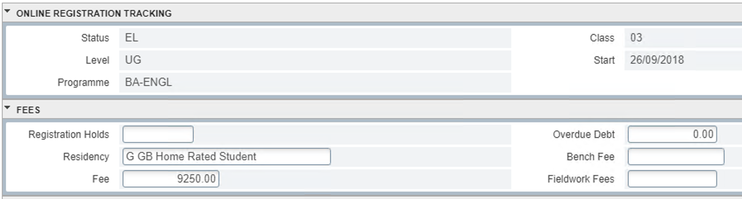
There are many ways that a student can arrange for their fees to be paid. The Fees “tuition fee payment” page is full of information regarding all aspects of fee payment: https://students.leeds.ac.uk/info/10210/paying_fees_and_charges
Tuition Scholarships
If tuition fees are being paid (in full or part) by a University of Leeds scholarship the student should be sent a scholarship award letter and Student Fees require an FA1 Form (sent to fa1@leeds.ac.uk) by an authorised signatory before the student attempts registration. More information and the FA1 template are on the "Tuition fee scholarships and awards" staff page: http://ses.leeds.ac.uk/info/21720/fees_and_charges/839/tuition_fee_scholarships_and_awards
Sponsored students
Students with a sponsor must send their sponsor letter to Sponsors@leeds.ac.uk. When Fees have processed the sponsor letter, they will update the student’s record and you will be able to see the confirmed sponsor details on SWATRAC. Only after this can the student complete the Fee Payment Arrangements section of Registration.
Payment by More than One Method
Each student is responsible for making arrangements for their entire fee, they may need to make payment using multiple methods as listed on the student “how to pay” pages.
For example, if a student is receiving partial funding from a sponsor or the SLC, they must make arrangements to pay the remainder. They can do this by either making a one-off payment or setting up an instalment plan. For the standard instalment plan, each instalment will be for 50% of the remainder of their fee.
To put the example in figures: if an undergraduate student’s total fee is £9250 and the SLC are paying £5000 towards it, the remaining fee is £4250 and so each instalment will be for £2125.
Students with an approved Postgraduate Student Loan can pay in three equal instalments using the “PG Loan” instalment option.

1.8 Top questions

Question | Answer
What will I need to register? | A full list is at: http://students.leeds.ac.uk/info/10102/registration/647/what_you_will_need_to_register
Why do I need to register if I have already chosen my modules? | Module enrolment is not confirming you will be studying, only registration confirms this. You need to agree to the terms and conditions of study for the academic year (as in the Student Contract) and confirm fee payment arrangements.
I can’t retrieve my username and password. | Ask the following to see if these resolve the query first:  - Are they entering their university ID (not their UCAS number)?  - Have they got a “current student” record yet/accepted an unconditional offer (and paid tuition fee deposit if applicable)? Did they accept their offer today? (3 working days required for student record and IT account to be fully generated)  - Are they attempting to retrieve their log in before their registration opening date? (see 1.2)  - Do they have a registration hold? (if so refer to relevant team in list of holds – 1.9, page 18)  If the issue remains, refer via email to the Registration Helpline.
My username and password won’t let me log in. | - Direct students to the How to Register webpage – gives guidance on logging in for the first time via Office365  - Check they have entered specifically their username@leeds.ac.uk  - Check if they studied with us before – if so, the password will be their old password and will need to request IT reset this if they do not remember it.  - Check they have copied the password exactly (we do not want to know the password!), and reset the password if they have been prompted to do so  - Ask if it states they need to wait 30 minutes and if so, ask them to try again in 30 minutes  - Check SWATRAC to see if there is an RG hold and refer to holds list if so (in 1.9, page 18)  If the above does not help ask them to reset their password, they can either visit http://passwordreset.leeds.ac.uk/ or contact the IT Service Desk.  Password reset information can be found at this link.
I can log in but it says I can’t register (holds) | Lots of different reasons, the particular reason will be specified on the screen. Please see “Registration holds” in section 1.9.
I can't get past Step 6 - fee payment arrangements | Common reasons for this include delayed bank transfer, students awaiting sponsor letters and delays with Student Finance loan approval (Student Support Number needs to be present in SWATRAC). Fees related problems should be sent to UGFees@leeds.ac.uk (for undergraduates) or PGFees@leeds.ac.uk (for postgraduates).
Where do I get a bank letter to open a UK bank account? | Please provide information as at http://students.leeds.ac.uk/info/21503/welcome_and_arrival/671/opening_a_uk_bank_account
I haven’t got my Student Finance loan – why? | The student must complete registration fully (inclusive of identity check if new) for the Funding team to confirm the student is attending/engaging. This confirmation is the trigger the Student Loans Company (SLC) use to release the student’s maintenance loans.  Providing the student has satisfied all of the SLC conditions, the first instalment should arrive within 3-5 working days or on their first instalment date, whichever is later. The instalment dates are provided to all students when their loan is approved (see http://students.leeds.ac.uk/info/21508/student_loans/677/if_your_student_loan_is_delayed). If the student isn’t sure whether they have satisfied the conditions of their loan, the above page provides details on how to check their account status.
Where and how do I get my BRP (Biometric Residence Permit)? | Please provide information as at http://students.leeds.ac.uk/info/21506/your_visa/974/collecting_your_biometric_residence_permit  Students must have submitted their identity check documents first and had these checked, and their BRP must have been delivered to the University. They will be invited to collect their BRP when both conditions are fulfilled.
What documents do I need for my identity check and how do I complete this? | Please provide information as at https://students.leeds.ac.uk/idcheck
I need a replacement student card | Please provide information as at: http://students.leeds.ac.uk/studentcard
I can’t access the ID check form | Please see ‘Issues accessing the online form’ on https://students.leeds.ac.uk/idcheck

1.9 Technical tips

Student registration statuses
Student status can be seen on both SWATRAC and indicates the student’s eligibility to register online. Below is a table of all the student statuses you might see, and what they mean.
Tip: The most common statuses will be EL (eligible to register), RE (registered online) and NR (not eligible to register). Students who took August resits will be NR until the School has received marks and entered a progression code.
Status | Full title | What does it mean? | Steps to take
EL | Eligible to register | The students should be able to proceed through registration (unless they have holds – see holds table on page 16). | Check for holds – follow advice on holds table (page 16).  Troubleshoot the registration step where the student is having problems (see “online steps walkthrough...” doc).
RE/RO | Registered | The student has completed the online registration process. They may or may not have completed their identity check. | If the student doesn’t remember completing the process: check SWATRAC on Banner, or ask Operations to check the record.  If the student hasn’t completed identity check: provide guidance as in 1.3.
NR | Not eligible to register | The School has indicated the student should not be able to register at this time (often due to pending August resit results). | Enquiry to be dealt with by parent School.
EF | External full year | The student is resitting/resubmitting assessment(s) without attending teaching. They do not need to register online, but they do need to apply for their resits. | If the student has not applied for their resits: enquiry to be dealt with by the contact assigned to the student’s department in Examinations.
EP | External part year
NA/SP/  CS/SF | Temporarily withdrawn | The student is on a period of temporary leave and is not expected to re-register at this time. | If student is returning now: enquiry to be dealt with by the parent School who will need to confirm the student’s return to Operations.
NS | No show | The School has informed us the student has not arrived for the course, or student has declined their offer in CRM (TP only). | If student is here and ready to attend: enquiry to be dealt with by the parent School or relevant Admissions team.
WD/  WA | Withdrawn | Student permanently withdrawn from the University – not expected to register. | If student thinks this is incorrect – ask Operations to check record.

Banner screen SWATRAC
To view an individual student and details on how far the student has progressed with the online registration steps (view only).
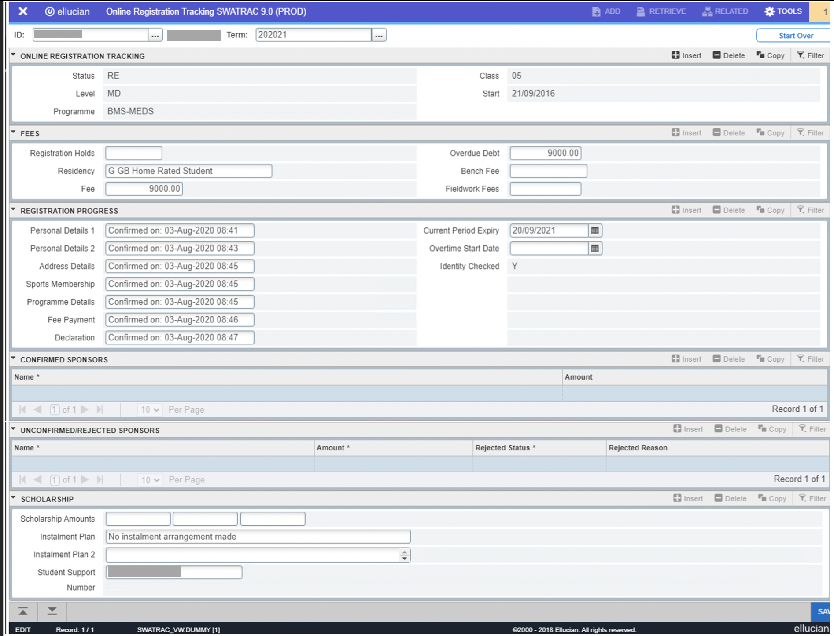
SWATRAC shows you:
- Registration status
- programme /year of study (class)
- Any registration related holds (see 1.9 holds section)
- full fee
- overdue debts they may have (from previous academic years)
- how many steps of online registration have been completed
- whether the student has completed an identity check
- sponsorship and scholarship information
- instalment plans the student has set up
- their Student Support Number (if applicable) – this needs to be present for a Student Loans Company tuition fee loan to be acknowledged on step 6 (fee payment) of registration

Holds on student records
Holds are a way of preventing students from proceeding past a certain point of the Registration process, or from being able to log in to their account at all. Only the RG hold locks new student accounts, meaning they usually can’t log in using their username and password (unless they were a previous student here). Other holds display a message on the student’s registration page explaining why registration is blocked.
Holds are administered by different teams depending on what they are for. Below is a table of hold codes you may see (in the Holds field on SWATRAC), what they mean for the student and what you should do if you see one. NB: the hold text examples are illustrative and may be subject to change.
Contact details are at the start of this document or otherwise stated in text.
Hold | What it says | What it means | Student enquires - what to do next?
RG  Registration Hold | You are not eligible to register due to a Registration Hold.  You should have access to this page around 30 days before your programme start date. Please contact registration@leeds.ac.uk for advice if you are within 30 days of programme start date and be sure to include your Student ID number. | The student is not eligible to register at this time (generic hold applied by Operations). | Ask Operations to check the record to see why the RG hold is there. Operations will advise what you should tell the student.
QUAL  Qualifications Hold | Qualifications Required  Although you are eligible to register, the University may need to verify the original or certified true copies of your academic qualifications and translations before you can begin online registration. Separate guidance for taught postgraduate (Masters) and undergraduate students is provided below.  For any specific queries regarding the qualifications required, please contact your School directly.  Taught Postgraduates  When you begin your course, new taught postgraduate (Masters) students (except University of Leeds graduates) may need to show the original or certified copies of your qualifications before being able to access online registration. More information will be provided to those who need to provide further documentation.  The Registration team cannot update any qualifications information, please contact your School directly.  Undergraduates  If you completed your qualifications before this year, or outside the UK, you may need to show the original or certified copies of your qualifications when you begin your course before being able to access online registration. More information will be provided to those who need to provide further documentation.  The Registration Helpline cannot update any qualifications information, please contact your School directly. | The student has yet to provide proof of their previous qualifications. | If QUAL hold on, ask if student has received guidance from the relevant Admissions team on which documents must be provided/where to go. If not, contact relevant Admissions team.  If they have received guidance and already provided the documents, must wait 24 hours.  If waited 24 hours, forward the enquiry to the relevant School Admissions team who will advise the student and remove the hold if possible.
U18  Under 18s Admissions Hold | Consent Form  Due to you being under 18 at the commencement of your studies you must return the signed parental/guardian consent form to the School/Department admissions team in order for you to complete registration. Please contact your School (subject department) directly if you have any queries. | The student has not returned the parental/guardian consent form, or their School have not sent this to Taught Admissions. | Advise the student to send their parental/guardian consent form to their School.  If already done, check with School/Taught Admissions. Send through to ug_enquiry@leeds.ac.uk with the email subject title as Removal of U18 Hold and include in the email the applicant name, UCAS and Banner ID and confirmation you have received the parental consent forms.
RM  Medical Hold | Return to Study note required  You must provide your Parent School with a return to study note from your Doctor stating that you are fit to return to your studies.  If you have further queries, please contact your School (subject department). | The student has been on temporary leave due to illness and needs to provide a” fit to return” note. | Advise the student to provide a note from their doctor stating that they are fit to return to studies to their Parent School (who can then confirm receipt to Operations, and the hold will be removed).
RV  Visa Hold | Visa Hold  You are not eligible to register due to a Registration Visa Hold.  if you do not have a new visa, please email studentvisaadvice@leeds.ac.uk for advice.  If you have your new visa, please email BRP@leeds.ac.uk with your student number, and copies of your Passport and Visa, where staff will be able to advise you and remove this visa hold. | The student has changed the duration of their course and needs to provide new visa details. | Advise the student to contact the Student Services Counter (BRP@leeds.ac.uk) for it to be checked (the hold can then be removed.) If they do not have a new visa, advise them to contact the International Student Advice team (internationalstudents@leeds.ac.uk).
IC  Identity Check | Identity Check  You have not yet completed an Identity Check for your course of study - this must be completed as described on our registration pages.  You must be in the UK to complete your Identity Check.  After you have completed your Identity Check, please email BRP@leeds.ac.uk to let us know you have completed your Identity Check. A member of staff will then check your documents and, if no further information is required, they will remove your hold and email your student email address to let you know you can complete your online registration.  Please include your student number when you email BRP@leeds.ac.uk. | The student has not completed an identity check.  This hold is being used for returning students who have not completed an identity check (due to remote study), and students who are coming back from temporary leave and have not completed an identity check. | Ask student to complete the identity check remotely as directed on http://students.leeds.ac.uk/idcheck.
RD, R1, R2, R3, R4  Research Degrees Holds | R1: You are currently not eligible to register as we require confirmation of your academic qualifications. Please provide a copy of your certificate and transcript to Doctoral College Admissions - rp_applications@adm.leeds.ac.uk.  Other R holds similarly refer Student to Doctoral College Operations. | The student is a Research Postgraduate (RP) student and cannot proceed in registration for one of several reasons. | Forward the enquiry to Doctoral College Operations rp_applications@adm.leeds.ac.uk. (who will be able to further advise the student/remove the holds when appropriate).
S1, S2, S3  School research holds | Hold messages asks student to contact their school (does not specify contact details). Ask student to quote message for detail. | The student is a Research Postgraduate (RP) student and cannot proceed in registration for one of several reasons. | Forward the enquiry to Doctoral College Operations rp_applications@adm.leeds.ac.uk. (who will be able to further advise the student/remove the holds when appropriate).
H1, H2, H3  Healthcare/LICAMM Holds | Hold states various reasons for not being able to register and contact instructions for who to talk to. Ask student to quote message for detail. | The student is a Healthcare Studies/LICAMM student - they automatically apply holds to all their students for various reasons. | The student should contact the listed department contact details (generally provided in the holds text).
FI  Finance (Fees) Hold | Hold message states need to contact fees due to outstanding debt. Ask student to quote message for detail. | The student needs to make an outstanding payment before they can proceed. | Transfer or forward enquiry to Fees (they will investigate and contact the student to advise/ remove the hold if appropriate).
EX  Examination (often healthcare) | Medicine Students  Your module results from the August 2022 assessment period have not yet been confirmed. You should re-visit the registration system to complete your registration from mid-September onwards.  If you have any queries please contact:  BSc Healthcare Science (Audiology) Email: somarcs@leeds.ac.uk  BSc Healthcare Science (Cardiac Physiology)Email: somarcs@leeds.ac.uk  BSc Diagnostic Radiography Email: somarcs@leeds.ac.uk  Healthcare Students  Your examination results are not confirmed. You should re-visit the registration system to complete your registration from mid-September onwards. Please email reception@healthcare.leeds.ac.uk for further advice.  All other students should check with their Parent School as to when they will be able to complete registration. | The student is still due to get examination results through for their previous academic year. | The student should either wait for their results to be provided (there will be a date quoted on the message by which these are released) or enquire with their parent School for an update on the progress of their results.
IF  International Foundation Year | International Foundation Year  You will NOT be able to register until you have contacted the International Foundation Year Office. Please email IFYAdmissions@leeds.ac.uk for further guidance.  The International Foundation Year Office is in Room 12.01, International Pathways Centre in the Marjorie and Arnold Ziff Building on the University of Leeds campus. | The student has not yet contacted the Foundation Year office, where they need to confirm qualification and ID. | Advise the student to contact IFYAdmissions@leeds.ac.uk with their original qualification documents and ID documents.
LN  Language requirements | You are currently not eligible to register as an original English Language qualification is required - for full details please see your current offer letter. If you have further queries please contact rp_applications@adm.leeds.ac.uk | The student has not yet provided proof of their language qualifications to Doctoral College Operations. | Refer to Doctoral College Operations- rp_student@adm.leeds.ac.uk
AT  ATAS hold | ATAS clearance  The University is awaiting notification from the Home Office of your ATAS clearance. Please contact brp@leeds.ac.uk for further advice. | Certain programmes require this visa for some student visa in addition to their visa. This may be for new or returning students. | Email brp@leeds.ac.uk for further guidance
AR  Accounts receivable | Hold error message states need to contact fees due to outstanding debt. Ask student to quote message for detail. | This hold does NOT stop registration, only graduation. | Forward enquiry to Fees (they will investigate and contact the student to advise/ remove the hold if appropriate).

Banner report SWRDEPT
To check who will be able to register online, who has registered once registration is open and what data the student record contains including number of credits students are enrolled for, modules on their record, and expected completion date. If you choose to view all the modules a student is enrolled for, the output is as follows:
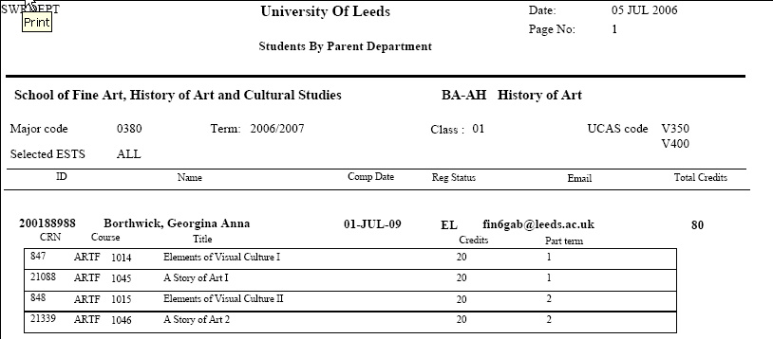
SWRDEPT
If you choose NOT to view the modules a student is enrolled for, the output is as follows: 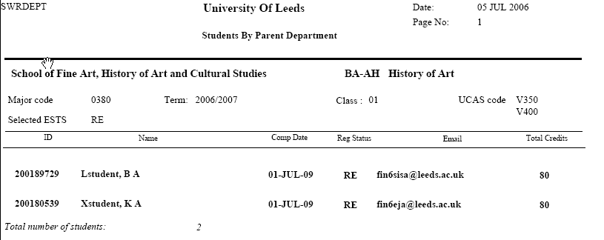

Argos report “Monthly Registration Chase Up”
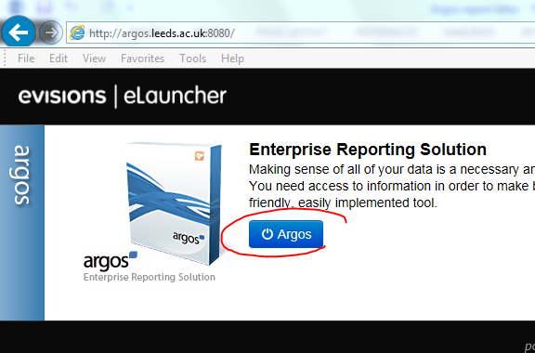
To access an Argos go to http://argos.leeds.ac.uk:8080 (in Internet Explorer) and click the Argos button. Log in using your normal username and Argos password (if you do not have access you will need to request it via https://it.leeds.ac.uk/it?id=kb_article&sysparm_article=KB0011496).
Navigate to > General > Registration > “Monthly Registration Chase Up”. Double click on “Monthly Registration Chase Up”.

Click on “Run Dashboard” and enter your information into the form (see below). For Registration status, select “Unregistered ESTS codes” to ensure you can chase EN and ER students as well as EL students (see registration status list). In the top right ‘Report Options’ dropdown, select “Monthly Registration Chase Up Report” and select the button that reflect whether you want to save/open/email the report.
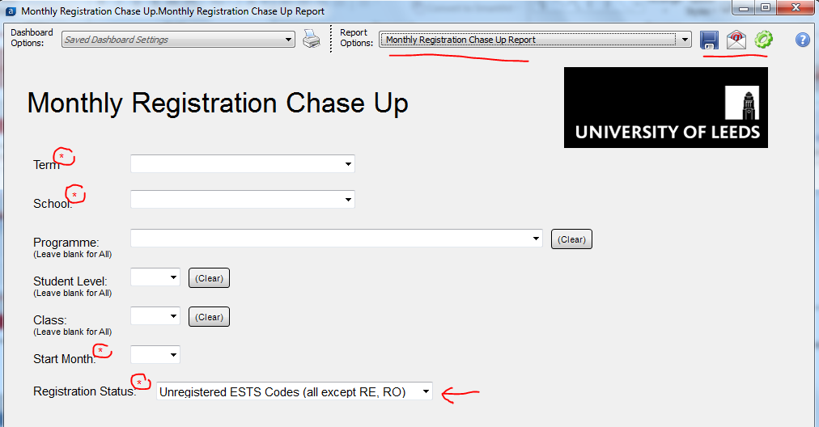

The report will be displayed.
All students returned on this report should be contacted by School staff, using the templates available in the “Registration timeline schools example contact emails” download, from https://ses.leeds.ac.uk/registration.

Part 2: Associated processes

Module enrolment
The online registration process does not include module enrolment – the two processes have been separated. Students do not need to be registered to complete module enrolment. Information provided below is brief, further information can be found at students.leeds.ac.uk/modules and ses.leeds.ac.uk/enrolment.
If students are studying on a programme which requires them to choose optional and/or discovery modules then most will complete this first-come, first-served process online through Student Services.

2.1 Enrolment dates
Module enrolment takes place in May for returning students and September for new students. Postgraduate students will be advised by their Parent School if/when the module enrolment system is available to them.
Enrolment dates for the upcoming academic year can be found at students.leeds.ac.uk/whentoenrol

2.2 Student guidance
Information detailing how to navigate the online enrolment system, including a step-by-step guide for students, can be found at students.leeds.ac.uk/howtoenrol

2.3 Staff guidance
Information relating to the module enrolment exercise, can be found on the Staff SES website at ses.leeds.ac.uk/enrolment.

2.4 Change of module
If a returning student has undertaken online module enrolment and wishes to change these choices (drop and/or add modules) they should be asked to complete a Change of Module form – guidance can be found here: https://students.leeds.ac.uk/info/10104/making_changes/652/change_of_module
Change of Module forms must be agreed by both the Teaching and Parent School (where they differ). The Parent School will update Banner as necessary, adding and dropping the relevant modules and will retain the change of module evidence.
The Parent School is responsible for updating and checking the modules on their students’ records to ensure they comply with the rules for each particular Programme of Study. A number of reports, (Banner and ARGOS) are available to assist with checking.
For further information please visit ses.leeds.ac.uk/info/22108/registration_enrolment_and_attendance/937/change_of_module

Change of programme

2.5 Change of programme
Students will not be able to change their programme of study as part of online registration. However, they will be asked to confirm their programme of study as part of the online registration process. If they are unable to provide this confirmation because they wish to change their programme of study, they are asked to contact their Parent School. They should not confirm their programme of study if this is incorrect, as this has a direct link to the fee they will be charged.
Please check the following pages for the most up to date guidance on the process students should follow if they wish to change their programme:
ses.leeds.ac.uk/info/22108/registration_enrolment_and_attendance/938/change_of_programme
https://students.leeds.ac.uk/info/10104/making_changes/650/transfer_to_a_new_programme
When Changes of Programme are approved by both current parent and new parent School (if different), the accepting/new parent School can then update Banner (as is the current process for change of programme during the academic year). The NEW parent School will then be responsible for advising the student that they can then go online, confirm their programme and continue to complete online registration.

Part 3: Student contact from Admissions – September cohort
The communications in this section are used for the main September cohort intake ONLY.
This is NOT intended for use by Schools, Schools email templates are provided in the document “Registration timeline School template emails” downloadable from https://ses.leeds.ac.uk/registration.

3.1 Welcome email to new UK UG students
Automatically sent from 18th August if student record has been generated
Subject line: WELCOME TO LEEDS

Dear [first name],

Student ID number: [student ID number]

Congratulations on gaining your place at the University of Leeds to study [course name]. We’re really pleased you’ve chosen to study with us.

It means you can now officially get excited about all the amazing things that your university experience will bring.

Getting started
Our online Welcome Guide covers everything you need to know about joining us. It includes a simple list of 10 things you need to do to help you get started and feel more prepared.

Learning and teaching
We want you to have the best possible learning experience, where you can actively engage with the people around you. As well as your learning and teaching on campus, you'll also benefit from a variety of digital technologies to enhance your learning experience.

We'll email you again in the coming weeks with more information about getting started on your course, including your specific University school or faculty welcome and induction activities.

Registration
Your student number is included in this email, which you’ll need to start online registration from 1 September 2022. You’ll find details about how to register on our online Welcome Guide.

Accommodation
If you applied for University accommodation before the deadline we'll email you separately, so check your emails regularly, including your junk mail. If you've yet to apply, contact our Accommodation Services for information about the next steps on 0113 343 7777 or email accom@leeds.ac.uk.

Help and support
If you need help or you have any questions, let us know by contacting our Student Information Service.

We understand that you may have concerns about the ongoing COVID-19 situation and your plans to study with us at Leeds. Keep checking our website for the latest updates.

We're really excited to welcome you to our community and help you settle into university life.

Best wishes,
Lisa Summers
Head of Admissions

3.2 Welcome email to new international/EU UG students
Automatically sent from 18th August if student record has been generated
Subject line: WELCOME TO LEEDS

Dear [first name],

Student ID number: [student ID number]

Congratulations on gaining your place at the University of Leeds to study [course name]. We’re really pleased you’ve chosen to study with us.

It means you can now officially get excited about all the amazing things that your university experience will bring.

Getting started
Our online Welcome Guide covers everything you need to know about joining us. It includes a simple list of 10 things you need to do to help you get started and feel more prepared.

Take some time to read through everything before you start your journey to Leeds. We’ve included lots of advice to help you prepare for coming to the UK, as well as information about the travel and arrival support we’ve put in place for you.

Learning and teaching
We want you to have the best possible learning experience, where you can actively engage with the people around you. As well as your learning and teaching on campus, you'll also benefit from a variety of digital technologies to enhance your learning experience.

We'll email you again in the coming weeks with more information about getting started on your course, including your specific University school or faculty welcome and induction activities.

Registration
Your student number is included in this email, which you’ll need to start online registration from 1 September 2022. You’ll find details about how to register on our online Welcome Guide.

Accommodation
If you applied for University accommodation before the deadline we'll email you separately, so check your emails regularly, including your junk mail. If you've yet to apply, contact our Accommodation Services for information about the next steps on +44 (0)113 343 7777 or email accom@leeds.ac.uk

Arriving
There’s lots of information on our website to help you plan your journey Leeds. You’ll also be able to book your arrival support, including our airport pick-up service available from Leeds Bradford Airport and Manchester Airport.

You should apply for your visa as soon as possible to make sure your arrival in Leeds is not delayed. If you expect there to be a delay in getting your visa, contact your academic school to let them know.

Help and support
If you need help or you have any questions, let us know by contacting our Student Information Service.

We understand that you may have concerns about the ongoing COVID-19 situation and your plans to study with us at Leeds. Keep checking our website for the latest updates.

We're really excited to welcome you to our community and help you settle into university life.

Best wishes,
Lisa Summers
Head of Admissions

3.3 Welcome email to new UK TP students
Automatically sent from 1st August if student record has been generated
SUBJECT: WELCOME TO LEEDS

Dear [first name],

Student ID number: [student ID number]

Congratulations on gaining your place at the University of Leeds to study [course name]. We’re really pleased you’ve chosen to study with us.

Getting started
Our online Welcome Guide covers everything you need to know about joining us. It includes a simple list of 10 things you need to do to help you get started and feel more prepared.

Learning and teaching
We want you to have the best possible learning experience, where you can actively engage with the people around you. As well as your learning and teaching on campus, you'll also benefit from a variety of digital technologies to enhance your learning experience.

We'll email you again in the coming weeks with more information about getting started on your course, including your specific school or faculty welcome and induction activities.

Registration
Your student number is included in this email, which you’ll need to start online registration from 1 August 2022. You’ll find details about how to register on our online Welcome Guide.

Masters study support
Once you have your University username and password and you've registered as a student, you'll be able to access our online Prepare for Postgrad guide, designed to help your transition to Masters level study. It includes lots of advice about getting started and what you can expect, so you feel more confident about starting your course. You'll also find information about the support that's available to you and how you can take advantage of everything Leeds has to offer.

Accommodation
If you need help with organising your accommodation, contact our Accommodation Services on 0113 343 7777 or email accom@leeds.ac.uk.

You’ll find there’s plenty of good quality private accommodation to choose from in Leeds.

Help and support
If you need help or you have any questions, let us know by contacting our Student Information Service.

We understand that you may have concerns about the ongoing COVID-19 situation and your plans to study with us at Leeds. Keep checking our website for the latest updates.

We're really looking forward to welcoming you and helping you settle into university life.

Best wishes,
Lisa Summers
Head of Admissions

3.4 Welcome email to new international/EU TP students
Automatically sent from 1st August if student record has been generated
SUBJECT: WELCOME TO LEEDS

Dear [first name],

Student ID number: [student ID number]

Congratulations on gaining your place at the University of Leeds to study [course name]. We’re really pleased you’ve chosen to study with us.

Getting started
Our online Welcome Guide covers everything you need to know about joining us. It includes a simple list of 10 things you need to do to help you get started and feel more prepared.

Take some time to read through everything before you start your journey to Leeds. We’ve included lots of advice to help you prepare for coming to the UK, as well as information about the travel and arrival support we’ve put in place for you.

Learning and teaching
We want you to have the best possible learning experience, where you can actively engage with the people around you. As well as your learning and teaching on campus, you'll also benefit from a variety of digital technologies to enhance your learning experience.

We'll email you again in the coming weeks with more information about getting started on your course, including your specific school or faculty welcome and induction activities.

Registration
Your student number is included in this email, which you’ll need to start online registration from 1 August 2022. You’ll find details about how to register on our online Welcome Guide.

Accommodation
If you applied for University accommodation before the deadline we'll email you separately, so check your emails regularly, including your junk mail. If you've yet to apply, contact our Accommodation Services for information about the next steps on +44 (0)113 343 7777 or email accom@leeds.ac.uk.

Alternatively, there’s also plenty of good quality private accommodation to choose from in Leeds.

Arriving
There’s lots of information on our website to help you plan your journey Leeds. You’ll also be able to book your arrival support, including our airport pick-up service available from Leeds Bradford Airport and Manchester Airport.

You should apply for your visa as soon as possible to make sure your arrival in Leeds is not delayed. If you expect there to be a delay in getting your visa, contact your academic school to let them know.

Help and support
If you need help or you have any questions, let us know by contacting our Student Information Service.

We understand that you may have concerns about the ongoing COVID-19 situation and your plans to study with us at Leeds. Keep checking our website for the latest updates.

We're really looking forward to welcoming you and helping you settle into university life.

Best wishes,
Lisa Summers
Head of Admissions

3.5 Welcome Guide for new students (accompanies other info)
All welcome content produced for all students can be found online for 2021/22 at: https://www.leeds.ac.uk/welcome
This replaces historical physical ‘Welcome packs’.

Part 4: Student contact from Operations – September cohort

4.1 From Operations: returning students reminder email A
Emailed to September starters in the w/c 15th August
SUBJECT: Registration for the new academic year
«GreetingLine»«ID»
We are delighted that you will be returning to the University to continue your studies in the 2022/23 academic year.
Online registration is now open for your coming year with the University, this can be accessed by logging into Student Services. Please go to our registration pages to find instructions on how to register
Registration is a requirement of your studies each year, including for those going on a study abroad or industry placement year.
If you have taken resits, been on a year abroad or placement, or are on certain Healthcare courses, you may see a notification blocking you from completing these steps until your marks for 2021/22 have been confirmed. This postpones the start of registration up to a stated time and is nothing to be concerned about. If the delay goes on longer than stated, please contact your parent school.
We expect students to complete registration by 17th October 2022, if possible. It is essential that you complete your registration as soon as possible, to avoid being assumed as withdrawn from your course or delaying our confirmation of your study to the Student Loans Company (if you have a UK government student loan).
For international students, completing registration is a requirement of UK Visas and Immigration (UKVI) regulations – UKVI is told of students who are withdrawn on our scheduled reports.
If you have problems with registration, it is important to resolve this as soon as possible using the university’s resources on offer below:
Student website: http://students.leeds.ac.uk/registration
Student Information Helpline:
- studentinfo@leeds.ac.uk
- Call +44 (0)113 343 7000 (from outside of the UK)
- Call 0800 915 0402 (from inside the UK. This is free phone number, and you won’t be charged for calling this from your mobile or landline).
Kind regards,
Registration team,
Student Education Service,
University of Leeds

4.2 From Operations: all students reminder email B
Emailed to all September starters/returners in the w/c 20 September

4.21 All ‘EL’ students
SUBJECT: Registration reminder for 2022/23
«GreetingLine»
«ID»
Our records show that you have not yet started/only partially completed your registration for the academic year.
We expect students to complete registration by 17th October 2022, if possible.
For international students, completing registration is a requirement of UK Visas and Immigration (UKVI) regulations – UKVI is told of students who are withdrawn on our scheduled reports.
We collaborate with your school (subject department) to encourage you to register in good time - you should have already received communication from your school about registration. Registration requires all students to annually complete online registration via https://studentservices.leeds.ac.uk/, and for students starting a new course to also complete any requested academic qualification checks and an identity check. For further information on how to register, please look at our webpages: http://students.leeds.ac.uk/registration
If you have any issues with registration, you must address these as soon as possible (see help tips at bottom of email). If you still cannot register for a particular reason, you MUST inform your parent school (subject department) as soon as possible.
Failure to register by 31st October 2022 will result in your account being shut down and withdrawal from your studies at the University of Leeds, so it is vital that you do this as soon as possible.
We look forward to seeing you registered with us at the University of Leeds.
Kind regards,
Registration team,
Student Education Service
University of Leeds
If you are having problems making your fee payment arrangements (step 6 of online registration): please contact Student Fees either via phone (0113 343 6700) or email (UGfees@leeds.ac.uk or PGfees@leeds.ac.uk). For more information about paying your fees please visit the following website: http://students.leeds.ac.uk/feescharges.
If you are an international student studying on a student visa and you are unable to register due to visa issues: please contact the Student Visa Advice team for further advice on studentvisaadvice@leeds.ac.uk, or check their webpage for further contact information at http://students.leeds.ac.uk/info/10500/international_students/877/international_student_office.
If you need any other help with registration, contact the Student Information Helpline:
- studentinfo@leeds.ac.uk
- Call +44 (0)113 343 7000 (from outside of the UK)
- Call 0800 915 0402 (from inside the UK. This is free phone number, and you won’t be charged for calling this from your mobile or landline).

4.22 New ‘RE’ students
SUBJECT: Registration for the new academic year – identity check reminder
«GreetingLine»
«ID»
Our records show that you have not yet completed your registration for the academic year as you still need to complete your identity check. If you have already submitted your identity check documents online, you can ignore this email and wait for the ID Checking team to get back to you to confirm the check has been completed/request further information from you.
We expect students to submit their identity check by 24th October 2022.. Failure to submit your identity check documents will eventually result in your account being shut down and withdrawal from your studies at the University of Leeds, so it is vital that you do this as soon as possible.
For international students, completing registration is a requirement of UK Visas and Immigration (UKVI) regulations – UKVI is told of students who are withdrawn on our scheduled reports.
We collaborate with your school (subject department) to encourage you to register in good time - you should have already received communication from your school about registration. Registration requires you to complete several different steps, including ensuring any requested documents have been checked, online registration steps on minerva.leeds.ac.uk and verifying your identity.
For further information on how to complete your identity check, please check: http://students.leeds.ac.uk/registration
Kind regards,
Registration team,
Student Education Service
University of Leeds

If you are having problems making your fee payment arrangements (step 6 of online registration): please contact Student Fees either via phone (0113 343 6700) or email (UGfees@leeds.ac.uk or PGfees@leeds.ac.uk). For more information about paying your fees please visit the following website: http://students.leeds.ac.uk/feescharges.
If you are an international student studying on a student visa and you are unable to register due to visa issues: please contact the Student Visa Advice team for further advice on studentvisaadvice@leeds.ac.uk, or check their webpage for further contact information at http://students.leeds.ac.uk/info/10500/international_students/877/international_student_office.
If you need any other help with registration, contact the Student Information Helpline:
- studentinfo@leeds.ac.uk
- Call +44 (0)113 343 7000 (from outside of the UK)
- Call 0800 915 0402 (from inside the UK. This is free phone number, and you won’t be charged for calling this from your mobile or landline).

4.23 Personal email reminder
(Sent to ADM/EMA/EM addresses on GOAEMAL)
SUBJECT: ACTION REQUIRED - email account for the University of Leeds
«GreetingLine»

We have recently sent important information about your registration at the University of Leeds to your @leeds.ac.uk email address. Please note that all communications from the University will be sent to this email address and it is your responsibility to check it regularly.
You can access your University email account by visiting minerva.leeds.ac.uk. If you haven’t activated your account, please go to mypassword.leeds.ac.uk. If you have locked your account, but think you know your password, please wait 30 minutes and try again. If you have forgotten your password, please visit passwordreset.leeds.ac.uk or contact to the IT Service Desk.
Please check the email we have sent, as it includes details of actions that you need to take to successfully complete your registration at the University. Failure to do so may result in your account being closed and you being withdrawn from your programme at the University of Leeds.
Should you have any further questions or think this email has been sent in error, contact us via email: registration@leeds.ac.uk.
Kind regards,
Registration, Student Education Service

4.3 From Operations: all students 5-day warning email C
Sent from Operations 5 days prior to registration deadline

4.31 All ‘EL’ students
SUBJECT: URGENT - final deadline warning for registration
Our records show that you have not yet started/only partially completed your registration for the academic year.
The final working day for completing registration is Friday 28th October 2022 – you now have five working days left to register. Failure to register by the deadline of 9am on Monday 31st October 2022 will result in your account being shut down and withdrawal from your studies at the University of Leeds.
For international students, completing registration is a requirement of UK Visas and Immigration (UKVI) regulations – UKVI is told of students who are withdrawn on our scheduled reports.
For further information on how to register, please look at our webpages: http://students.leeds.ac.uk/registration
If you have any issues with registration, you must address these as soon as possible (see help tips at bottom of email). If you still cannot register for a particular reason but have already made a plan of action with the University of Leeds Fees Team, the International Student Office or your parent school, please follow the plan made. If you have not done this, you MUST discuss your next steps with one of these departments as soon as possible.
We look forward to seeing you registered with us at the University of Leeds.
Kind regards,
Registration team,
Student Education Service
University of Leeds
If you are having problems making your fee payment arrangements (step 6 of online registration): please contact Student Fees either via phone (0113 343 6700) or email (UGfees@leeds.ac.uk or PGfees@leeds.ac.uk). For more information about paying your fees please visit the following website: http://students.leeds.ac.uk/feescharges.
If you are an international student studying on a student visa and you are unable to register due to visa issues: please contact the Student Visa Advice team for further advice on studentvisaadvice@leeds.ac.uk, or check their webpage for further contact information at http://students.leeds.ac.uk/info/10500/international_students/877/international_student_office.
If you need any other help with registration, contact the Student Information Helpline:
- studentinfo@leeds.ac.uk
- Call +44 (0)113 343 7000 (from outside of the UK)
- Call 0800 915 0402 (from inside the UK. This is free phone number, and you won’t be charged for calling this from your mobile or landline).

4.33 Personal email reminder
(Sent to ADM/EMA/EM addresses on GOAEMAL)
SUBJECT: ACTION REQUIRED - email account for the University of Leeds
«GreetingLine»

We have recently sent urgent information about your registration at the University of Leeds to your @leeds.ac.uk email address. Please note that all communications from the University will be sent to this email address and it is your responsibility to check it regularly.
You can access your University email account by visiting minerva.leeds.ac.uk. If you haven’t activated your account, please go to mypassword.leeds.ac.uk. If you have locked your account, but think you know your password, please wait 30 minutes and try again. If you have forgotten your password, please visit passwordreset.leeds.ac.uk or contact the IT Service Desk.
Please check the email we have sent, as it includes details of actions that you need to take to successfully complete your registration at the University. Failure to do so may result in your account being closed and you being withdrawn from your programme at the University of Leeds.
Should you have any further questions or think this email has been sent in error, contact us via email: registration@leeds.ac.uk.
Kind regards,
Registration, Student Education Service

Payment arrangements for accommodation are not required at registration.

